Version Control

# Lesson 1: What is Version Control

## Introduction

### What is Version Control

<https://www.youtube.com/watch?v=lbR82UD5F0c&feature=emb_logo>

I just said "version control". Now since you're in this course, you might already know a bit about version control. But if you don't, a handy trick I've learned is to try reading the words in reverse - so "version control" would become "control version"! So a Version Control System is just software that helps you control (or manage) the different versions...of something (typically source code).

#### Further Research

**[Version Control on Wikipedia](https://en.wikipedia.org/wiki/Version_control" \t "_blank)**

### VCS Info

<https://www.youtube.com/watch?time_continue=1&v=b7TjsVoTo3Q&feature=emb_logo>

There are **[a number of Version Control Systems out there](https://en.wikipedia.org/wiki/List_of_version_control_software" \t "_blank)**. This alone should prove that version control is incredibly important. Three of the most popular version control systems are:

* **[Git](https://git-scm.com/" \t "_blank)**
* **[Subversion](https://subversion.apache.org/" \t "_blank)**
* **[Mercurial](https://www.mercurial-scm.org/" \t "_blank)**

There are two main types of version control system models:

* the centralized model - all users connect to a central, master repository
* the distributed model - each user has the entire repository on their computer

#### Further Research

* **[Centralized vs. DVCS from the Atlassian Blog](http://blogs.atlassian.com/2012/02/version-control-centralized-dvcs/" \t "_blank)**
* **[Distributed version control on Wikipedia](https://en.wikipedia.org/wiki/Distributed_version_control" \t "_blank)**

### Recap

Remember that the main point of a version control system is to help you maintain a detailed history of the project as well as the ability to work on different versions of it. Having a detailed history of a project is important because it lets you see the progress of the project over time. If needed, you can also jump back to any point in the project to recover data or files.

In this course, we'll be using Git which is a distributed version control system. You might be surprised to discover that you're already using version control all the time!

## Version Control In Daily Use

### Version Control Is Everywhere

My job revolves around working with documents. I create new documents all the time, I fill them with information (hopefully informative information!) and then edit...edit...edit! Is your job like this? Perhaps it's not documents of text, but you're probably working with data in some form or another that changes over time.

Now you might not think that you're using version control when working with documents, and you'd be right...sort of. You're not actively maintaining different versions of a document as you write it. But that doesn't mean there aren't different versions of the document. The computer is keeping track of the different versions for you!

Don't believe me? Aside from pondering your propensity towards doubting, let's prove I'm right:

* open up your favorite text editor/code editor
* type some content (how about "version control is dull!")
* change one of the words in you wrote (e.g. change "dull" to "life-changing awesome")
* now (here it comes…!) press cmd + z or ctrl + z

💥 Version control in action! (See?...told you I wasn't lying) I bet you use the "undo" command all the time. I know that I sure do!

Practically every application I've ever used has an undo feature. You can think of this as a form of version control, but it's a rather limited form of version control. Let's look at a more powerful form by checking out a Google Docs document.

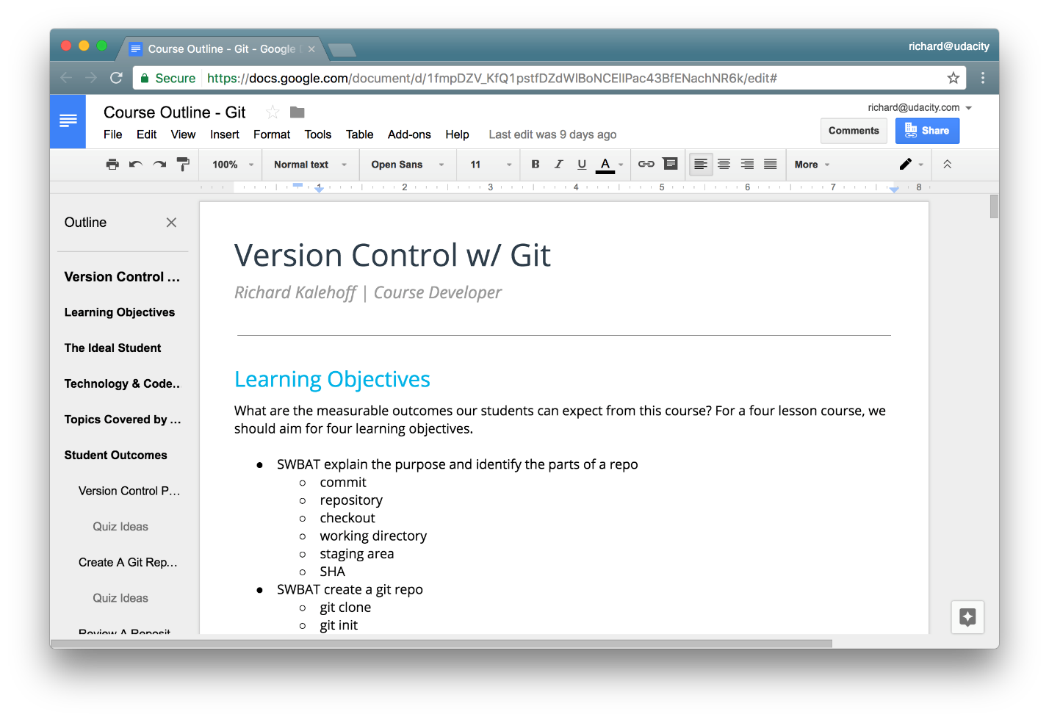

The Google Doc outline for this Git Course.

If you've ever written in a Google doc, have you noticed the small gray text at the top that tells you about the status of the document? Ever noticed that as you type, it's actively saving the document? Then, when you finish typing, it tells you that the document has saved.



Status of a Google Docs document. The status says "Saving…" while the document is being edited, and changes to "All changes saved in Drive" after the content is saved.

The real question is, did you know that is a link that you can click on? Wanna see for yourself? Try it out in one of your own Google Docs.

Clicking on the link takes you to a "Revision history" page. (Ooo! Did you notice the word "revision"? The word "version" is a synonym for "revision"!)

<https://www.youtube.com/watch?v=GcvvbdKEchk&feature=emb_logo>

### Revision History Isn't Powerful Enough

Google Docs' Revision history page is incredibly powerful! I've used it on several occasions to salvage text that I'd written at one point, erased, and then realized I actually did want to keep.

But for all its ability, it's not as powerful as we'd like. What's it missing? A few that I can think of are:

* the ability to label a change
* the ability to give a detailed explanation of why a change was made
* the ability to move between different versions of the same document
* the ability to undo change A, make edit B, then get back change A without affecting edit B

The version control tool, Git, can do all of those things - and more!!! (bet you didn't see that coming!) So have I sold you yet on the awesomeness that is Git? I hope so, cause we're about to dive into it in the next section.

## Git and Version Control Terminology

<https://www.youtube.com/watch?v=bf26adzeqMM&feature=emb_logo>

You can find the Terminology handout at the bottom of the page. The file is named **Git Key Terms** and is in the Course Materials section.

**Terminologies:**

### Version Control System / Source Code Manager

A **version control system** (abbreviated as **VCS**) is a tool that manages different versions of source code. A **source code manager** (abbreviated as **SCM**) is another name for a version control system.

Git is an SCM (and therefore a VCS!). The URL for the Git website is **[https://git-scm.com/](https://git-scm.com/" \t "_blank)** (see how it has "SCM" directly in its domain!).

### Commit

Git thinks of its data like a set of snapshots of a mini filesystem. Every time you **commit** (save the state of your project in Git), it basically takes a picture of what all your files look like at that moment and stores a reference to that snapshot. You can think of it as a save point in a game - it saves your project's files and any information about them.

Everything you do in Git is to help you make commits, so a commit is the fundamental unit in Git.

### Repository / repo

A **repository** is a directory which contains your project work, as well as a few files (hidden by default on Mac OS X) which are used to communicate with Git. Repositories can exist either locally on your computer or as a remote copy on another computer. A repository is made up of commits.

### Working Directory

The **Working Directory** is the files that you see in your computer's file system. When you open your project files up on a code editor, you're working with files in the Working Directory.

This is in contrast to the files that have been saved (in commits!) in the repository.

When working with Git, the Working Directory is also different from the command line's concept of the current working directory which is the directory that your shell is "looking at" right now.

### Checkout

A **checkout** is when content in the repository has been copied to the Working Directory.

### Staging Area / Staging Index / Index

A file in the Git directory that stores information about what will go into your next commit. You can think of the **staging area** as a prep table where Git will take the next commit. Files on the Staging Index are poised to be added to the repository.

### SHA

A **SHA** is basically an ID number for each commit. Here's what a commit's SHA might look like: e2adf8ae3e2e4ed40add75cc44cf9d0a869afeb6.

It is a 40-character string composed of characters (0–9 and a–f) and calculated based on the contents of a file or directory structure in Git. "SHA" is shorthand for "Secure Hash Algorithm". If you're interested in learning about hashes, check out our **[Intro to Computer Science course](https://www.udacity.com/course/intro-to-computer-science--cs101" \t "_blank)**.

### Branch

A **branch** is when a new line of development is created that diverges from the main line of development. This alternative line of development can continue without altering the main line.

Going back to the example of save point in a game, you can think of a branch as where you make a save point in your game and then decide to try out a risky move in the game. If the risky move doesn't pan out, then you can just go back to the save point. The key thing that makes branches incredibly powerful is that you can make save points on one branch, and then switch to a different branch and make save points there, too.

With this terminology in mind, let's take a high-level look at how we'll be using Git by looking at the typical workflow when working with version control.

<https://www.youtube.com/watch?v=dVil8e0yptQ&feature=emb_logo>

The HTML file has HTML and CSS changes on the Staging Index and an additional HTML change in the Working Directory. From what you've learned so far with how committing works, what do you think will get committed if a commit were made right now?

* 

only the HTML file changes on the Staging Index

* 

only the CSS file changes on the Staging Index

* 

the HTML and CSS file changes on the Staging Index

* 

the HTML file changes in both the Working Directory and the Staging Index

<https://www.youtube.com/watch?v=rFtUkk-sCqw&feature=emb_logo>

<https://www.youtube.com/watch?v=xqD9ImXXXHk&feature=emb_logo>

#### **Supporting Materials**

**[Git Terms PDF](http://video.udacity-data.com.s3.amazonaws.com/topher/2017/March/58d31eb5_ud123-git-keyterms/ud123-git-keyterms.pdf" \t "_blank)**

## Mac/Linux Setup

### Installing Git

Git is actually installed on MacOS, but we'll be reinstalling it so that we'll have the newest version:

1. go to **[https://git-scm.com/downloads](https://git-scm.com/downloads" \t "_blank)**
2. download the software for Mac
3. install Git choosing all of the default options

Once everything is installed, you should be able to run git on the command line. If it displays the usage information, then you're good to go!

If you run into any issues, please remember to take advantage of **[Knowledge](https://knowledge.udacity.com/" \t "_blank)** and the community in your Student Hub.

### Configuring Mac's Terminal

We're about to configure the Terminal to display helpful information when in a directory that's under version control. This is an optional step! You do not need to re-configure your terminal for Git to work. You can complete the entire course without reconfiguring it. However, reconfiguring the Terminal makes it significantly easier to use.

If you choose to configure your Terminal, here's what it should look like when you're finished.

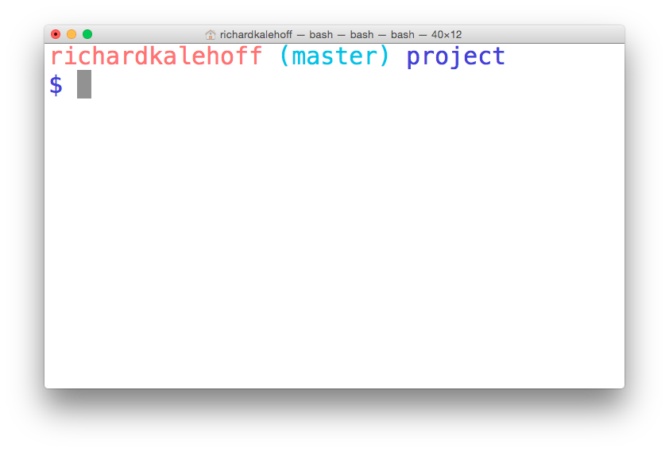

The terminal application on MacOS. The terminal has been configured to display version control information.

### Configuration Steps

To configure the terminal, we'll perform the following steps:

1. download the zipped file from the Resources pane, or the bottom of this page
2. move the directory udacity-terminal-config to your home directory and name it .udacity-terminal-config (there's a dot at the front, now!)
3. move the bash\_profile file to your home directory and name it .bash\_profile (there's a dot at the front, now!)
   * if you already have a .bash\_profile file in your home directory, transfer the content from the downloaded bash\_profile to your existing .bash\_profile

<https://www.youtube.com/watch?v=h00n9QLfbqU&feature=emb_logo>

### First Time Git Configuration

Before you can start using Git, you need to configure it. Run each of the following lines on the command line to make sure everything is set up.

*# sets up Git with your name*

git config --global user.name "<Your-Full-Name>"

*# sets up Git with your email*

git config --global user.email "<your-email-address>"

*# makes sure that Git output is colored*

git config --global color.ui auto

*# displays the original state in a conflict*

git config --global merge.conflictstyle diff3

git config --list

#### Git & Code Editor

The last step of configuration is to get Git working with your code editor. Below are three of the most popular code editors. If you use a different editor, then do a quick search on Google for "associate X text editor with Git" (replace the X with the name of your code editor).

#### Atom Editor Setup

git config --global core.editor "atom --wait"

#### Sublime Text Setup

git config --global core.editor "'/Applications/Sublime Text 2.app/Contents/SharedSupport/bin/subl' -n -w"

#### VSCode Setup

git config --global core.editor "code --wait"

If you have any questions, post them on the forum.

#### Everything Is All Set Up

Task List

* 

I've installed Git

* 

I've configured Git with my username

* 

I've configured Git with my email

* 

I've configured Git to use my chosen editor

### Supporting Materials

**[udacity-terminal-config.zip](http://video.udacity-data.com.s3.amazonaws.com/topher/2017/March/58d31ce3_ud123-udacity-terminal-config/ud123-udacity-terminal-config.zip" \t "_blank)**

## Windows Setup

### Installing Git

To download Git:

1. go to **[https://git-scm.com/downloads](https://git-scm.com/downloads" \t "_blank)**
2. download the software for Windows
3. install Git choosing all of the default options

Once everything is installed, you should be able to run git on the command line. If it displays the usage information, then you're good to go!

If you run into any issues, please remember to take advantage of **[Knowledge](https://knowledge.udacity.com/" \t "_blank)** and the community in your Study Group.

### Configuring the Command Prompt on Windows

We're about to configure the Command Prompt to display helpful information when in a directory that's under version control. This is an optional step! You do not need to re-configure your Command Prompt for Git to work. You can complete the entire course without reconfiguring it. However, reconfiguring the Command Prompt makes it significantly easier to use.

If you choose to configure your Command Prompt, here's what it should look like when you're finished.

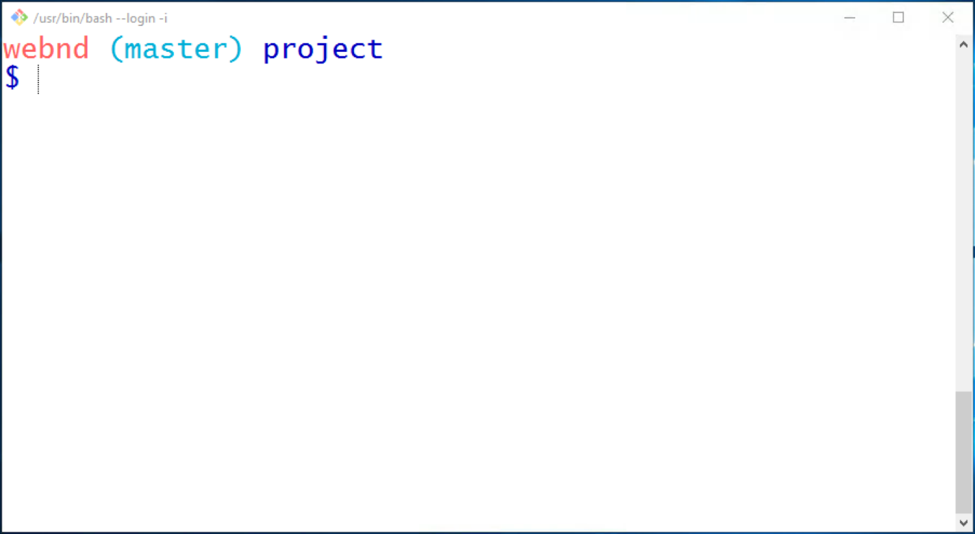

The Command Prompt application on Windows. The Command Prompt has been configured to display version control information.

<https://www.youtube.com/watch?v=CCYjHfBk9hw&feature=emb_logo>

### First Time Git Configuration

Before you can start using Git, you need to configure it. Run each of the following lines on the command line to make sure everything is set up.

*# sets up Git with your name*

git config --global user.name "<Your-Full-Name>"

*# sets up Git with your email*

git config --global user.email "<your-email-address>"

*# makes sure that Git output is colored*

git config --global color.ui auto

*# displays the original state in a conflict*

git config --global merge.conflictstyle diff3

git config --list

#### Git & Code Editor

The last step of configuration is to get Git working with your code editor. Below are three of the most popular code editors. If you use a different editor, then do a quick search on Google for "associate X text editor with Git" (replace the X with the name of your code editor).

#### Atom Editor Setup

git config --global core.editor "atom --wait"

#### Sublime Text Setup

git config --global core.editor "'C:/Program Files/Sublime Text 2/sublime\_text.exe' -n -w"

#### VSCode Setup

git config --global core.editor "code --wait"

#### Everything Is All Set Up

Task List

* 

I've installed Git

* 

I've configured Git with my username

* 

I've configured Git with my email

* 

I've configured Git to use my chosen editor

### Supporting Materials

**[udacity-terminal-config.zip](http://video.udacity-data.com.s3.amazonaws.com/topher/2017/March/58d31ce3_ud123-udacity-terminal-config/ud123-udacity-terminal-config.zip" \t "_blank)**

## Onward

<https://www.youtube.com/watch?v=iXbMaTwfIJI&feature=emb_logo>

### Supporting Materials

**[Git Terms PDF](http://video.udacity-data.com.s3.amazonaws.com/topher/2017/March/58d31eb5_ud123-git-keyterms/ud123-git-keyterms.pdf" \t "_blank)**

# Lesson 2: Create a Git Repo

## Intro

<https://www.youtube.com/watch?time_continue=6&v=KT163BkqIeg&feature=emb_logo>

## Create A Repo From Scratch

Before you can make commits or do anything else with a git repository, the repository needs to actually exist. To create a new repository with Git, we'll use the git init command.

The init subcommand is short for "initialize", which is helpful because it's the command that will do all of the initial setup of a repository. We'll look at what it does in just a second.

### Required Commands

Heads up! We'll be using the following terminal commands in this lesson:

* ls - used to list files and directories
* mkdir - used to create a new directory
* cd - used to change directories
* rm - used to remove files and directories

If you're not sure how to use them, check out our course **[Shell Workshop](https://www.udacity.com/course/shell-workshop--ud206" \t "_blank)**!

We'll also be using the idea of the current working directory, the directory that your shell is "looking at" right now. Using cd changes your working directory, and using ls (by itself) lists the files in the working directory. If you lose track of what your shell's working directory is, you can print its name with the pwd command (which stands for "print working directory").

### Create Course Directories

We're about to create a new project for this course. Since we're all professionals, we want our projects organized. If you already have a location on your computer where you put all your projects, then keep doing what you're doing. I'll be storing all of my work in a directory called udacity-git-course.

If you want to follow along with me:

* create a directory called udacity-git-course
* inside that, create another directory called new-git-project
* use the cd command to move into the new-git-project directory

If you're a copy/paster like me, just run this command on the terminal - mkdir -p udacity-git-course/new-git-project && cd $\_ (Before running this command, make sure you cd to where you want these files stored. For example, if you want the files stored on your Desktop, then make sure you cd to the Desktop before running the command.)

If you're all set, then your terminal should be "inside" the new-git-project directory and look like this:

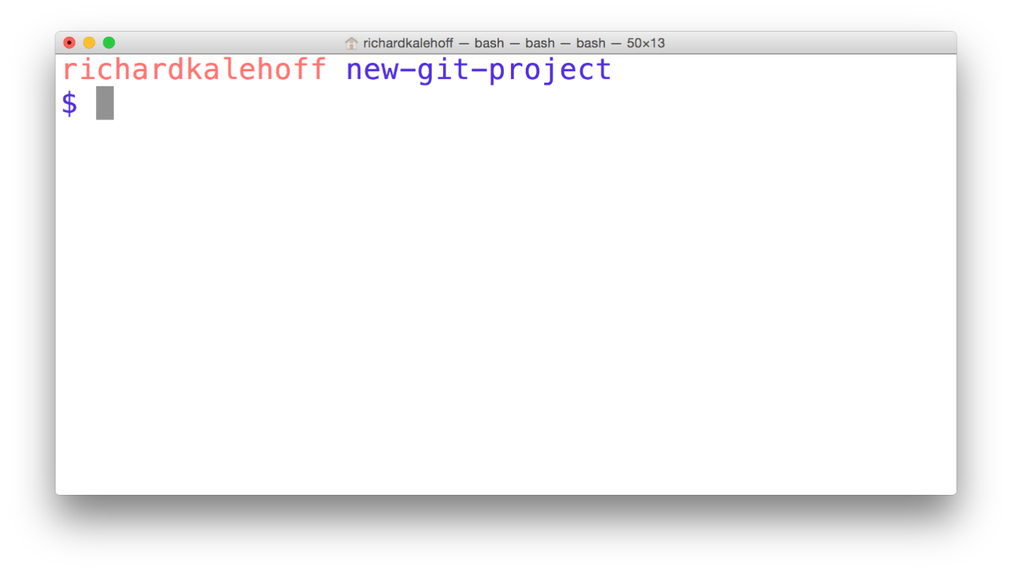

The Terminal application located in the new-git-project directory.

### Git Init

Fantastic work - we're all set up and ready to start using the git init command!

This is one of the easiest commands to run. All you have to do is run git init on the terminal. That's it! Go ahead, why not give it a try right now!



The terminal application showing the *git init* command being run. The command initializes an empty Git repository in the current directory.

Did you run git init yet? If not, do it now because you'll need it to answer this quiz!

After running git init, the text "Initialized empty Git repository in " followed by a path. should have appeared. The question is, has anything changed with your command prompt? If so, what?

* 

Yes - I now see the word "master".

* 

No, it looks exactly the same.

### Git Init's Effect

Running the git init command sets up all of the necessary files and directories that Git will use to keep track of everything. All of these files are stored in a directory called .git (notice the . at the beginning - that means it'll be a hidden directory on Mac/Linux). This .git directory is the "repo"! This is where git records all of the commits and keeps track of everything!

Let's take a brief look at the contents of the .git directory.

WARNING: Don't directly edit any files inside the .git directory. This is the heart of the repository. If you change file names and/or file content, git will probably lose track of the files that you're keeping in the repo, and you could lose a lot of work! It's okay to look at those files though, but don't edit or delete them.

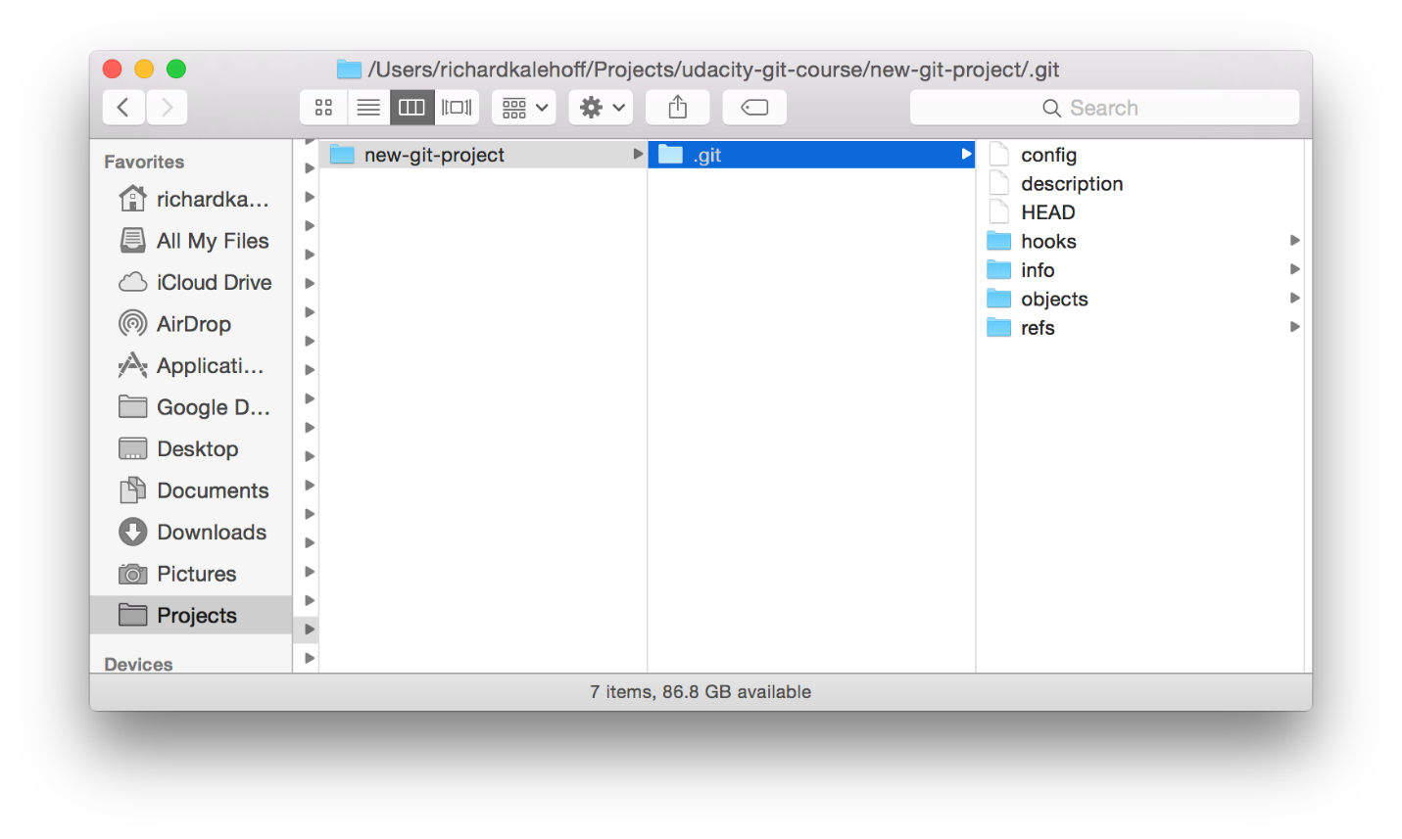

Mac's Finder window showing the contents of the hidden ".git" directory.

### .Git Directory Contents

We're about to take a look at the *.git* directory...it's not vital for this course, though, so don't worry about memorizing anything, it's here if you want to dig a little deeper into how Git works under the hood.

Here's a brief synopsis on each of the items in the .git directory:

* **config file** - where all project specific configuration settings are stored.  
  From the **[Git Book](https://git-scm.com/book/en/v2/Customizing-Git-Git-Configuration" \t "_blank)**:

Git looks for configuration values in the configuration file in the Git directory (.git/config) of whatever repository you’re currently using. These values are specific to that single repository.

For example, let's say you set that the global configuration for Git uses your personal email address. If you want your work email to be used for a specific project rather than your personal email, that change would be added to this file.

* **description file** - this file is only used by the GitWeb program, so we can ignore it
* **hooks directory** - this is where we could place client-side or server-side scripts that we can use to hook into Git's different lifecycle events
* **info directory** - contains the global excludes file
* **objects directory** - this directory will store all of the commits we make
* **refs directory** - this directory holds pointers to commits (basically the "branches" and "tags")

Remember, other than the "hooks" directory, you shouldn't mess with pretty much any of the content in here. The "hooks" directory can be used to hook into different parts or events of Git's workflow, but that's a more advanced topic that we won't be getting into in this course.

#### Further Research

* **[Git Internals - Plumbing and Porcelain](https://git-scm.com/book/en/v2/Git-Internals-Plumbing-and-Porcelain" \t "_blank)** (advanced - bookmark this and check it out later)
* **[Customizing Git - Git Hooks](https://git-scm.com/book/en/v2/Customizing-Git-Git-Hooks" \t "_blank)**

### Git Init Recap

Use the git init command to create a new, empty repository in the current directory.

$ git init

Running this command creates a hidden .git directory. This .git directory is the brain/storage center for the repository. It holds all of the configuration files and directories and is where all of the commits are stored.

### Helpful Links

* **[Initializing a Repository in an Existing Directory](https://git-scm.com/book/en/v2/Git-Basics-Getting-a-Git-Repository" \l "Initializing-a-Repository-in-an-Existing-Directory" \t "_blank)**
* **[git init docs](https://git-scm.com/docs/git-init" \t "_blank)**
* **[git init Tutorial](https://www.atlassian.com/git/tutorials/setting-up-a-repository" \t "_blank)**

## Clone An Existing Repo

### Why Clone?

First, what is cloning?

to make an identical copy

What's the value of creating an identical copy of something, and how does this relate to Git and version control?

Why would you want to create an identical copy? Well, when I work on a new web project, I do the same set of steps:

* create an index.html file
* create a js directory
* create a css directory
* create an img directory
* create app.css in the css directory
* create app.js in the js directory
* add starter HTML code in index.html
* add configuration files for linting (validating code syntax)
  + **[HTML linting](http://htmlhint.com/" \t "_blank)**
  + **[CSS linting](https://stylelint.io/" \t "_blank)**
  + **[JavaScript linting](http://eslint.org/" \t "_blank)**
* **[configure my code editor](http://editorconfig.org/" \t "_blank)**

...and I do this every time I create a new project!...which is a lot of effort I'm putting in for each new project. I didn't want to keep doing these same steps over and over, so I did all of the steps listed above one last time and created a starter project for myself. Now when I create a new project, I just make an identical copy of that starter project!

The way that cloning relates to Git is that the command we'll be running on the terminal is git clone. You pass a path (usually a URL) of the Git repository you want to clone to the git clone command.

Wanna try cloning an existing project? Let's see how Git's clone command works!

### Verify Terminal Location

TIP: Now before you clone anything, make sure you are located in the correct directory on the command line. Cloning a project creates a new directory and places the cloned Git repository in it. The problem is that you can't have nested Git repositories. So make sure the terminal's current working directory isn't located in a Git repository. If your current working directory is not in your shell's prompt, type pwd to print the working directory.

### Cloning The Blog Repository

Ready? Let's get cloning!

The command is git clone and then you pass the path to the Git repository that you want to clone. The project that we'll be using throughout this course is located at this URL: **[https://github.com/udacity/course-git-blog-project](https://github.com/udacity/course-git-blog-project" \t "_blank)** So using this URL, the full command to clone blog project is:

$ git clone https://github.com/udacity/course-git-blog-project



The *git clone* command is used to copy the blog project repository into a *course-git-blog-project* folder in the current directory.

### Git Clone Output Explanation

Let's look briefly at the output that git clone displays.

The first line says "Cloning into 'course-git-blog-project'...". Git is creating a directory (with the same name of the project we're cloning) and putting the repository in it...that's pretty cool!

The rest of the output is basically validation - it's counting the remote repository's number of objects, then it compresses and receives them, then it unpacks them.

### Clone Project And Use Different Name

You just cloned the blog project for this course. Awesome job!

The command you ran in the terminal was:

$ git clone https://github.com/udacity/course-git-blog-project

...which created a directory named course-git-blog-project.

What if you want to use a different name instead of the default one? Yes, you could just run the command above and manually rename it in Finder/Windows Explorer or use mv on the terminal. But that's too many steps for us! Instead, we'd rather clone the project and have it use a different name all in one go! But how do we do that?

Why don't you check out **[the documentation for git clone](https://git-scm.com/book/en/v2/Git-Basics-Getting-a-Git-Repository" \l "Cloning-an-Existing-Repository" \t "_blank)** and pick the correct way to do it from the options below. The command should clone the blog project repo and store it in a directory named blog-project.

* 

git clone-new-dir **[https://github.com/udacity/course-git-blog-project](https://github.com/udacity/course-git-blog-project" \t "_blank)** blog-project

* 

git clone **[https://github.com/udacity/course-git-blog-project](https://github.com/udacity/course-git-blog-project" \t "_blank)** --out blog-project

* 

git clone **[https://github.com/udacity/course-git-blog-project](https://github.com/udacity/course-git-blog-project" \t "_blank)** --rename blog-project

* 

git clone **[https://github.com/udacity/course-git-blog-project](https://github.com/udacity/course-git-blog-project" \t "_blank)** blog-project

SUBMIT

### Not In A Git Repository?

WARNING: Here's a very important step that often gets missed when you first start working with Git. When the git clone command is used to clone a repository, it creates a new directory for the repository...you already know this. But, it doesn't change your shell's working directory. It created the new repo inside the current working directory, which means that the current working directory is still outside of this new Git repo! Make sure you cd into the new repository.

Remember to use the Terminal's command prompt as an aid - if you're in a directory that is a Git repository, the command prompt will include a name in parentheses.

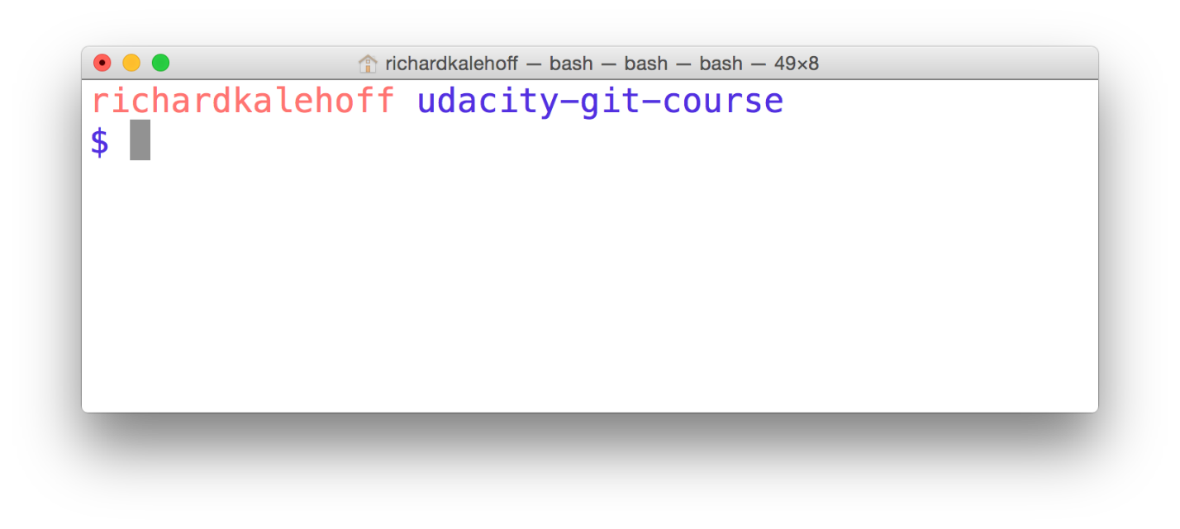

Mac's Terminal application. The terminal shows the starting directory.

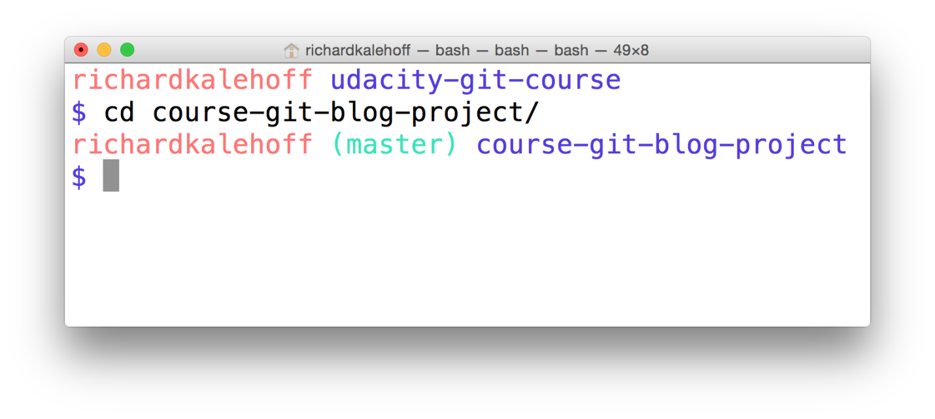

Mac's Terminal application. The terminal uses the *cd* command to move from the base directory into the course-git-blog-project which is a Git repository.

### Look At The Project

So you've cloned the project to your computer, and you've cded into it. Don't you think it's time you checked it out in a browser to see what it looks like?

Open up the index.html file in your favorite browser.

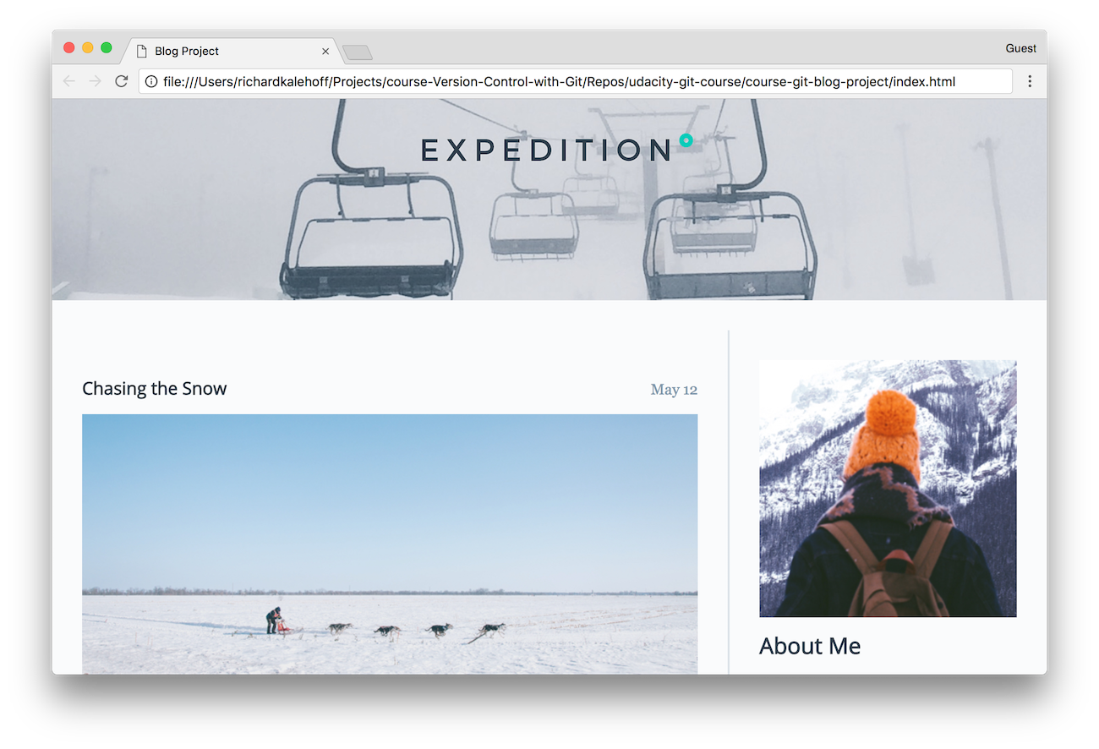

The blog project loaded in Chrome.

### Git Clone Recap

The git clone command is used to create an identical copy of an existing repository.

$ git clone <path-to-repository-to-clone>

This command:

* takes the path to an existing repository
* by default will create a directory with the same name as the repository that's being cloned
* can be given a second argument that will be used as the name of the directory
* will create the new repository inside of the current working directory

### Helpful Links

* **[Cloning an Existing Repository](https://git-scm.com/book/en/v2/Git-Basics-Getting-a-Git-Repository" \l "Cloning-an-Existing-Repository" \t "_blank)**
* **[git clone docs](https://git-scm.com/docs/git-clone" \t "_blank)**
* **[git clone Tutorial](https://www.atlassian.com/git/tutorials/setting-up-a-repository" \t "_blank)**

### Status Update

At this point, we have two Git repositories:

* the empty one that we created with the git init command
* the one we cloned with the git clone command

How can we find any information about these repositories? Git's controlling them, but how can we find out what Git knows about our repos? To figure out what's going on with a repository, we use the git status command. Knowing the status of a Git repository is extremely important, so head straight on over to the next concept: Determine A Repo's Status.

### Supporting Materials

**[Git Repository .zip file](https://video.udacity-data.com/topher/2020/March/5e714611_course-git-blog-project-master/course-git-blog-project-master.zip" \t "_blank)**

## Outro

<https://www.youtube.com/watch?time_continue=1&v=h7j4STDFCjs&feature=emb_logo>

# Lesson 3: Review a Repo’s History

## Intro

<https://www.youtube.com/watch?v=UBmg3syQS0E&feature=emb_logo>

## Displaying A Repository's Commits

TIP: In lesson 2 you used git clone to clone the blog project. This is the project we'll be using in this lesson. If you skipped cloning the project in the previous lesson, then run the following command to get the project:

$ git clone https://github.com/udacity/course-git-blog-project

Don't forget to cd into the project after you've cloned it.

If you have questions about this, review how to **[Clone An Existing Repo](https://classroom.udacity.com/courses/ud123/lessons/437a88fc-15f5-48b8-a6a5-0cf3347e6183/concepts/59082be0-c1af-4839-8ae5-0a182dc5bfe8" \t "_blank)** or ask in **[Knowledge](https://knowledge.udacity.com/" \t "_blank)**.

#### QUESTION 1 OF 7

After you’ve cloned the blog project repository, navigate to the project’s directory using the command line. Once you’re located inside the blog project, what is the very first thing you should do in a Git repository?

* 

run the git status command

* 

open the project in a code editor

* 

decide what new feature to work on

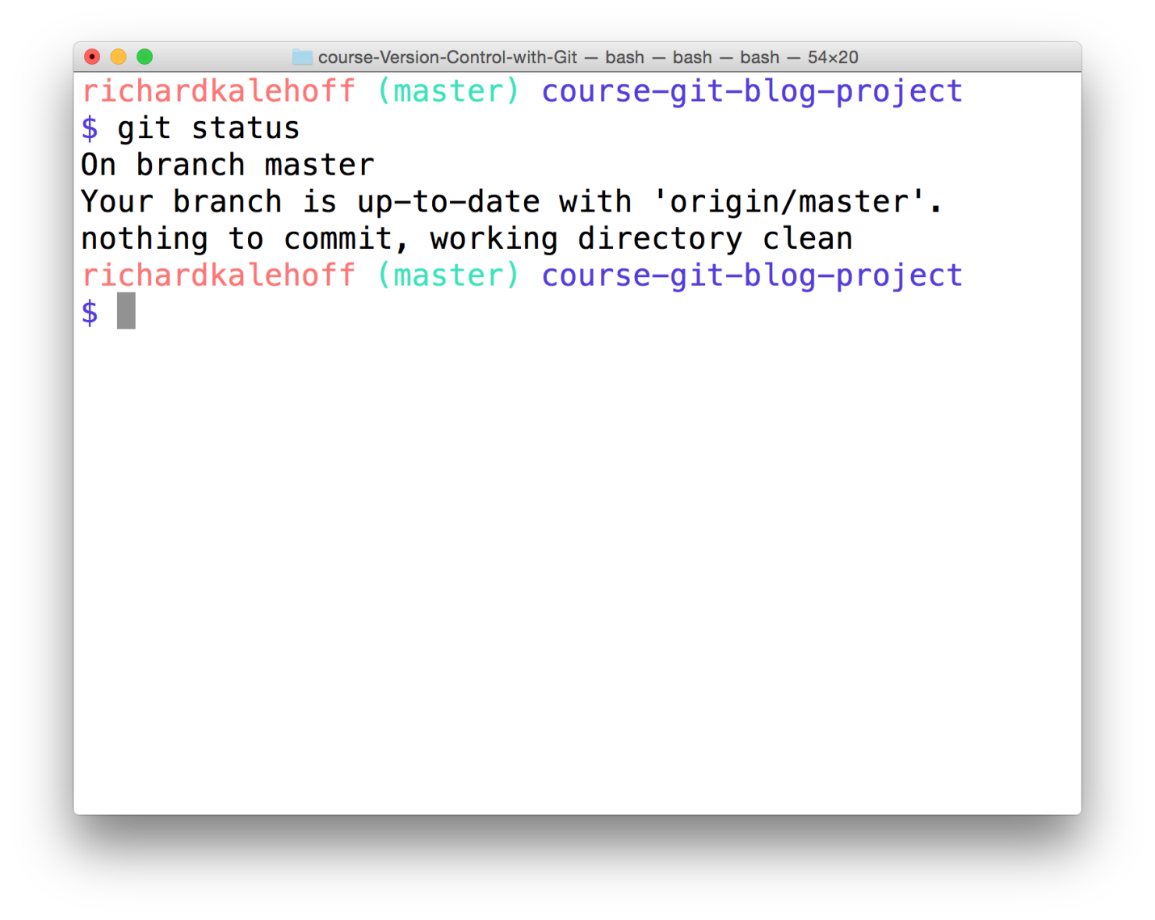

The Terminal application showing the output of the *git status* command.

### Git Status & Opening The Project

You can see that git status tells us that there's "nothing to commit, working directory clean". That means we're good to go ahead and check out the project!

So open the project in your favorite code editor. If you haven't yet, take a minute or two to look at the project – look over the CSS and the JavaScript files, but look particularly at the HTML file.

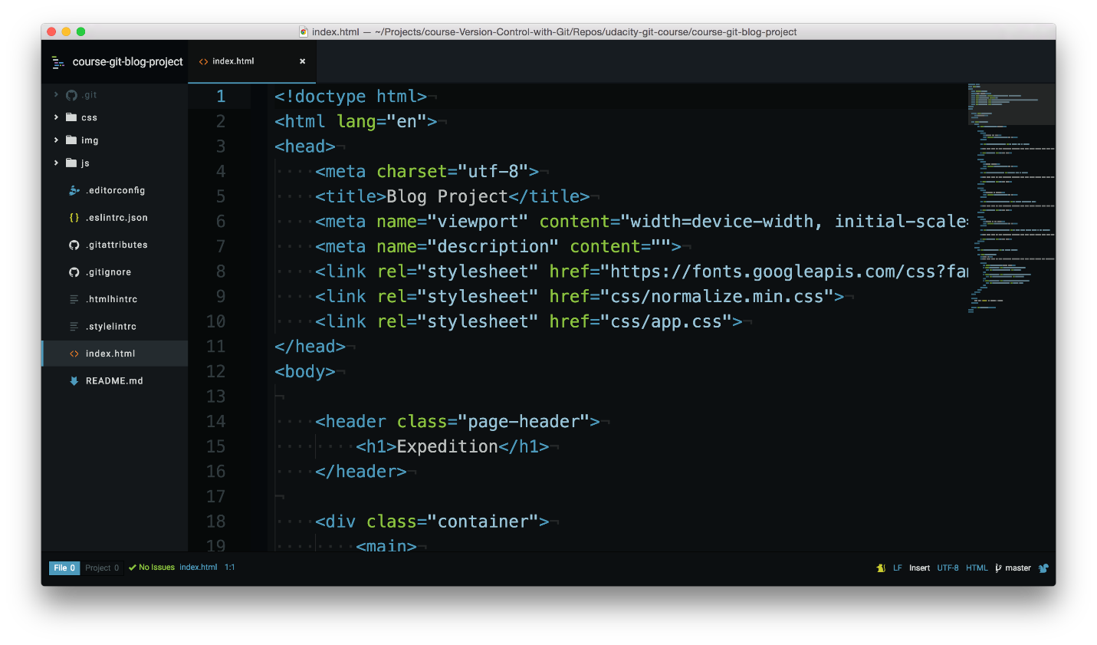

The course's Blog project open in a code editor. The *index.html* file is being displayed.

#### QUESTION 2 OF 7

In the index.html file, take a look at the <h1>Expedition</h1> heading around line 15.

Based on what you can see here when was that heading added?

* 

It was added on a Tuesday. Yeah, a Tuesday.

* 

3 weeks ago

* 

¯\(ツ)/¯ I can't tell that by looking at the code.

SUBMIT

#### QUESTION 3 OF 7

Ok, so we're not quite sure when the heading was added. How about an easier question - who added this heading? Again, what can you tell from just looking at the code?

* 

Richard did!

* 

No clue

### The Git Log Command

Finding the answers to these questions is exactly what git log can do for us! Instead of explaining everything that it can do for us, let's experience it! Go ahead and run the git log command in the terminal:

$ git log

The terminal should display the following screen.

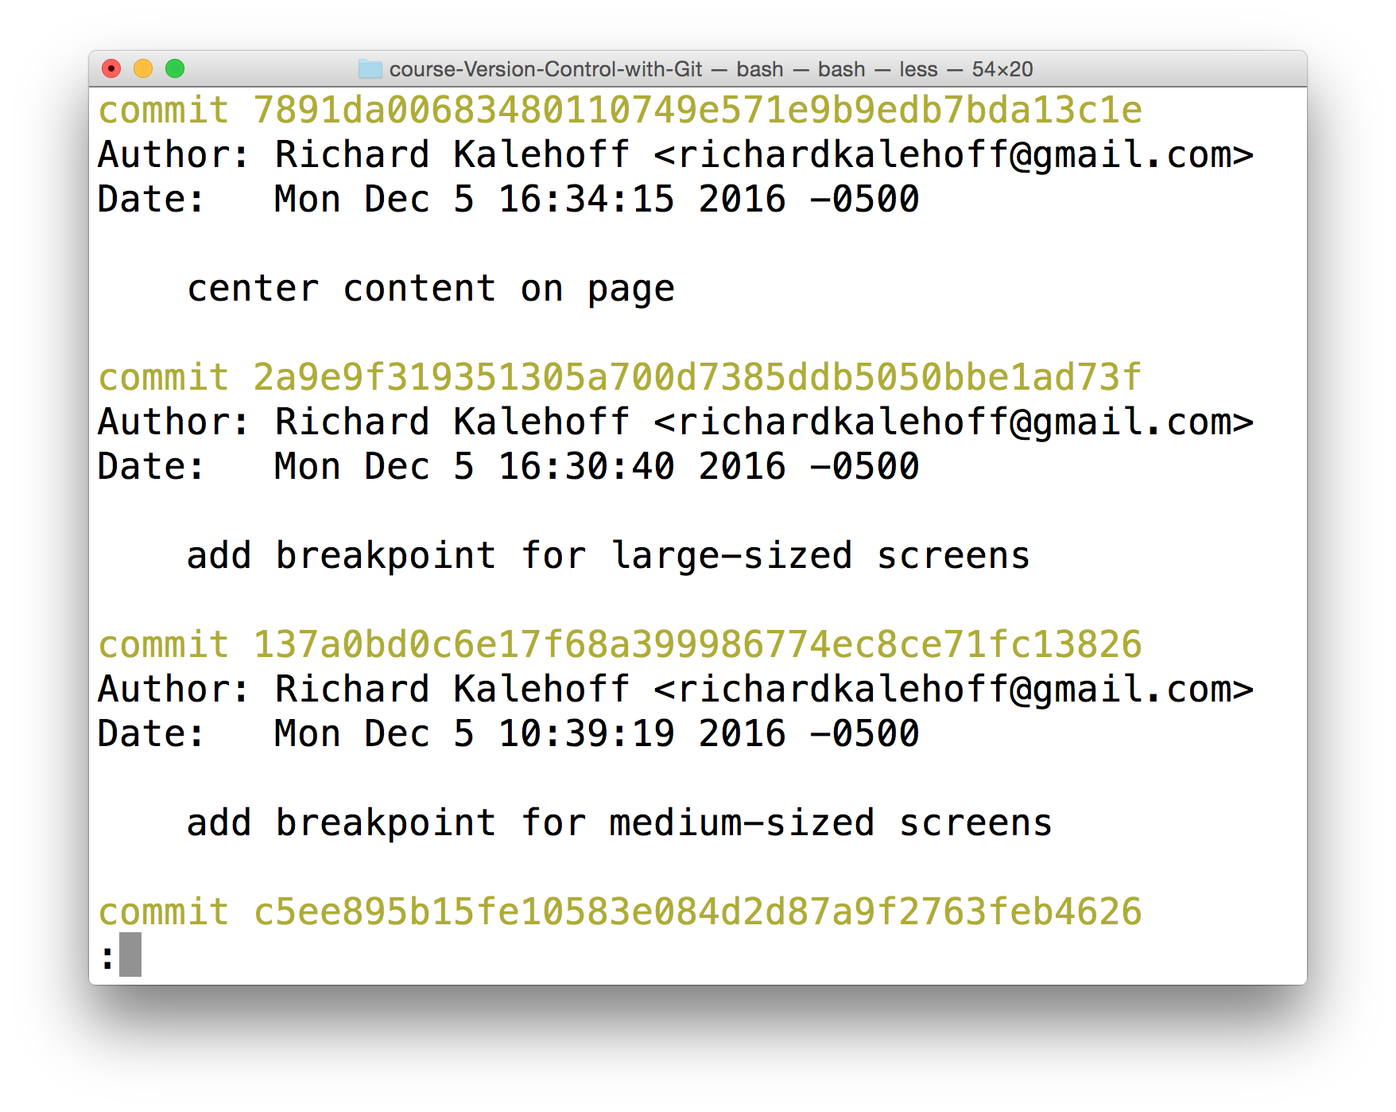

The Terminal application showing the output of the *git log* command.

<https://www.youtube.com/watch?v=xJfurQcVYfo&feature=emb_logo>

### Navigating The Log

If you're not used to a pager on the command line, navigating in **[Less](https://en.wikipedia.org/wiki/Less_(Unix)" \t "_blank)** can be a bit odd. Here are some helpful keys:

* to scroll **down**, press
  + j or ↓ to move down one line at a time
  + d to move by half the page screen
  + f to move by a whole page screen
* to scroll **up**, press
  + k or ↑ to move \_up\_ one line at a time
  + u to move by half the page screen
  + b to move by a whole page screen
* press q to **quit** out of the log (returns to the regular command prompt)

Git records a ton of information when a commit is made. See if you can use git log to answer the following questions!

#### QUESTION 4 OF 7

Use git log to find the commit that has a SHA that starts with f9720a. Who made the commit?

* 

James Parkes

* 

Richard Kalehoff

* 

Colt Steele

* 

Julia Van Cleve

* 

Godzilla McFiddlebrunches

SUBMIT

### What Is The Message?

Use git log to find the commit with the SHA that starts with 8aa6668. What is the message for that commit?

SUBMIT

#### QUESTION 6 OF 7

Use git log to find the commit with the SHA that starts with f9720a9. When was that commit made?

* 

Mon Dec 5 10:25:22 2016

* 

Mon Dec 5 10:11:51 2016

* 

Sat Dec 3 16:09:00 2016

* 

Fri Dec 2 16:58:27 2016

SUBMIT

### What Is The SHA?

Use git log to find the commit that has the message Set article timestamp color. Which commit belongs to that SHA? Provide the first 7 characters of the SHA.

SUBMIT

### Git Log Recap

Fantastic job! Do you feel your Git-power growing?

Let's do a quick recap of the git log command. The git log command is used to display all of the commits of a repository.

$ git log

By default, this command displays:

* the SHA
* the author
* the date
* and the message

...of every commit in the repository. I stress the "By default" part of what Git displays because the git log command can display a lot more information than just this.

Git uses the command line pager, Less, to page through all of the information. The important keys for Less are:

* to scroll down by a line, use j or ↓
* to scroll up by a line, use k or ↑
* to scroll down by a page, use the spacebar or the Page Down button
* to scroll up by a page, use b or the Page Up button
* to quit, use q

We'll increase our git log-wielding abilities in the next lesson when we look at displaying more info.

Why wait?!? Click the link to move to the next lesson!

## Changing How Git Log Displays Information

You made it all this way - congrats on getting this far! Seriously! Learning Git is a challenging undertaking. I applaud you on your perseverance.

Take a look at this output from running git log:



The Terminal application showing the output from running *git log*.

We've been looking closely at all the detailed information that git log displays. But now, take a step back and look at all of the information as a whole.

Let's think about some of these questions:

* **the SHA** - git log will display the complete SHA for every single commit. Each SHA is unique, so we don't really need to see the entire SHA. We could get by perfectly fine with knowing just the first 6-8 characters. Wouldn't it be great if we could save some space and show just the first 5 or so characters of the SHA?
* **the author** - the git log output displays the commit author for every single commit! It could be different for other repositories that have multiple people collaborating together, but for this one, there's only one person making all of the commits, so the commit author will be identical for all of them. Do we need to see the author for each one? What if we wanted to hide that information?
* **the date** - By default, git log will display the date for each commit. But do we really care about the commit's date? Knowing the date might be important occasionally, but typically knowing the date isn't vitally important and can be ignored in a lot of cases. Is there a way we could hide that to save space?
* **the commit message** - this is one of the most important parts of a commit message...we usually always want to see this

What could we do here to not waste a lot of space and make the output smaller? We can use a **flag**.

TIP: This isn't a course on the command line, but a flag is used to alter how a program functions. For example, the ls command will list all of the files in the current directory. The ls command has a -l flag (i.e. ls -l) that runs the same ls command but alters how it works; it now displays the information in the long format (the -l for long).

Flags can be used to alter how a program functions and/or what is displayed. To learn more about command line programs and flags, check out our course **[Linux Command Line Basics](https://www.udacity.com/course/linux-command-line-basics--ud595" \t "_blank)**.

### git log --oneline

The git log command has a flag that can be used to alter how it displays the repository's information. That flag is --oneline:

$ git log --oneline

Check out how different the output is!

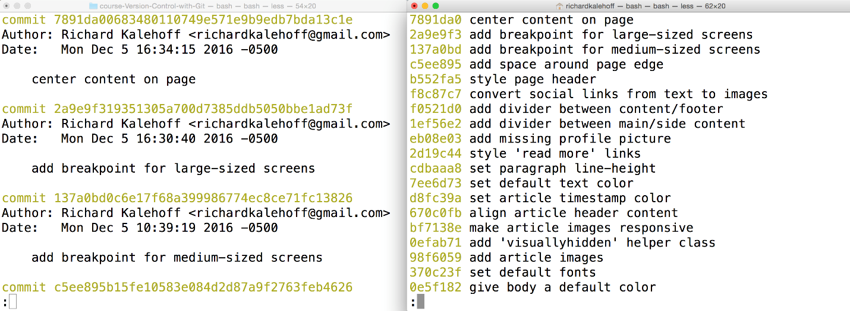

Two Terminal applications side-by-side. The left one shows the result of the *git log* command with all of the information while the right one shows the result of the *git log --oneline* command with just the short SHA and the commit message.

<https://www.youtube.com/watch?time_continue=3&v=rn6v_QgYFnU&feature=emb_logo>

#### QUIZ QUESTION

You're deep in the weeds of the git log --oneline command and want to get out of the git log --oneline output and return to the regular command prompt. What do you press on the keyboard to return to the regular command prompt?

* 

the esc key

* 

the q key

* 

the ctrl + c keys

* 

the ctrl + d keys

<https://www.youtube.com/watch?v=xtsugblSwrU&feature=emb_logo>

### git log --oneline Recap

To recap, the --oneline flag is used to alter how git log displays information:

$ git log --oneline

This command:

* lists one commit per line
* shows the first 7 characters of the commit's SHA
* shows the commit's message

## Viewing Modified Files

We just looked at the --oneline flag to show one commit per line. That's great for getting an overview of the repository. But what if we want to dig in a little to see what file or files were changed by a commit?

#### QUESTION 1 OF 4

If you look in the repository at commit a3dc99a, it has the message "Center content on page".

What file or files were changed in this commit?

* 

An HTML file

* 

A CSS file

* 

A JavaScript file

* 

An HTML and CSS file

* 

An HTML and JS file

* 

There's no way to know for sure.

### git log --stat Intro

The git log command has a flag that can be used to display the files that have been changed in the commit, as well as the number of lines that have been added or deleted. The flag is --stat ("stat" is short for "statistics"):

$ git log --stat

Run this command and check out what it displays.

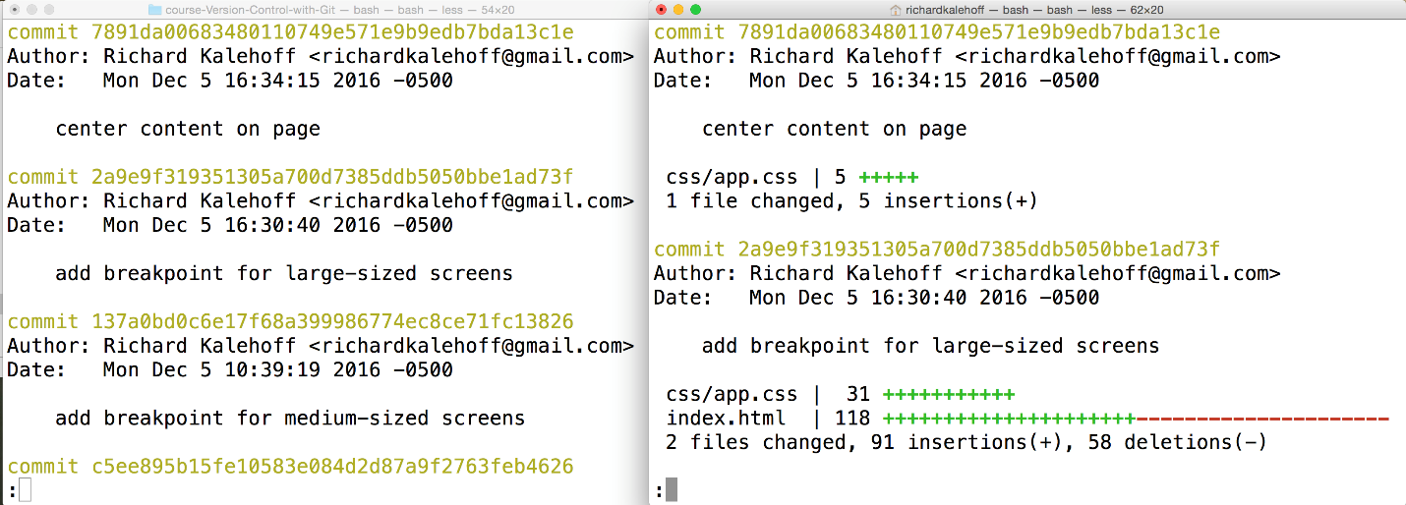

Two Terminal applications side-by-side. The left one shows the result of the *git log* command with all of the information while the right one shows the result of the *git log --stat* command which lists the files that were changed as well as the number of added/removed lines.

<https://www.youtube.com/watch?v=aOICKP_9xiY&feature=emb_logo>

#### QUESTION 2 OF 4

Using what you've learned so far about git log and its flags, how many files were modified in the commit with the SHA 6f04ddd?

* 

1 file

* 

2 files

* 

9 files

* 

10 files

SUBMIT

#### QUESTION 3 OF 4

You did so well with the first one, so here's another! How many files were modified in the commit with the SHA 8d3ea36?

* 

1 file

* 

2 files

* 

3 files

* 

5 files

#### QUESTION 4 OF 4

Now it's time to look at the other info the --stat flag displays. How many lines of code were deleted in index.html in the commit with the SHA 8d3ea36?

* 

2 lines

* 

4 lines

* 

9 lines

* 

13 lines

* 

28 lines

### git log --stat Recap

To recap, the --stat flag is used to alter how git log displays information:

$ git log --stat

This command:

* displays the file(s) that have been modified
* displays the number of lines that have been added/removed
* displays a summary line with the total number of modified files and lines that have been added/removed

## Viewing File Changes

### Viewing Changes

We know that git log will show us the commits in a repository, and if we add the --stat flag, we can see what files were modified and how many lines of code were added or removed. Wouldn't it be awesome if we could see exactly what those changes were?

If this isn't the best part of a version control system, I don't know what is! Being able to see the exact changes that were made to a file is incredibly important! Being able to say, "oh, ok, so this commit adds 5 pixels of border-radius to the button!".

For example, in the blog project, the commit a3dc99a has the message "center content on page" and modifies the CSS file by adding 5 lines. What are those five lines that were added? How can we figure out what those 5 lines are?



The Terminal application. The command *git log --stat* is run. It displays commits and zooms in on the first commit's stats showing the CSS file with 5 lines added.

### git log -p

The git log command has a flag that can be used to display the actual changes made to a file. The flag is --patch which can be shortened to just -p:

$ git log -p

Run this command and check out what it displays.

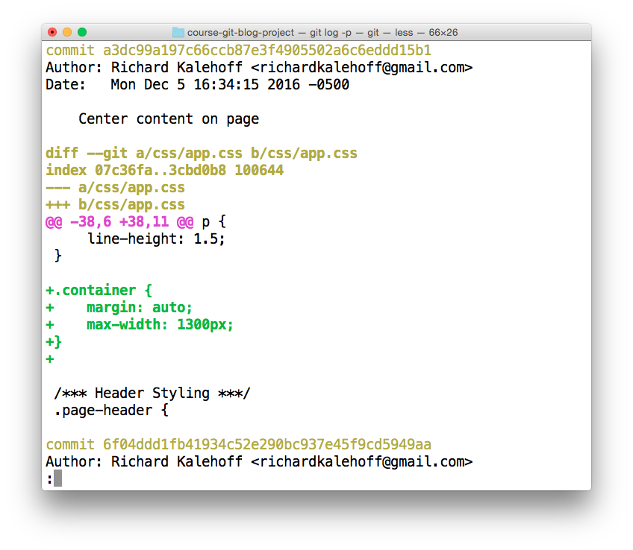

The Terminal application showing the output of the *git log -p* command. Note - the colors in your terminal might differ.

<https://www.youtube.com/watch?v=A8Kwocr-K8c&feature=emb_logo>

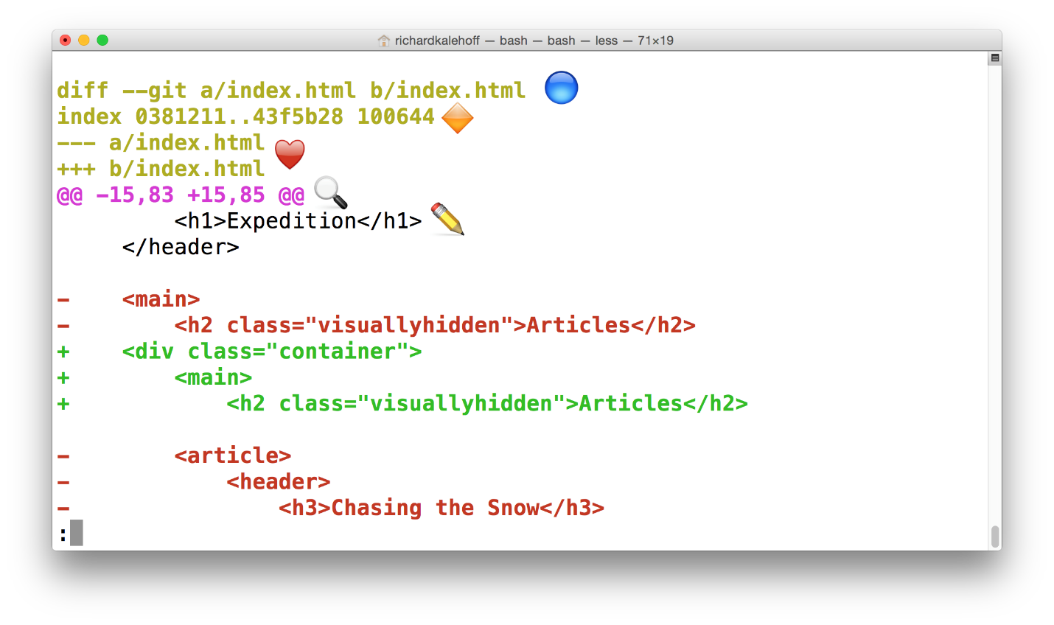

The Terminal application showing the output of the *git log -p* command. Check below for a detailed description of the output.

### Annotated git log -p Output

Using the image above, let's do a quick recap of the git log -p output:

* 🔵 - the file that is being displayed
* 🔶 - the hash of the first version of the file and the hash of the second version of the file
  + not usually important, so it's safe to ignore
* ❤️ - the old version and current version of the file
* 🔍 - the lines where the file is added and how many lines there are
  + -15,83 indicates that the old version (represented by the -) started at line 15 and that the file had 83 lines
  + +15,85 indicates that the current version (represented by the +) starts at line 15 and that there are now 85 lines...these 85 lines are shown in the patch below
* ✏️ - the actual changes made in the commit
  + lines that are red and start with a minus (-) were in the original version of the file but have been removed by the commit
  + lines that are green and start with a plus (+) are new lines that have been added in the commit

### Further Research

* **[Generating patches with -p](https://git-scm.com/docs/git-diff" \l "_generating_patches_with_p" \t "_blank)** from the Git docs

#### QUESTION 1 OF 4

Using what you've learned so far about git log's -p flag, look at the commit with the SHA 50d835d. What line number in app.css should you start looking at to see what has been changed?

Tip - don't forget that while looking at the git log output, the d key will scroll down by half a page while the u key will scroll \_up\_ half a page.

* 

line 63

* 

line 89

* 

line 127

* 

line 155

SUBMIT

#### QUESTION 2 OF 4

Using git log and any of its flags, what code was added in by commit 4a60beb?

* 

color: #352d2d;

* 

color: #250808;

* 

color: #333333;

* 

color: #2e3d49;

SUBMIT

#### QUESTION 3 OF 4

git log --stat and git log -p are both really helpful commands. Wouldn't it be great if we could have both of their output at the same time? Hmmm…

What happens when git log -p --stat is run?

* 

it displays only the patch information

* 

it displays only the stats

* 

it displays both with the patch info above the stats info

* 

it displays both with the stats info above the patch info

SUBMIT

In the video above, we looked at a commit that indents a lot of code. The patch output shows all of those lines as having been removed and then added again at their new level of indentation. Showing all of the indent changes makes it hard to tell what was actually added, though.

#### QUESTION 4 OF 4

What does the -w flag do to the patch information? For help, check **[this Git docs page](https://git-scm.com/docs/git-diff" \t "_blank)**.

* 

it displays non-whitespace characters in blinking text

* 

it displays non-whitespace changes in bold

* 

it ignores whitespace changes

* 

it shows a separate patch area with just new/removed content

SUBMIT

### git log -p Recap

To recap, the -p flag (which is the same as the --patch flag) is used to alter how git log displays information:

$ git log -p

This command adds the following to the default output:

* displays the files that have been modified
* displays the location of the lines that have been added/removed
* displays the actual changes that have been made

## Viewing A Specific Commit

### Too Much Scrolling

The last few quizzes in the previous section had you scrolling and scrolling through the patch output just to get to the right commit so you could see its info. Wouldn't it be super handy if you could just display a specific commit's details without worrying about all of the others in the repo?

There are actually two ways to do this!

* providing the SHA of the commit you want to see to git log
* use a new command git show

They're both pretty simple, but let's look at the git log way and then we'll look at git show.

You already know how to "log" information with:

* git log
* git log --oneline
* git log --stat
* git log -p

But did you know, you can supply the SHA of a commit as the final argument for all of these commands? For example:

$ git log -p fdf5493

By supplying a SHA, the git log -p command will start at that commit! No need to scroll through everything! Keep in mind that it will also show all of the commits that were made prior to the supplied SHA.

### New Command: git show

The other command that shows a specific commit is git show:

$ git show

Running it like the example above will only display the most recent commit. Typically, a SHA is provided as a final argument:

$ git show fdf5493

#### What does git show do?

The git show command will show only one commit. So don't get alarmed when you can't find any other commits - it only shows one. The output of the git show command is exactly the same as the git log -p command. So by default, git show displays:

* the commit
* the author
* the date
* the commit message
* the patch information

However, git show can be combined with most of the other flags we've looked at:

* --stat - to show the how many files were changed and the number of lines that were added/removed
* -p or --patch - this the default, but if --stat is used, the patch won't display, so pass -p to add it again
* -w - to ignore changes to whitespace

You are now among the git logging elite! Try your hand at a few quizzes.

#### QUESTION 1 OF 3

How many rulesets are added to the CSS by commit 8d3ea36?

* 

1

* 

2

* 

3

* 

4

SUBMIT

#### QUESTION 2 OF 3

There's a commit with the message "Convert social links from text to images". How many files were changed by this commit?

* 

2 files

* 

4 files

* 

5 files

* 

9 files

SUBMIT

#### QUESTION 3 OF 3

Look at commit fdf5493. What's the first HTML heading element that's added by this commit?

* 

an <h1>

* 

an <h2>

* 

an <h3>

* 

an <h4>

## Outro

<https://www.youtube.com/watch?time_continue=2&v=9rUf2HbdAd8&feature=emb_logo>

# Lesson 4: Add Commits to a Repo

## Intro

<https://www.youtube.com/watch?v=sLcOFQ4mGvo&feature=emb_logo>

## Git Add

### Move To Correct Project

If you've been following along, you should have two different directories with Git projects on your computer:

* new-git-project - an empty directory that you converted to a Git repository using git init
* course-git-blog-project - an existing blog project you retrieved using git clone

To avoid any confusion with existing commits, we'll be making our commits to the new-git-project Git repository.

On the Terminal, make sure you cd into the new-git-project directory. If you don't have a new-git-project directory, create it now. Once you're inside the directory, run the git init command. If you've already run git init before it's ok – running git init multiple times doesn't cause any problems since it just re-initializes the Git directory.

#### Proper Setup

Time to make sure we both have the same setup:

Task List

* 

I've cded into the new-git-project directory on the Terminal

* 

I've run git init to create a new Git repository

Your Terminal should look like this:

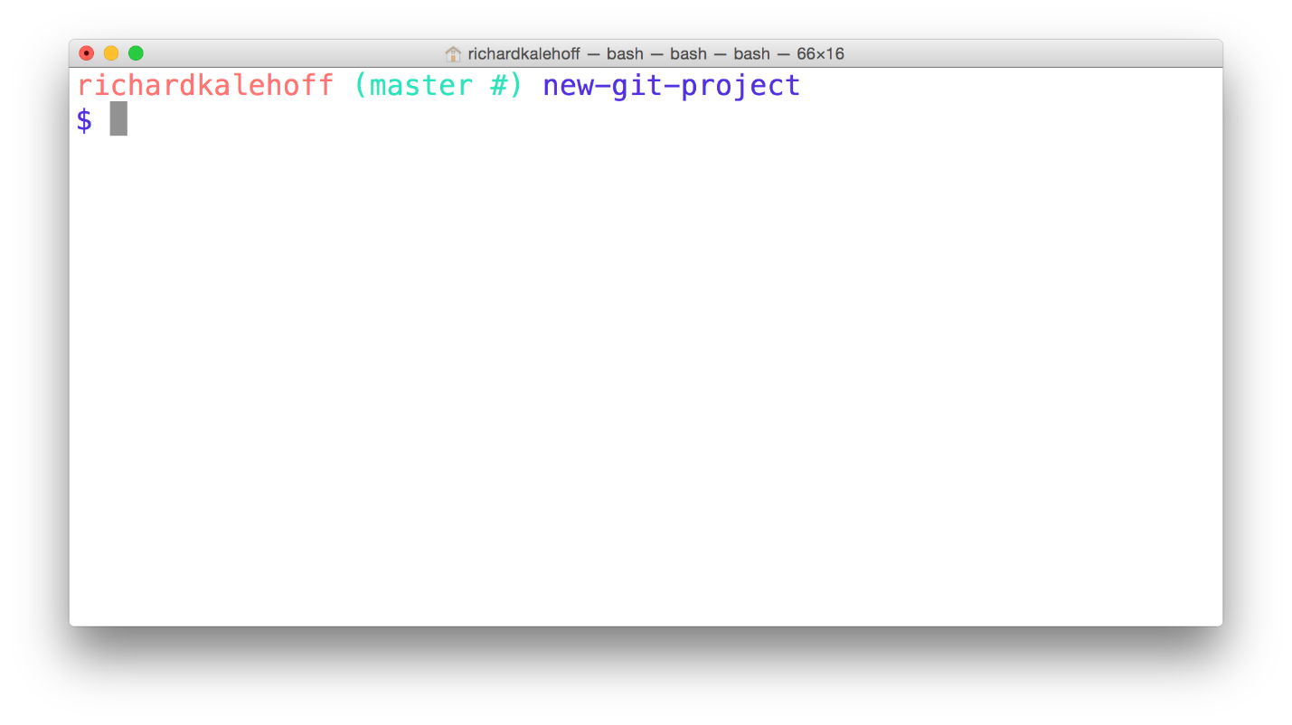

The Terminal application in the new-git-project directory.

### Status Status Status

I've said it a number of times already, but the git status command will be extremely helpful in this lesson. You should have it as your goal to run the git status command both before and after any other Git command.

Let's run it right now!

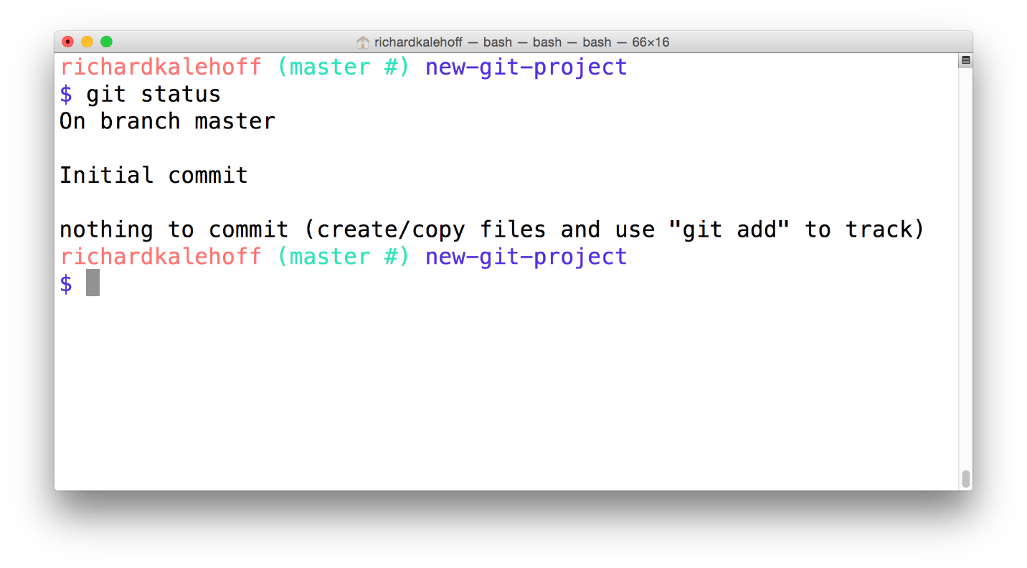

The Terminal application showing the output of the *git status* command.

### Git Status Output Review

This is the output:

On branch master

Initial commit

nothing to commit (create/copy files and use "git add" to track)

#### 💡 Changes in Git v2.14 💡

Remember that in Git version 2.14, the git status command changed the wording from "Inital commit" to the much clearer "No commits yet". So the output would be:

On branch master

No commits yet

nothing to commit (create/copy files and use "git add" to track)

Notice that last line – nothing to commit (create/copy files and use "git add" to track). See how it's recommending the git add command? that's super helpful! The git status output will give you advice or hints as to what you should do next.

Let's do what the feedback says and create some files.

### Create An HTML File

First, create a file named index.html, and fill it with some starter code:

**<!doctype html>**

<html lang="en">

<head>

<meta charset="utf-8">

<title>Blog Project</title>

<meta name="viewport" content="width=device-width, initial-scale=1">

<meta name="description" content="">

<link rel="stylesheet" href="css/app.css">

</head>

<body>

<script src="js/app.js"></script>

</body>

</html>

Things to note, the code references a CSS file and a JavaScript file.

Now create the CSS and JavaScript files. You can leave both of these files empty. We'll add content to them in a bit.

#### Verifying Project Setup

Before we proceed, let's make sure we have the same setup. Check off each of the following as you complete them:

Task List

* 

I have created index.html and filled it with the starter code above (and saved the file)

* 

I have created a css folder and created app.css inside of it

* 

I have created a js folder and created app.js inside of it

### Quick Git Status Check

We just made a number of changes to the repository by adding files and content. It's time to do a quick check-in with Git:

$ git status

Here's what my Terminal displays:

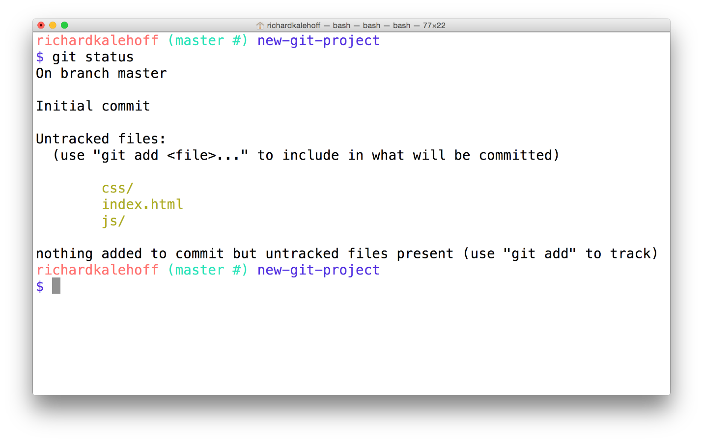

The Terminal application displays the index.html file, and the css and js folders in the new "Untracked files" section.

### Big Picture Review

That's really cool, isn't it! We haven't done anything specific with Git just yet, but it's watching this directory (since it's a Git project), and it knows that we've created a couple of new files. What's also pretty neat about the output of the git status command is that it's telling us that the files are untracked by Git.

Let's do a quick review of what's going on and what we're about to do:

* we have some new files that we want Git to start tracking
* for Git to track a file, it needs to be committed to the repository
* for a file to be committed, it needs to be in the Staging Index
* the git add command is used to move files from the Working Directory to the Staging Index
* there are currently three, untracked files in the Working Directory
  + index.html
  + app.css in the css directory
  + app.js in the js directory

So the first step to getting any files committed to the repository is to add them from the Working Directory to the Staging Index. We will be using the git add command to move all three of these files to the Staging Index.



The untracked HTML, CSS, and JavaScript files add from the Working Directory to the Staging Index.

### Staging Files

Alrighty, it's go time! Run the following command on the Terminal which uses git add to add index.html to the Staging Index:

$ git add index.html

Note - we are only adding the index.html file. We'll add the CSS and JavaScript files in just a second.



The Terminal application. The command "git add index.html" is being typed out to add the file to the Staging Index.

Running the git add command produces no output (as long as there wasn't an error). So how do we have Git tell us what it did and has happened to the index.html file that was added? That's what git status does. You're probably sick of me stressing the importance of the git status command, but it's an extremely helpful command, especially if you're new to version control and/or the command line.

Let's check out the status of the project:

$ git status

This is the output I get:

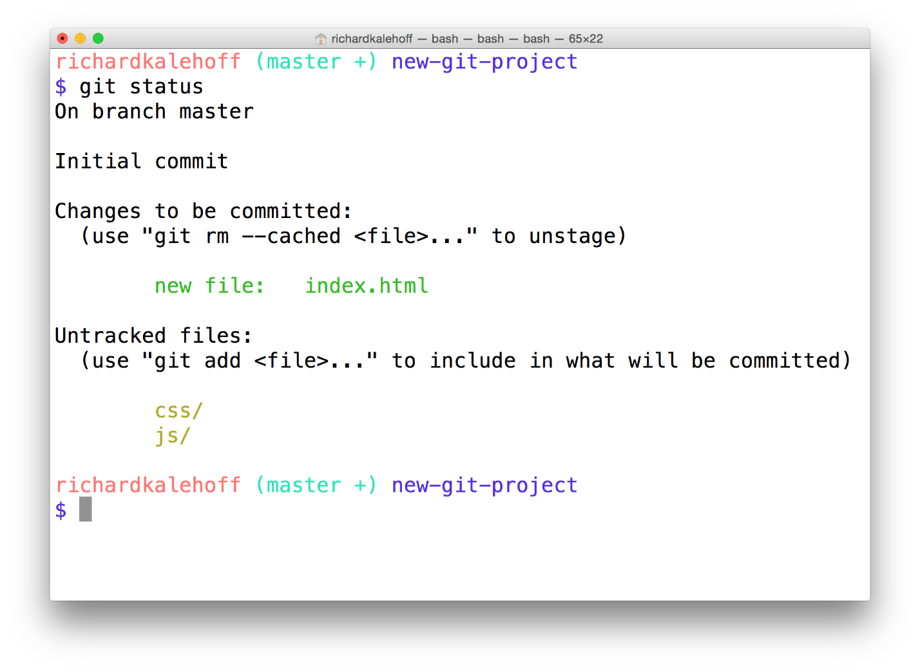

The Terminal application showing the result of running the *git status* command. It shows that index.html is now in the "Changes to be committed" category.

### Changes To Be Committed

There's now a new section in the output of git status - the "Changes to be committed" area! This new "Changes to be committed" section displays files that are in the Staging Area! Right now it only displays the index.html file, so this file is the only item on the Staging Index. To continue this train of thought, if we made a commit right now, only the index.html file would be committed.

TIP: Did you also notice the helpful text that's located just beneath "Changes to be committed"? It says (use "git rm --cached <file>..." to unstage) This is a hint of what you should do if you accidentally ran git add and gave it the wrong file.

As a side note, git rm --cached is not like the shell's rm command. git rm --cached will not destroy any of your work; it just removes it from the Staging Index.

Also, this used the word "unstage". The act of moving a file from the Working Directory to the Staging Index is called "staging". If a file has been moved, then it has been "staged". Moving a file from the Staging Index back to the Working Directory will unstage the file. If you read documentation that says "stage the following files" that means you should use the git add command.

### Stage Remaining Files

The index.html file has been staged. Let's stage the other two files. Now we could run the following:

$ git add css/app.css js/app.js

...but that's a lot of extra typing. We could use a special command line character to help:

#### The Period .

The period refers to the current directory and can be used as a shortcut to refer to all files and directories (including all nested files and directories!).

$ git add css/app.css js/app.js

*# would become*

$ git add .

The only thing to be careful of is that you might accidentally include more files than you meant to. Right now we want both css/app.css and js/app.js to be staged, so running this command is fine right now. But let's say you added some images to an img directory but didn't want to stage them just yet. Running git add . will stage them. If you do stage files that you didn't mean to, remember that git status will tell you the command to use to "unstage" files.

### Stage The Remaining Files

Let's use the shortcut to stage the remaining files:

$ git add .

And then a quick git status:

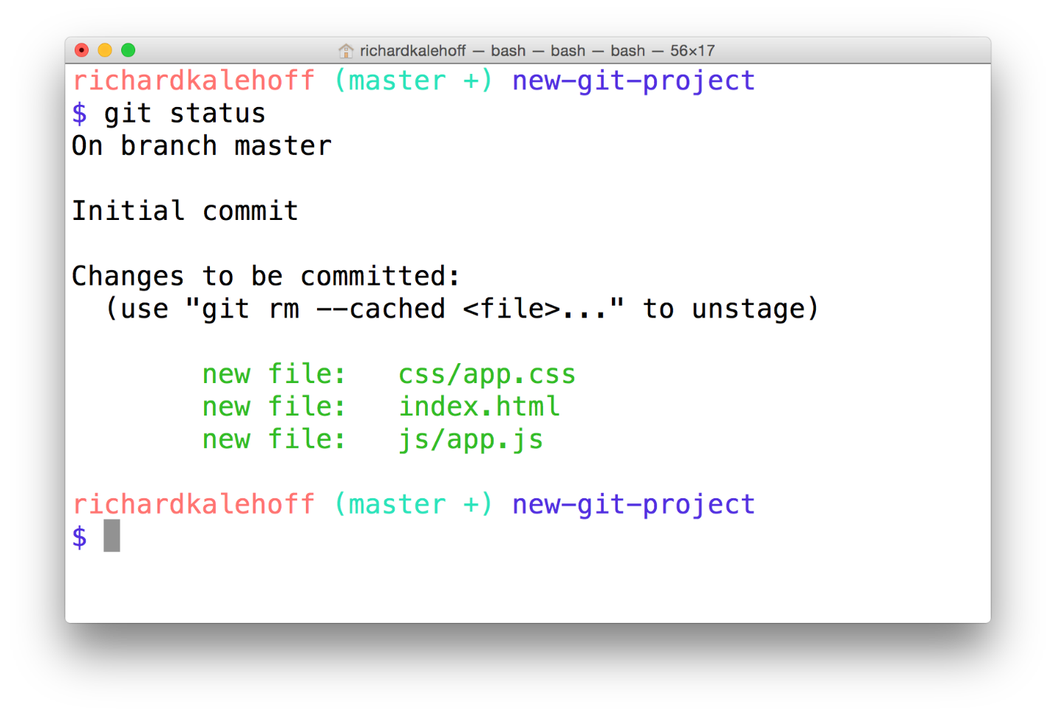

The Terminal application showing the index.html, css/app.css, and js/app.js have been staged.

### Git Add Recap

The git add command is used to move files from the Working Directory to the Staging Index.

$ git add <file1> <file2> … <fileN>

This command:

* takes a space-separated list of file names
* alternatively, the period . can be used in place of a list of files to tell Git to add the current directory (and all nested files)

## Git Commit

### Quick Check In

We're just about to make our first commit, so let's verify that our projects are set up the same way:

Task List

* 

the index.html file exists and has starter code in it

* 

the app.css file exists in the css folder

* 

the app.js file exists in the js folder

* 

all three files have been staged

### One Last Git Status Check

If you haven't added any new files to the Working Directory or modified any of the existing files, nothing will have changed, but to make sure, let's run a quick git status again right before we make the commit just to make absolutely sure the project is how we left it.



The Terminal application shows that the index.html, css/app.css, and js/app.js have been staged and are ready to be committed.

### Make A Commit

Ok, let's do it!

To make a commit in Git you use the git commit command, but don't run it just yet. Running this command will open the code editor that you configured way back in the first lesson. If you haven't run this command yet:

$ git config --global core.editor <your-editor's-config-went-here>

...go back to the Git configuration step and configure Git to use your chosen editor.

If you didn't do this step and you already ran git commit, then Git probably defaulted to using the "Vim" editor. Vim is a popular editor for people who have been using Unix or Linux systems forever, but it's not the friendliest for new users. It's definitely not in the scope of this course. Check out **[this Stack Overflow post on how to get out of Vim](https://stackoverflow.com/questions/11828270/how-to-exit-the-vim-editor" \t "_blank)** and return to the regular command prompt.

If you did configure your editor, then go ahead and make a commit using the git commit command:

$ git commit

Remember, your editor should pop open and you should see something like this:

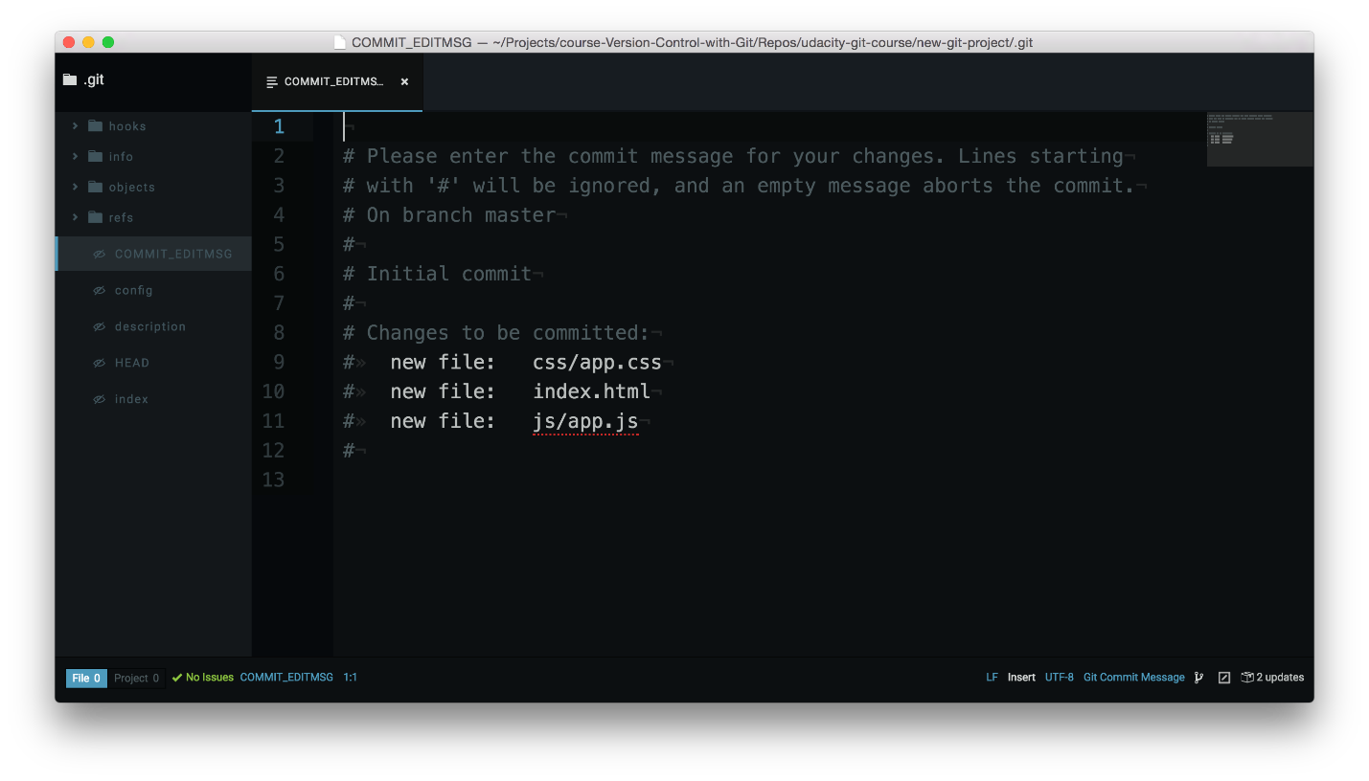

Code editor displaying the default commit edit message content and is waiting for a commit message to be supplied.

### Terminal Hangs

If you switch back to the Terminal for a quick second, you'll see that the Terminal is chillin' out just waiting for you to finish with the code editor that popped up. You don't need to worry about this, though. Once we add the necessary content to the code editor and finally close the code editor window, the Terminal will unfreeze and return to normal.

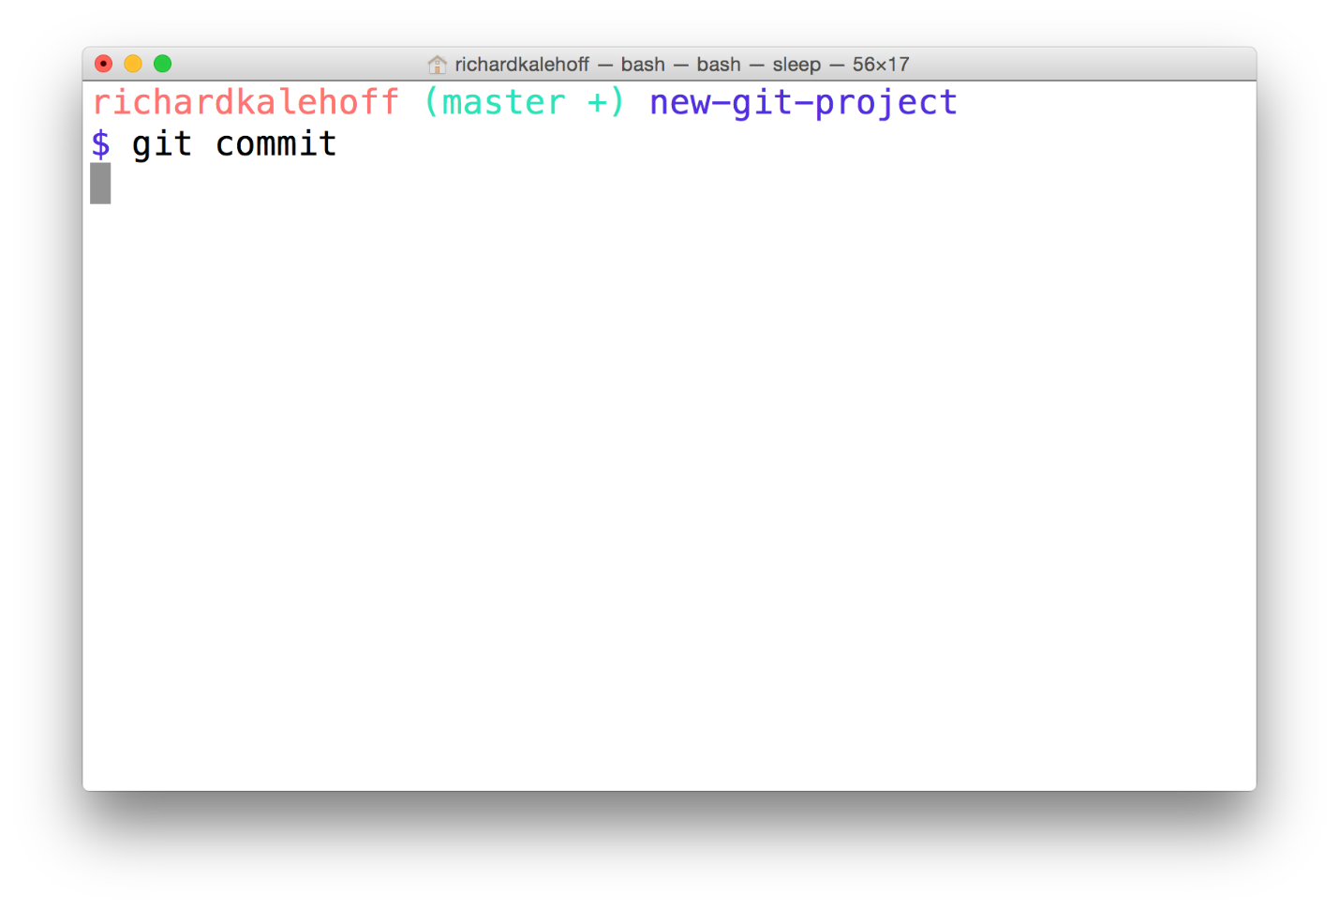

The Terminal application showing *git commit* but it appears to be hanging and waiting for something.

### Code Editor Commit Message Explanation

Ok, switch back to the code editor. Here's what's showing in my editor:

*# Please enter the commit message for your changes. Lines starting*

*# with '#' will be ignored, and an empty message aborts the commit.*

*# On branch master*

*#*

*# Initial commit*

*#*

*# Changes to be committed:*

*# new file: css/app.css*

*# new file: index.html*

*# new file: js/app.js*

*#*

The first paragraph is telling us exactly what we need to do - we need to supply a message for this commit. Also, any line that begins with the # character will be ignored. Farther down it says that this will be the initial commit. Lastly, it's giving us a list of the files that will be committed.

Since this is the very first commit of the repository, we'll use the commit message "Initial commit". The text "Initial commit" isn't special, but it's the de facto commit message for the very first commit. If you want to use something else, feel free!

Type out your commit message on the first line of the code editor:

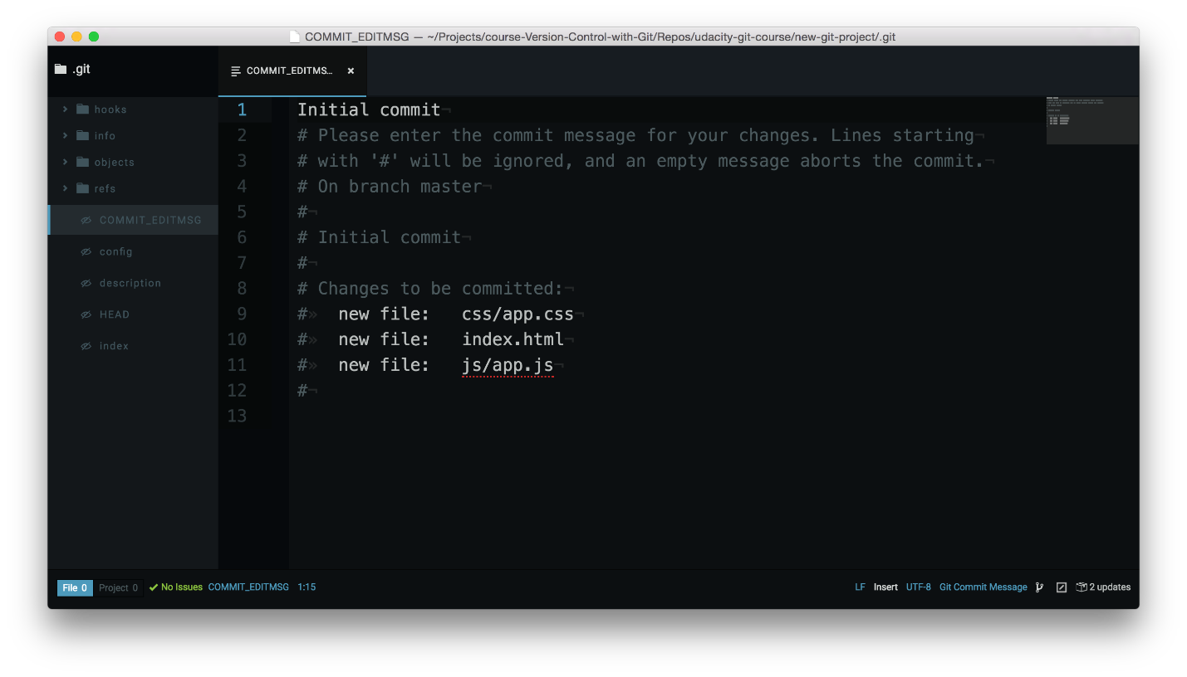

Code editor with the commit message entered on the first line.

### Finish Committing

Now save the file and close the editor window (closing just the pane/tab isn't enough, you need to close the code editor window that the git commit command opened).

Awesome, now switch back to the Terminal and you should see something like the following:

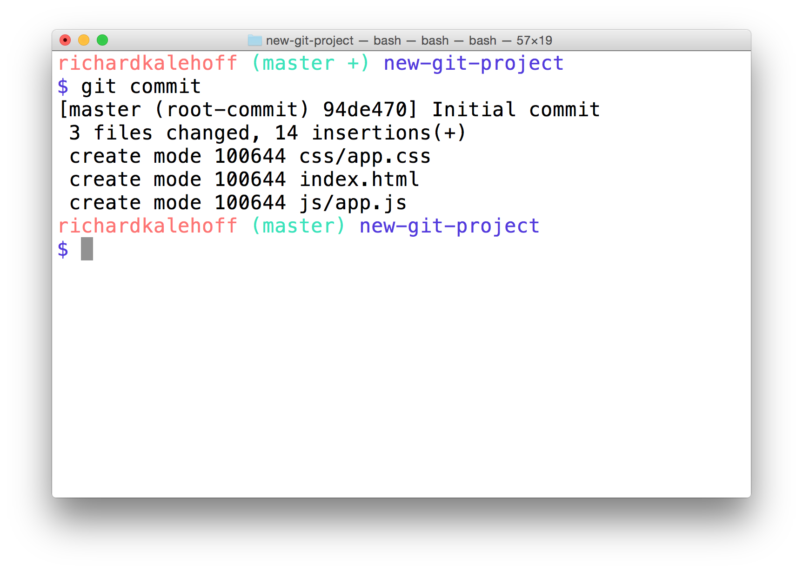

The Terminal application after closing the code editor. It displays the SHA for the new commit as well as information about the commit like the files that were added and how many lines of code were added.

### First Commit, Congrats!

You just made your first commit - woohoo! 🙌🏼 How does it feel? Was it more towards the awe-inspiring side or the anticlimactic? Honestly, when I made my first commit, I was a bit like:

"Wait...is that it? You just add the files you want to have committed to the Staging Area, and then you run 'git commit'?"

...and the answer to my questions are "Yes" and "Yes". That's all there is to it. At first, version control seems like this overwhelming obstacle that one must overcome to become a true programmer/developer/designer/etc. But once you get a handle on the terminology (which I think is the most challenging part), then actually using version control isn't all that challenging.

### Bypass The Editor With The -m Flag

TIP: If the commit message you're writing is short and you don't want to wait for your code editor to open up to type it out, you can pass your message directly on the command line with the -m flag:

$ git commit -m "Initial commit"

In the example above, the text "Initial commit" is used as the commit message. Be aware that you can't provide a description for the commit, only the message part.

### 2nd Commit - Add Changes

We've had a short breather, so let's make a second commit! Here, add this just inside the body tag in index.html:

<header>

<h1>Expedition</h1>

</header>

Ok, now what do you do next? That's right, it's our good old friend git status!

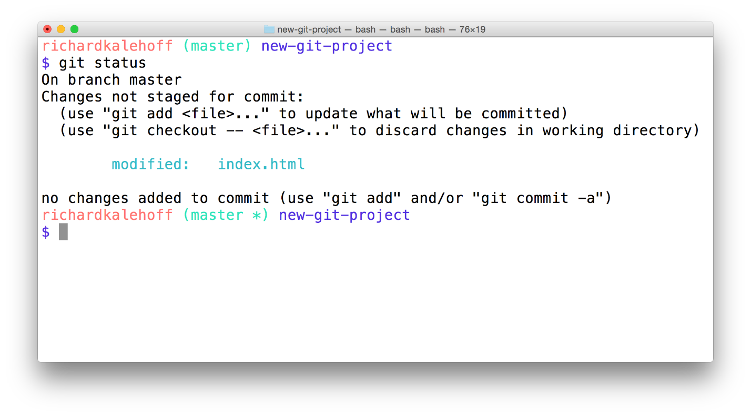

The Terminal application showing the result of the *git status* command. It displays a "Changes not staged for commit" section that includes the modified "index.html" file.

TIP: If you run git status but don't see that index.html has changed, make sure to save the file. I modify a file and then forget to save it - all - the - time! I like to think that forgetting to save a file after editing it is the mark of a true professional.

### Multipurpose Git Add

So we've modified our file. Git sees that it's been modified. So we're doing well so far. Now remember, to make a commit, the file or files we want committed need to be on the Staging Index. What command do we use to move files from the Working Directory to the Staging Index? You got it - git add!

Even though we used git add to add newly created files to the Staging Index, we use the same command to move modified files to the Staging Index.

Use the git add command to move the file over to the Staging Index, now. Verify that it's there with git status.

### Second Commit

Now that we have a file with changes we can commit, let's make our second commit! Use the git commit command to make a commit. Use the commit message Add header to blog.

Now you might be asking yourself, "Why did Richard pick that as the commit message to use?" or "What makes a good commit message?". These are fantastic questions that we'll be looking at in the next concept!

#### QUIZ QUESTION

Let's say you have a personal blog and want to change the color of the article headings. You

* edit the HTML files to give each heading a class
* edit the CSS file to add the new class and give it a color
* you save all files
* you run git commit on the terminal

Will your code editor open up to let you type out the commit message?

* 

Yes

* 

No

SUBMIT

### What To Include In A Commit

I've been telling you what files to create, giving you the content to include, and telling you when you should make commits. But when you're on your own, how do you know what you should include in a commit and when/how often you should make commits?

**The goal is that each commit has a single focus.** Each commit should record a single-unit change. Now this can be a bit subjective (which is totally fine), but each commit should make a change to just one aspect of the project.

Now this isn't limiting the number of lines of code that are added/removed or the number of files that are added/removed/modified. Let's say you want to change your sidebar to add a new image. You'll probably:

* add a new image to the project files
* alter the HTML
* add/modify CSS to incorporate the new image

A commit that records all of these changes would be totally fine!

Conversely, a commit shouldn't include unrelated changes - changes to the sidebar and rewording content in the footer. These two aren't related to each other and shouldn't be included in the same commit. Work on one change first, commit that, and then change the second one. That way, if it turns out that one change had a bug and you have to undo it, you don't have to undo the other change too.

The best way that I've found to think about what should be in a commit is to think, "What if all changes introduced in this commit were erased?". If a commit were erased, it should only remove one thing.

Don't worry, commits don't get randomly erased.

In a later lesson, we'll look at using Git to undo changes made in commits and how to manually, carefully remove the last commit that was made.

### Git Commit Recap

The git commit command takes files from the Staging Index and saves them in the repository.

$ git commit

This command:

* will open the code editor that is specified in your configuration
  + (check out the Git configuration step from the first lesson to configure your editor)

Inside the code editor:

* a commit message must be supplied
* lines that start with a # are comments and will not be recorded
* save the file after adding a commit message
* close the editor to make the commit

Then, use git log to review the commit you just made!

### Further Research

* **[Associating text editors with Git](https://help.github.com/articles/associating-text-editors-with-git/" \t "_blank)** from GitHub Help Docs
* **[Getting Started - First-Time Git Setup](https://git-scm.com/book/en/v2/Getting-Started-First-Time-Git-Setup" \t "_blank)** from Git book

## Commit Messages

### Good Commit Messages

Let's take a quick stroll down Stickler Lane and ask the question:

How do I write a good commit message? And why should I care?

These are fantastic questions! I can't stress enough how important it is to spend some time writing a good commit message.

Now, what makes a "good" commit message? That's a great question and has been **[written about](https://chris.beams.io/posts/git-commit/" \t "_blank)** **[a number](https://medium.com/@preslavrachev/what-s-with-the-50-72-rule-8a906f61f09c" \l ".jwprsco0n" \t "_blank)** **[of times](http://tbaggery.com/2008/04/19/a-note-about-git-commit-messages.html" \t "_blank)**. Here are some important things to think about when crafting a good commit message:

**Do**

* do keep the message short (less than 60-ish characters)
* do explain what the commit does (not how or why!)

**Do not**

* do not explain why the changes are made (more on this below)
* do not explain how the changes are made (that's what git log -p is for!)
* do not use the word "and"
  + if you have to use "and", your commit message is probably doing too many changes - break the changes into separate commits
  + e.g. "make the background color pink and increase the size of the sidebar"

The best way that I've found to come up with a commit message is to finish this phrase, "This commit will...". However, you finish that phrase, use that as your commit message.

Above all, ***be consistent*** in how you write your commit messages!

#### QUESTION 1 OF 3

Reviewing the guidelines on what makes a good commit message, is the following commit message good?

"Update the footer to copyright information"

* 

Yes

* 

No

SUBMIT

#### QUESTION 2 OF 3

Is the following a good commit message?

"Add a

tag to the body"

* 

Yes

* 

No

SUBMIT

#### QUESTION 3 OF 3

Is the following a good commit message?

"Add changes to app.js"

* 

Yes

* 

No

SUBMIT

### Explain the Why

If you need to explain why a commit needs to be made, you can!

When you're writing the commit message, the first line is the message itself. After the message, leave a blank line, and then type out the body or explanation including details about why the commit is needed (e.g. URL links).

Here's what a commit message edit screen might look like:

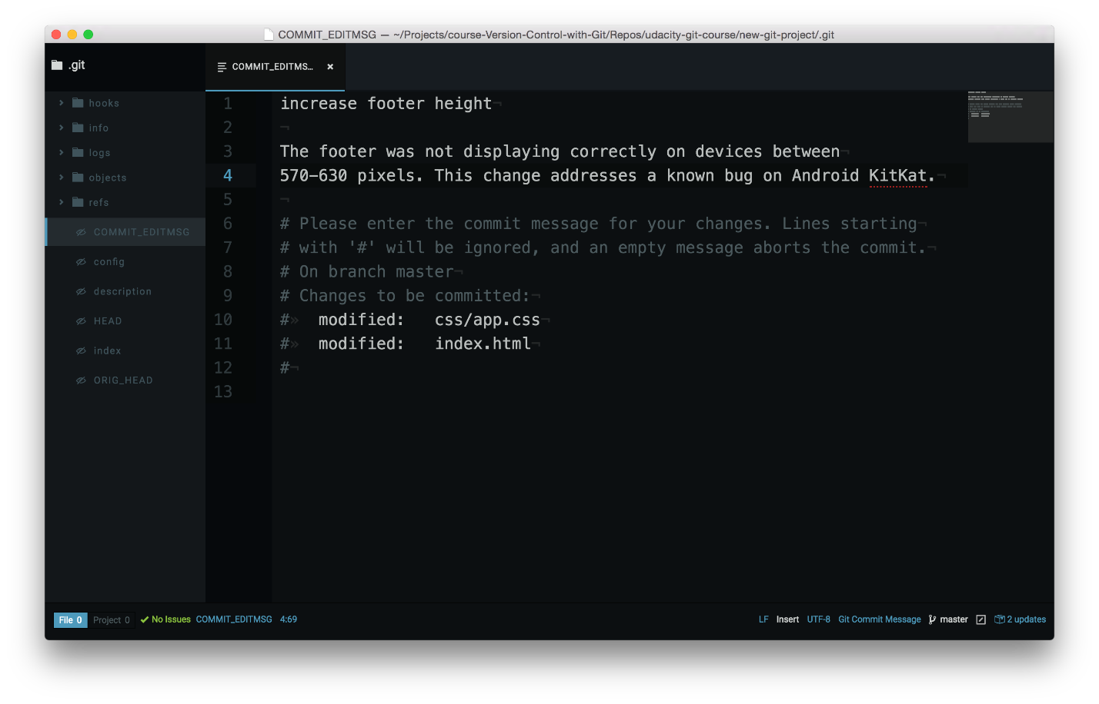

Code editor showing the commit message edit window. A message has been typed, followed by a blank line, followed by the body of the commit.

This details section of a commit message \_is\_ included in the git log. To see a commit message with a body, check out the Blog project repo and look at commit 8a11b3f.

Only the message (the first line) is included in git log --oneline, though!

### Udacity's Commit Style Requirements

As I've mentioned, there are a number of ways to write commit messages. If you're working on a team, they might already have a predetermined way of writing commit messages. Here at Udacity, we have our own standard for commit messages. You can check it out on our **[Git Commit Message Style Guide](https://udacity.github.io/git-styleguide/" \t "_blank)**.

If you haven't chosen a commit message style, feel free to use ours. But if you're working on an existing project, use their existing style; it's much more important to be consistent with your actual team than to be consistent with us!

### Git Diff Up Next!

In the next section, we'll look at a new tool (with a familiar output!). This tool will tell us what changes we've made to files before the files have been committed!

## Having Git Ignore Files

### Why Should Files Be Ignored

Remember a couple sections back when we were learning about git add? Instead of adding the files one by one, there was a special character that we could use to indicate the current directory and all subdirectories. Do you remember what that character is?

That's right, the period (.)!

#### The Problem

Let's say you add a file like a Word document to the directory where your project is stored but don't want it added to the repository. (You can simulate adding a Word document by running touch project.docx) Git will see this new file, so if you run git status it'll show up in the list of files.

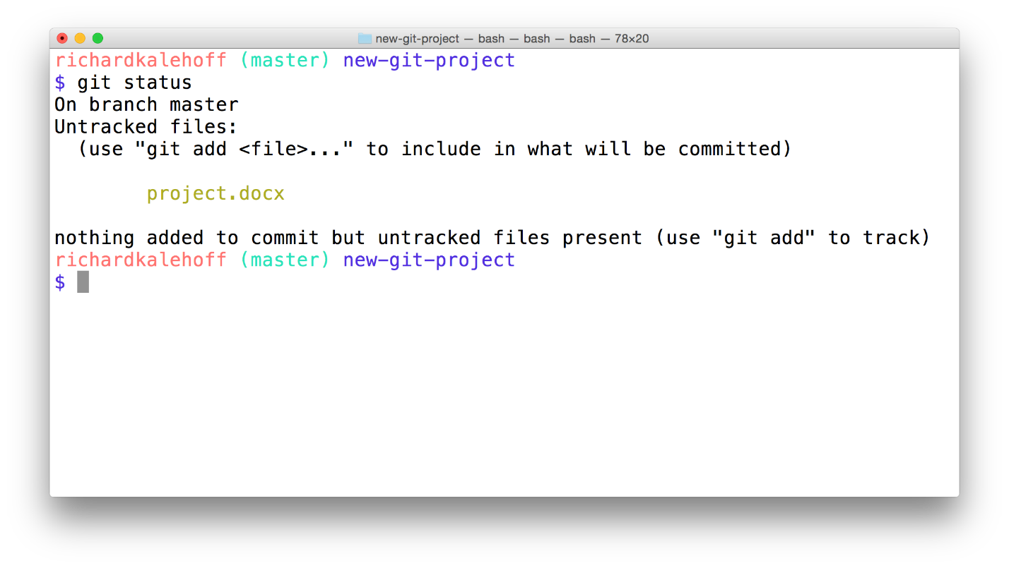

The Terminal application showing the output of the *git status* command. The output shows a new Word document that is in Git's "Untracked files" section.

The potential problem with having this file in your project is that, because git add . adds all files, the Word document might get accidentally committed to the repository.

### Git Ignore

If you want to keep a file in your project's directory structure but make sure it isn't accidentally committed to the project, you can use the specially named file, .gitignore (note the dot at the front, it's important!). Add this file to your project in the same directory that the hidden .git directory is located. All you have to do is list the names of files that you want Git to ignore (not track) and it will ignore them.

Let's try it with the "project.docx" file. Add the following line inside the .gitignore file:

project.docx

Now run git status and check its output:

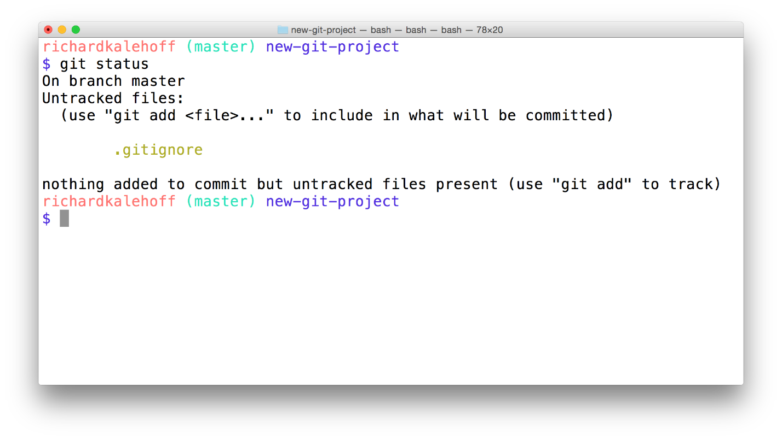

The Terminal application showing the output of *git status*. The Word document is no longer listed as an untracked file. The new ".gitignore" file is listed, though.

Git knows to look at the contents of a file with the name .gitignore. Since it saw "project.docx" in it, it ignored that file and doesn't show it in the output of git status.

### Globbing Crash Course

Let's say that you add 50 images to your project, but want Git to ignore all of them. Does this mean you have to list each and every filename in the .gitignore file? Oh gosh no, that would be crazy! Instead, you can use a concept called **[globbing](https://en.wikipedia.org/wiki/Glob_(programming" \t "_blank)**.

Globbing lets you use special characters to match patterns/characters. In the .gitignore file, you can use the following:

* blank lines can be used for spacing
* # - marks line as a comment
* \* - matches 0 or more characters
* ? - matches 1 character
* [abc] - matches a, b, \_or\_ c
* \*\* - matches nested directories - a/\*\*/z matches
  + a/z
  + a/b/z
  + a/b/c/z

So if all of the 50 images are JPEG images in the "samples" folder, we could add the following line to .gitignore to have Git ignore all 50 images.

samples/\*.jpg

#### QUESTION 1 OF 2

Which of the following files will be ignored if \*.png is entered into the .gitignore file?

* 

ocean.jpg

* 

trees.png

* 

png-format.pdf

* 

not-a-png.jpeg

* 

bg-pattern.png

* 

logo.gif

* 

LOUDFILE.PNG

#### QUESTION 2 OF 2

If you ask Git to ignore "be?rs", which of the following filenames will be ignored?

* 

bears

* 

beavers

* 

BeArS

* 

beers

* 

boars

### Git Ignore Recap

To recap, the .gitignore file is used to tell Git about the files that Git should not track. This file should be placed in the same directory that the .git directory is in.

### Further Research

* **[Ignoring files](https://git-scm.com/book/en/v2/Git-Basics-Recording-Changes-to-the-Repository" \l "Ignoring-Files" \t "_blank)** from the Git Book
* **[gitignore](https://git-scm.com/docs/gitignore" \l "_pattern_format" \t "_blank)** from the Git Docs
* **[Ignoring files](https://help.github.com/articles/ignoring-files/" \t "_blank)** from the GitHub Docs
* **[gitignore.io](https://www.gitignore.io/" \t "_blank)**

## Outro

<https://www.youtube.com/watch?v=5eyvsMvAPYs&feature=emb_logo>

# Lesson 5: Tagging, Branching, And Merging

## Intro

<https://www.youtube.com/watch?time_continue=2&v=sMf_r4_z-Ls&feature=emb_logo>

## Tagging

So far in this course, we've been zoomed in on the specific Git commands. We've learned how they work in detail and what it looks like running them on the Terminal.

Let's zoom out a bit to look at how a Git tag fits into a repository.

<https://www.youtube.com/watch?time_continue=1&v=D4VdXT72ASE&feature=emb_logo>

### Where Are We?

You can do these steps in either project, but I'll be doing them in the new-git-project project.

Let's take a look at the log of the project so far:

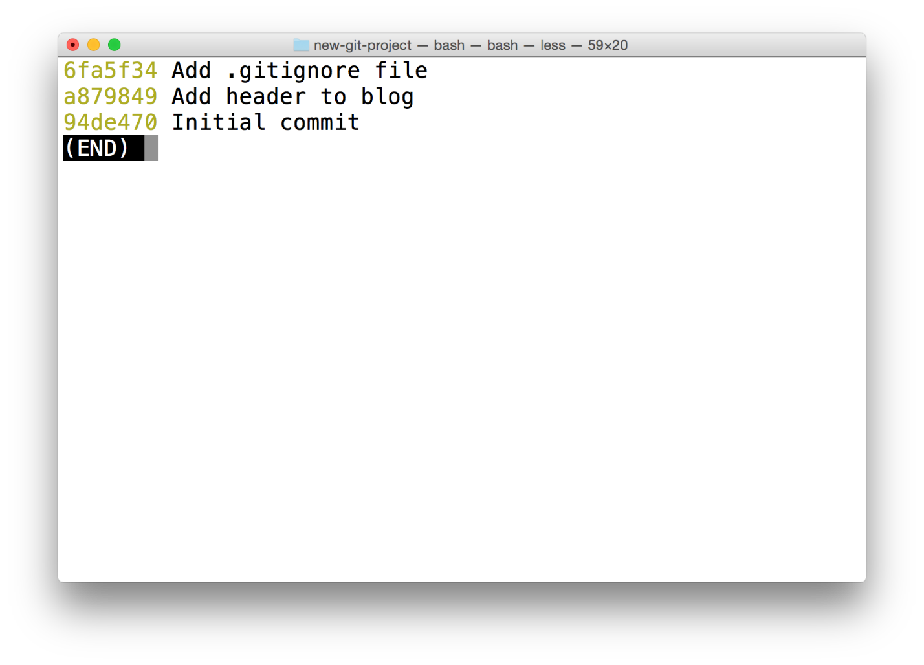

The Terminal application showing the output from running *git log --oneline*.

### Git Tag Command

Pay attention to what's shown (just the SHA and the commit message)

The command we'll be using to interact with the repository's tags is the git tag command:

$ git tag -a v1.0

This will open your code editor and wait for you to supply a message for the tag. How about the message "Ready for content"?

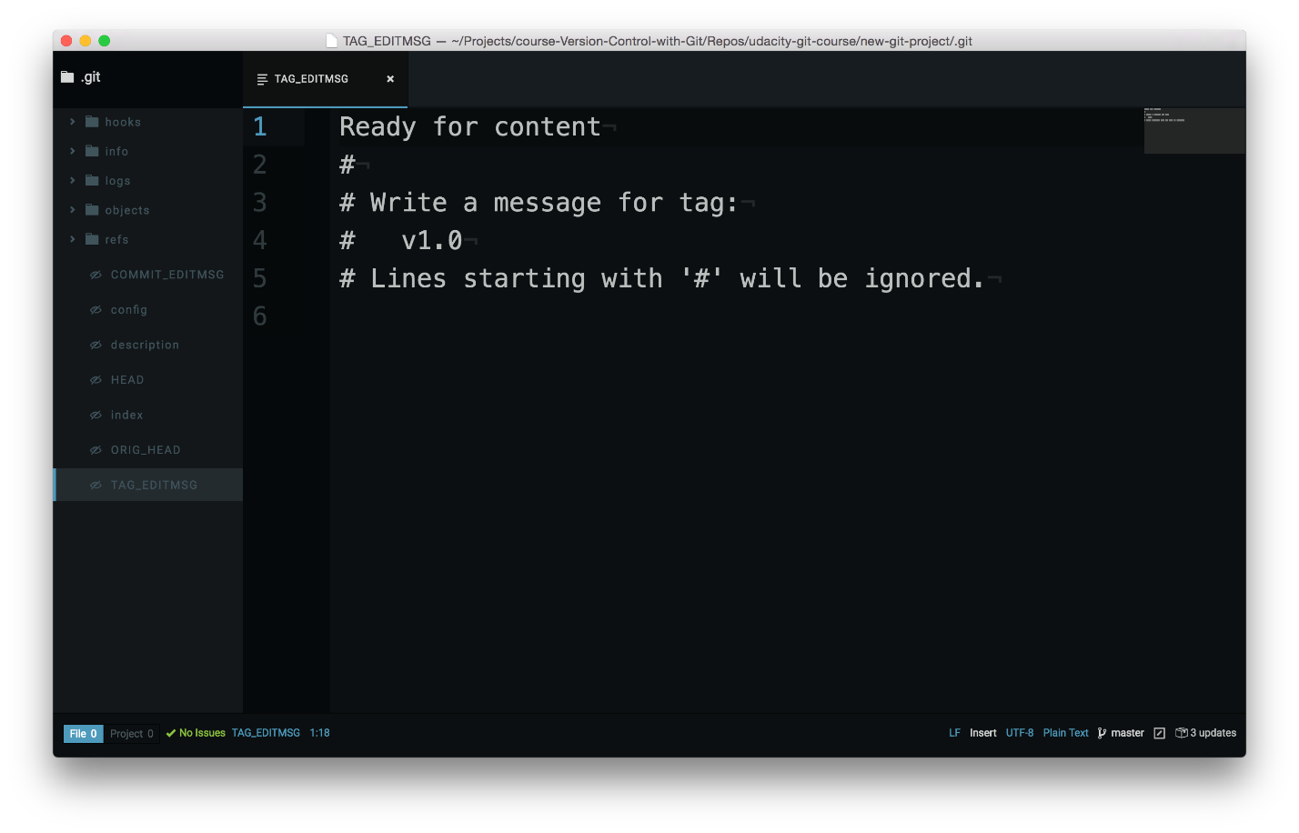

Code editor waiting for the tag's message to be supplied.

CAREFUL: In the command above (git tag -a v1.0) the -a flag is used. This flag tells Git to create an annotated flag. If you don't provide the flag (i.e. git tag v1.0) then it'll create what's called a lightweight tag.

Annotated tags are recommended because they include a lot of extra information such as:

* the person who made the tag
* the date the tag was made
* a message for the tag

Because of this, you should always use annotated tags.

### Verify Tag

After saving and quitting the editor, nothing is displayed on the command line. So how do we know that a tag was actually added to the project? If you type out just git tag, it will display all tags that are in the repository.

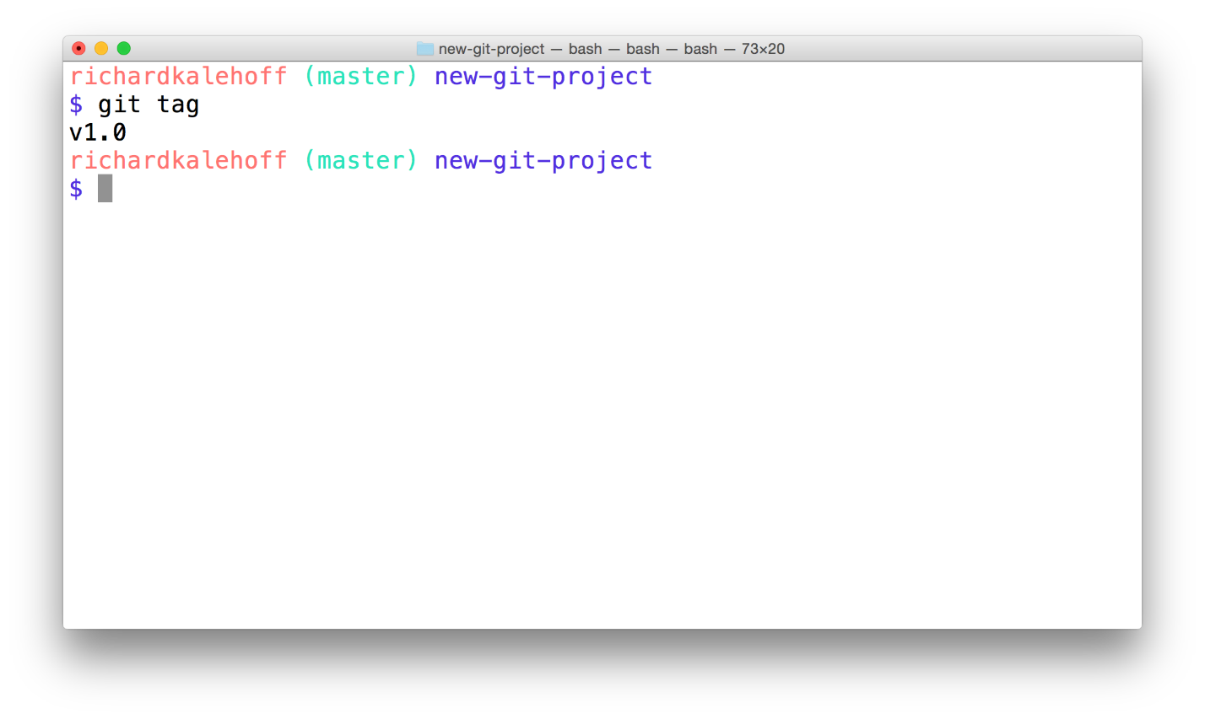

The Terminal application showing the output of the *git tag* command. The tag *v1.0* is listed.

So we've verified that it's in the repository, but let's actually see where it is inside the repository. To do that, we'll go back to our good old friend, git log!

### Git Log's --decorate Flag

As you've learned, git log is a pretty powerful tool for letting us check out a repository's commits. We've already looked at a couple of its flags, but it's time to add a new one to our toolbelt. The --decorate flag will show us some details that are hidden from the default view.

Try running git log --decorate now!

### 💡 --decorate Flag Changes in Git 2.13 💡

In the 2.13 update to Git, the log command has changed to automatically enable the --decorate flag. This means that you do not need to include the --decorate flag in your command, since it is automatically included, anyway! So the following commands result in the exact same output:

$ git log --decorate

$ git log

Check out **[the 2.13 release notes](https://github.com/git/git/blob/v2.13.0/Documentation/RelNotes/2.13.0.txt" \l "L176-L177" \t "_blank)**.

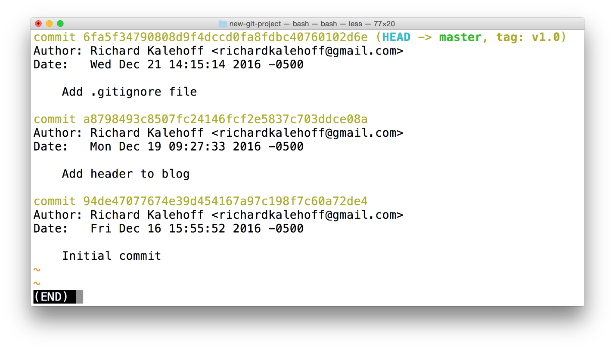

The Terminal application showing the output of the *git log --decorate* command. The log output now displays the newly created tag.

The tag information is at the very end of the first line:

commit 6fa5f34790808d9f4dccd0fa8fdbc40760102d6e (HEAD -> master, tag: v1.0)

See how it says tag: v1.0? That's the tag! Remember that tags are associated with a specific commit. This is why the tag is on the same line as the commit's SHA.

### HEAD -> master?

Did you notice that, in addition to the tag information being displayed in the log, the --decorate also revealed HEAD -> master? That's information about a branch! We'll be looking at branches in Git, next.

### Deleting A Tag

What if you accidentally misspelled something in the tag's message, or mistyped the actual tag name (v0.1 instead of v1.0). How could you fix this? The easiest way is just to delete the tag and make a new one.

A Git tag can be deleted with the -d flag (for delete!) and the name of the tag:

$ git tag -d v1.0

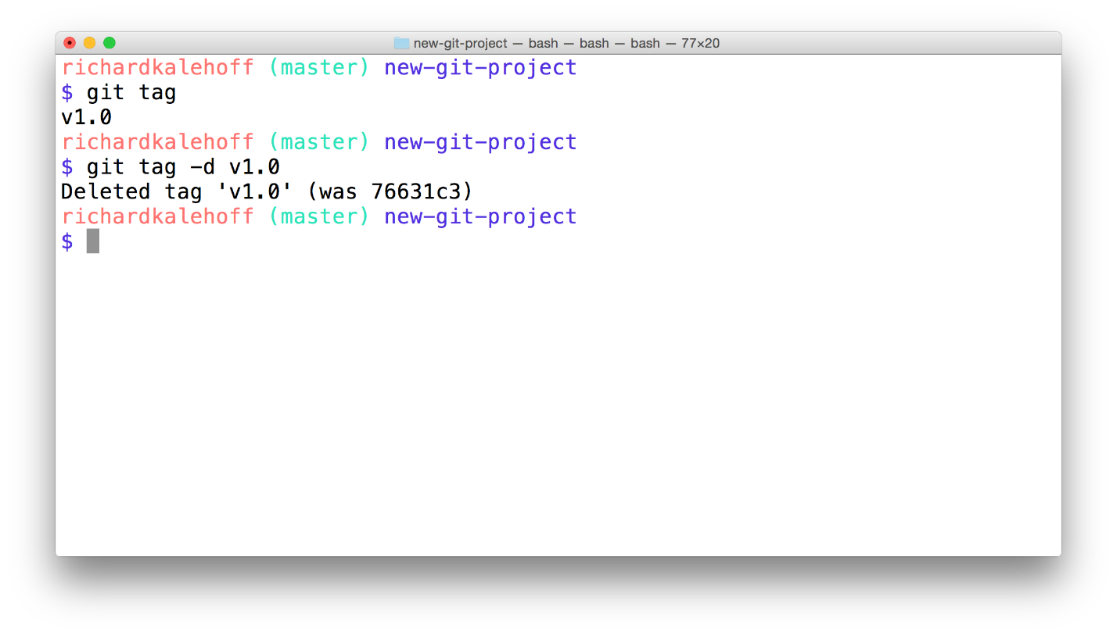

The Terminal application showing the removal of a tag by using the *-d* flag. The command that is run is *git tag -d v1.0*.

#### QUESTION 1 OF 3

By default, a Git tag will not appear in a log. What flag must be used to display the tag information in the output of git log?

* 

--show-tags

* 

--tags

* 

--display-all

* 

--decorate

SUBMIT

#### QUESTION 2 OF 3

Which of the following will delete the tag v-1?

* 

git tag --delete v-1

* 

git remove v-1

* 

git tag -d v-1

* 

git delete v-1

SUBMIT

### Adding A Tag To A Past Commit

Running git tag -a v1.0 will tag the most recent commit. But what if you wanted to tag a commit that occurred farther back in the repo's history?

All you have to do is provide the SHA of the commit you want to tag!

$ git tag -a v1.0 a87984

(after popping open a code editor to let you supply the tag's message) this command will tag the commit with the SHA a87084 with the tag v1.0. Using this technique, you can tag any commit in the entire git repository! Pretty neat, right?...and it's just a simple addition to add the SHA of a commit to the Git tagging command you already know.

### Tag Older Commit?

Using the following git log --oneline information, what command would you run to give the commit with the message "style page header" a tag of beta?

2a9e9f3 add breakpoint **for** large-sized screens

137a0bd add breakpoint **for** medium-sized screens

c5ee895 add space around page edge

b552fa5 style page header

f8c87c7 convert social links from text to images

SUBMIT

### Git Tag Recap

To recap, the git tag command is used to add a marker on a specific commit. The tag does not move around as new commits are added.

$ git tag -a beta

This command will:

* add a tag to the most recent commit
* add a tag to a specific commit if a SHA is passed

### Further Research

* **[Git Basics - Tagging](https://git-scm.com/book/en/v2/Git-Basics-Tagging" \t "_blank)** from the Git Book
* **[Git Tag](https://git-scm.com/docs/git-tag" \t "_blank)** from the Git Docs

## Branching

It's time to delve into the wonderful world of branches! Branches in Git are flexible and let you do some really powerful things. Before we get into the nitty gritty details of the commands, let's take another step back and look at the big picture of what branches are and how they function.

<https://www.youtube.com/watch?v=ywcOC6CLG4s&feature=emb_logo>

So that's the big picture of how branches work and how to switch between branches. Did you know that you've already seen the master branch on the command line? Because of the setup files you added in the first lesson, the current branch is displayed right in the command prompt.

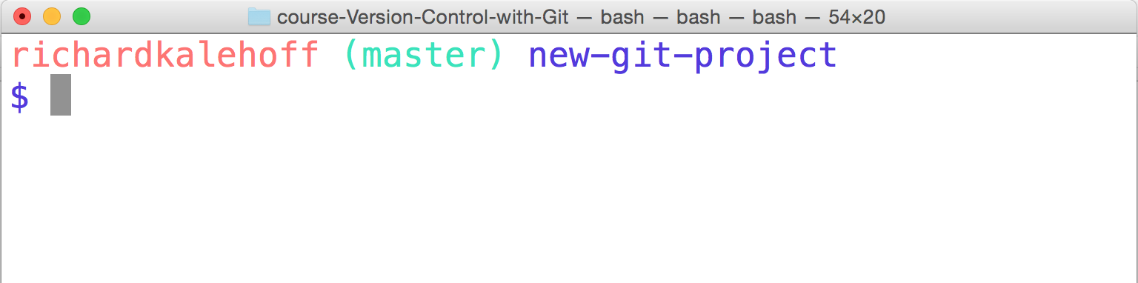

The Terminal application showing the current branch in the command prompt. The current branch is the "master" branch.

### The git branch command

The git branch command is used to interact with Git's branches:

$ git branch

It can be used to:

* list all branch names in the repository
* create new branches
* delete branches

If we type out just git branch it will list out the branches in a repository:

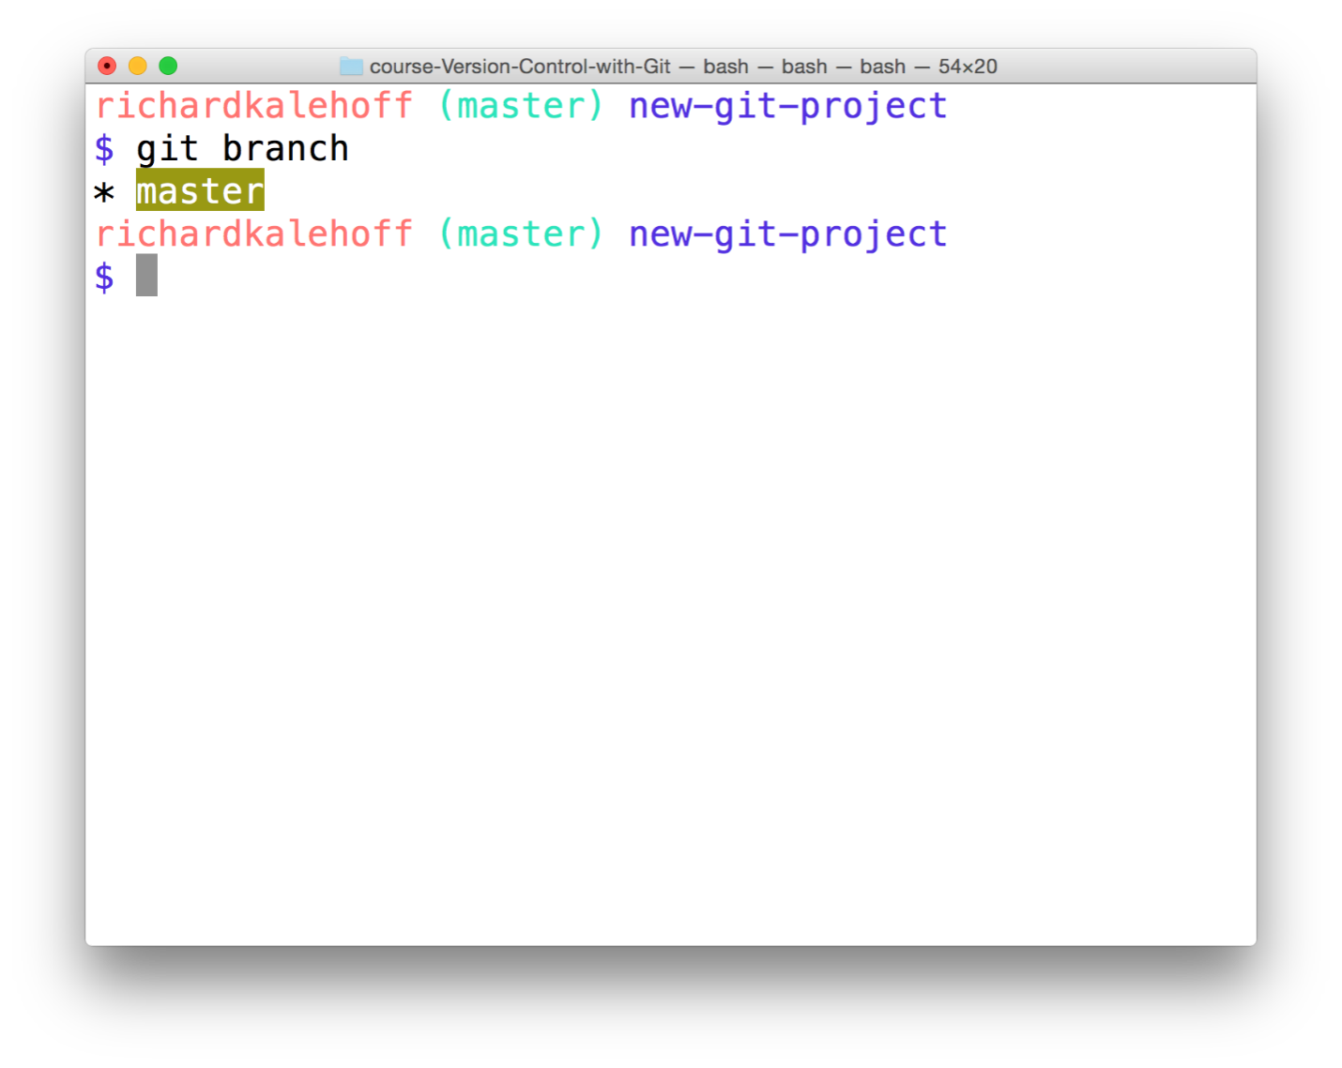

The Terminal application showing the output of the *git branch* command. The master branch is displayed.

### Create A Branch

To create a branch, all you have to do is use git branch and provide it the name of the branch you want it to create. So if you want a branch called "sidebar", you'd run this command:

$ git branch sidebar

#### QUESTION 1 OF 3

Remember that there are a number of branches in the repository, but that the command prompt displays the current branch.

Now that we just created a new "sidebar" branch, does the command prompt display sidebar or master?

* 

sidebar

* 

master

### The git checkout Command

Remember that when a commit is made that it will be added to the current branch. So even though we created the new sidebar, no new commits will be added to it since we haven't switched to it, yet. If we made a commit right now, that commit would be added to the master branch, not the sidebar branch. We've already seen this in the demo, but to switch between branches, we need to use Git's checkout command.

$ git checkout sidebar

It's important to understand how this command works. Running this command will:

* remove all files and directories from the Working Directory that Git is tracking
  + (files that Git tracks are stored in the repository, so nothing is lost)
* go into the repository and pull out all of the files and directories of the commit that the branch points to

So this will remove all of the files that are referenced by commits in the master branch. It will replace them with the files that are referenced by the commits in the sidebar branch. This is very important to understand, so go back and read these last two sentences.

The funny thing, though, is that both sidebar and master are pointing at the same commit, so it will look like nothing changes when you switch between them. But the command prompt will show "sidebar", now:

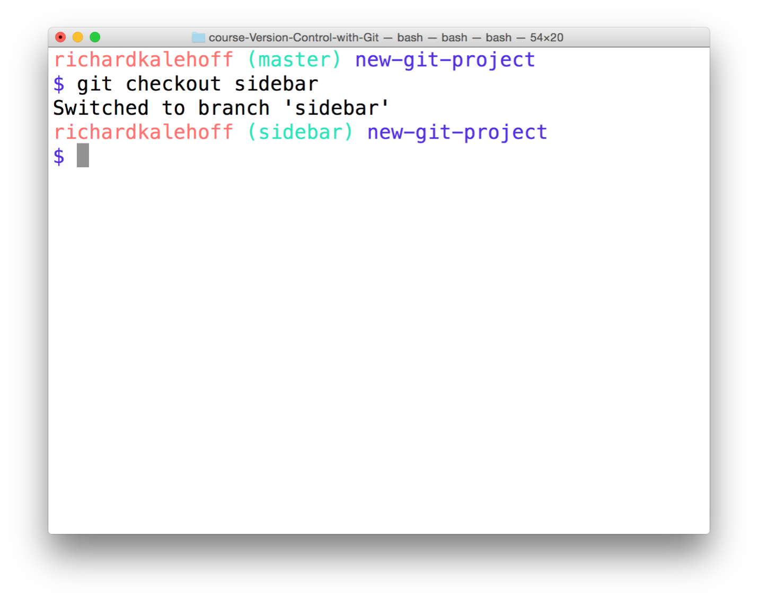

The Terminal application showing the "sidebar" branch in the command prompt.

### Branches In The Log

The branch information in the command prompt is helpful, but the clearest way to see it is by looking at the output of git log. But just like we had to use the --decorate flag to display Git tags, we need it to display branches.

$ git log --oneline --decorate

This is what my log output displays (yours might look different depending on what commits you've made):

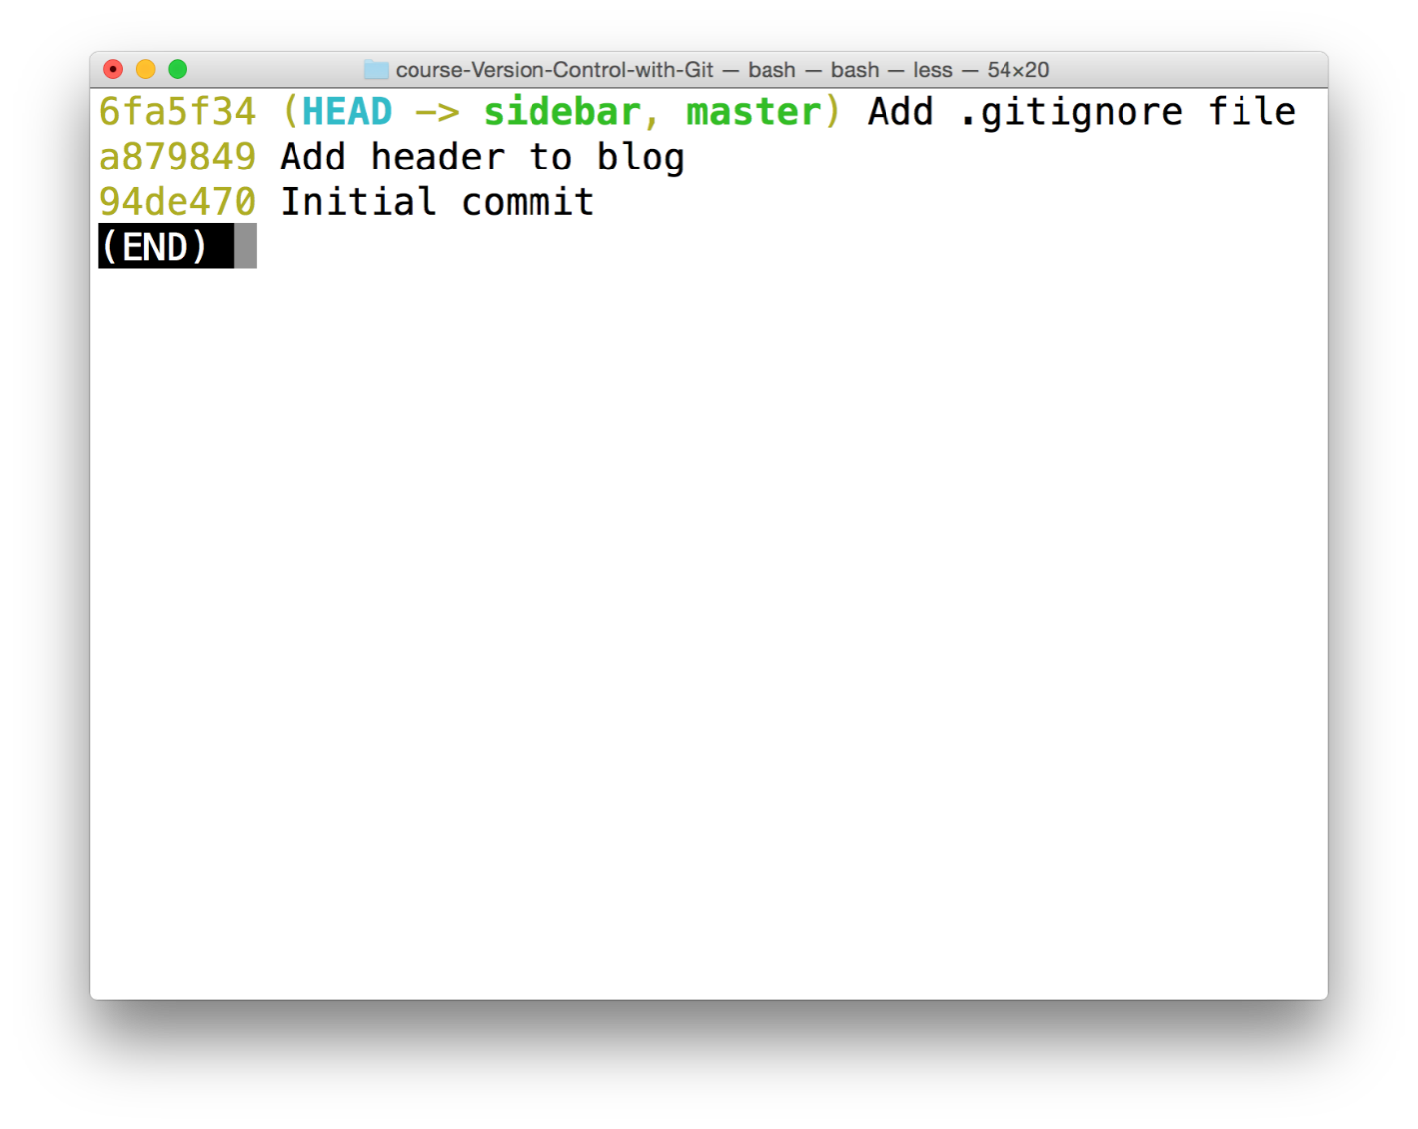

The Terminal application showing the output of the *git log --oneline --decorate* command. The word "HEAD" has an arrow pointing to "sidebar" which is the active branch.

In the output above, notice how the special "HEAD" indicator we saw earlier has an arrow pointing to the sidebar branch. It's pointing to sidebar because the sidebar branch is the current branch, and any commits made right now will be added to the sidebar branch.

### The Active Branch

The command prompt will display the active branch. But this is a special customization we made to our prompt. If you find yourself on a different computer, the fastest way to determine the active branch is to look at the output of the git branch command. An asterisk will appear next to the name of the active branch.

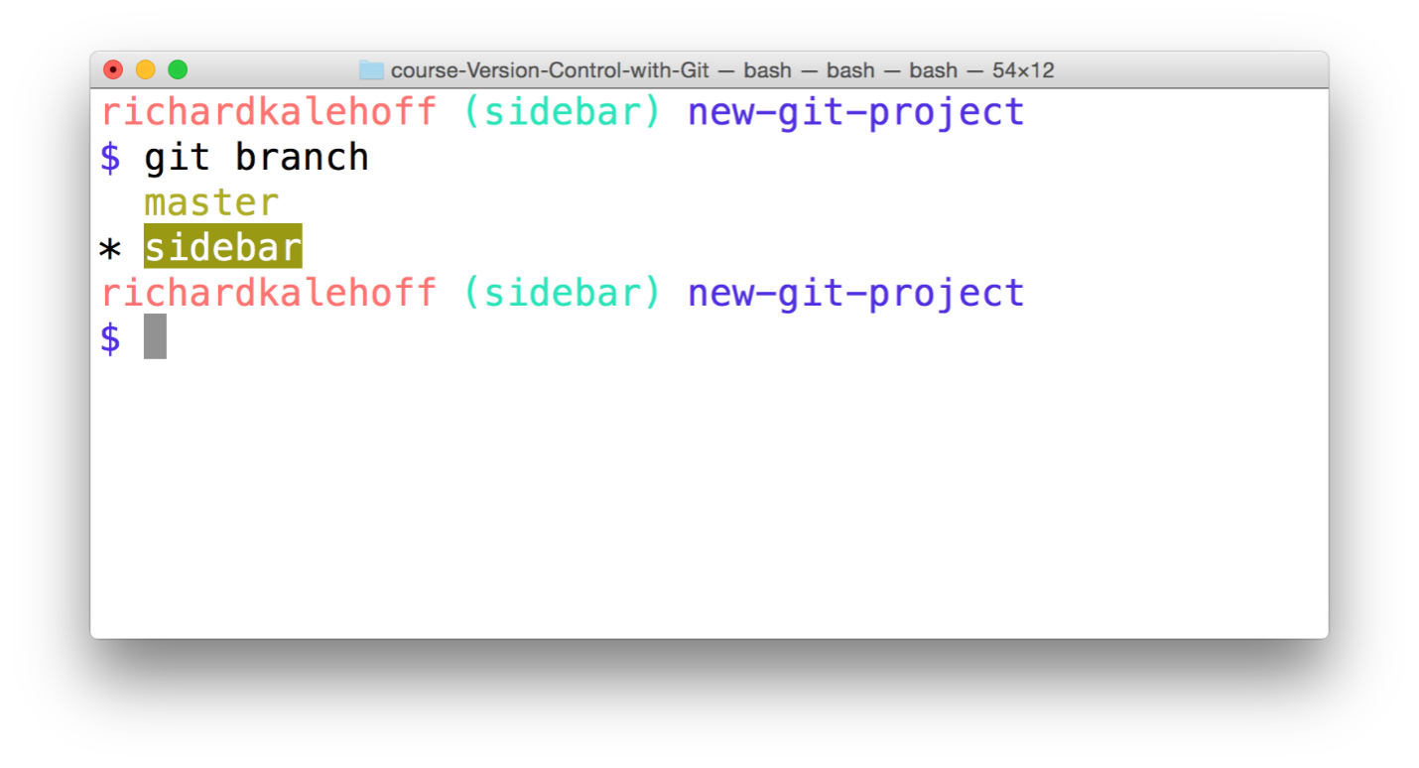

The Terminal application showing the output of the *git branch* command. The active branch (in this case, the "sidebar" branch) has an asterisk next to it.

#### QUESTION 2 OF 3

From what you know about both the git branch and git tag commands, what do you think the following command will do?

$ git branch alt-sidebar-loc 42a69f

* 

will create a branch alt at the same commit as the master branch

* 

will create the 3 branches alt, sidebar, loc

* 

will move the master branch to the commit with SHA 42a69f

* 

will create the alt-sidebar-loc branch and have it point to the commit with SHA 42a69f

SUBMIT

### Which Branch Is Active?

Given the following output from git branch:

$ git branch

barbara

\* footer-fix

master

richard

sidebar

social-icons

Which branch is the active branch?

SUBMIT

### Delete A Branch

A branch is used to do development or make a fix to the project that won't affect the project (since the changes are made on a branch). Once you make the change on the branch, you can combine that branch into the master branch (this "combining of branches" is called "merging" and we'll look at it shortly).

Now after a branch's changes have been merged, you probably won't need the branch anymore. If you want to delete the branch, you'd use the -d flag. The command below includes the -d flag which tells Git to delete the provided branch (in this case, the "sidebar" branch).

$ git branch -d sidebar

One thing to note is that you can't delete a branch that you're currently on. So to delete the sidebar branch, you'd have to switch to either the master branch or create and switch to a new branch.

Deleting something can be quite nerve-wracking. Don't worry, though. Git won't let you delete a branch if it has commits on it that aren't on any other branch (meaning the commits are unique to the branch that's about to be deleted). If you created the sidebar branch, added commits to it, and then tried to delete it with the git branch -d sidebar, Git wouldn't let you delete the branch because you can't delete a branch that you're currently on. If you switched to the master branch and tried to delete the sidebar branch, Git also wouldn't let you do that because those new commits on the sidebar branch would be lost! To force deletion, you need to use a capital D flag - git branch -D sidebar.

### Git Branch Recap

To recap, the git branch command is used to manage branches in Git:

*# to list all branches*

$ git branch

*# to create a new "footer-fix" branch*

$ git branch footer-fix

*# to delete the "footer-fix" branch*

$ git branch -d footer-fix

This command is used to:

* list out local branches
* create new branches
* remove branches

### Further Research

* **[Git Branching - Basic Branching and Merging](https://git-scm.com/book/en/v2/Git-Branching-Basic-Branching-and-Merging" \t "_blank)** from the Git Docs
* **[Learn Git Branching](http://learngitbranching.js.org/" \t "_blank)**
* **[Git Branching Tutorial](https://www.atlassian.com/git/tutorials/using-branches" \t "_blank)** from the Atlassian Blog

## Branching Effectively

Alright! Now that you've learned how to create, list, and delete branches, let's put that knowledge to use!

First, make sure we're on the same page and have the same starter code. We're going to be working in the new-git-project project. The project has the following files:

* index.html
* css/app.css (empty)
* js/app.js (empty)

The CSS and JavaScript files are empty. Make sure the index file has the following content:

**<!doctype html>**

<html lang="en">

<head>

<meta charset="utf-8">

<title>Blog Project</title>

<meta name="viewport" content="width=device-width, initial-scale=1">

<meta name="description" content="">

<link rel="stylesheet" href="css/app.css">

</head>

<body>

<header>

<h1>Expedition</h1>

</header>

<div class="container">

<main>

</main>

</div>

<footer>

Made with ♥ @ Udacity

</footer>

<script src="js/app.js"></script>

</body>

</html>

### Project Is Set Up

Before we proceed, let's make sure we have the same setup. Check off each of the following:

Task List

* 

I have an index.html file with the starter code from above

* 

I have an app.css file inside a css directory

* 

I have an app.js file inside a js directory

* 

all files have been saved

* 

all files have been staged and committed to the repository

* 

the current branch is the master branch

* 

I have deleted all other branches

* 

the output from running git status on the command line includes the text working directory clean

### The Game Plan

Right now we have all of our code on the master branch (which is the default branch). We're about to work with branches, by:

* adding content to them
* creating new branches
* switching back and forth between them

Let's use branches to make the following changes:

1. on the master branch - add a default color to the page
2. create a sidebar branch - create a sidebar for the page
3. on the master branch - change the heading of the page
4. on the sidebar branch - add more content to the sidebar
5. create a footer branch - add social links to the footer

### Change 1 - Add Page Color

Make sure you're on the master branch and add the following content to css/app.css:

body {

background-color: #00cae4;

}

Save the file. Then add the file to the staging index and commit it to the repository.

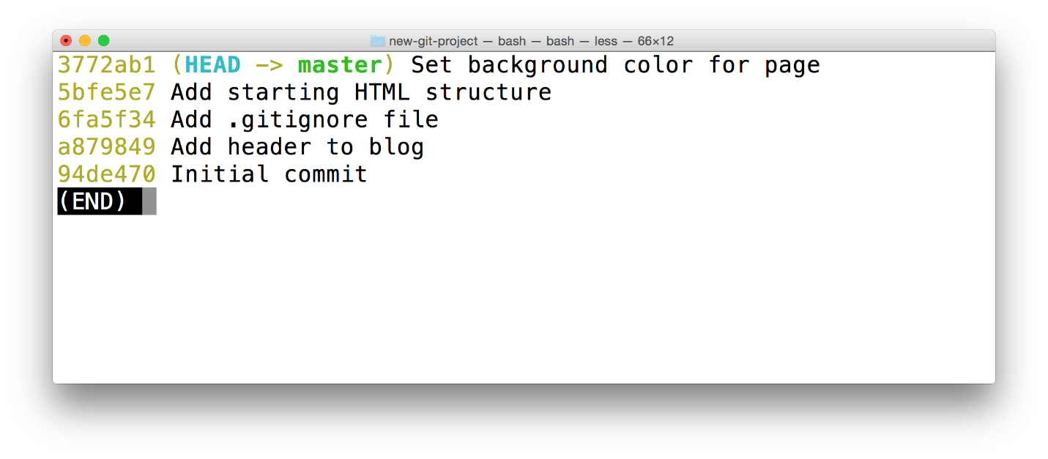

The Terminal application showing the output of the *git log --oneline --decorate* command. The most-recent commit adds a default background color to the page.

### Change 2 - Add Sidebar

Let's add a sidebar to the page. But let's say that we're not really sure if we like the new background color. So we'll place the sidebar branch on the commit before the one that sets the page's color. Your SHAs will be different, but, for me, the commit that's before the one that adds the color has a SHA of 5bfe5e7. So adding the branch to that commit would look like:

$ git branch sidebar 5bfe5e7

Now use the git checkout command to switch to the new sidebar branch. Running a git log --oneline --decorate shows me:

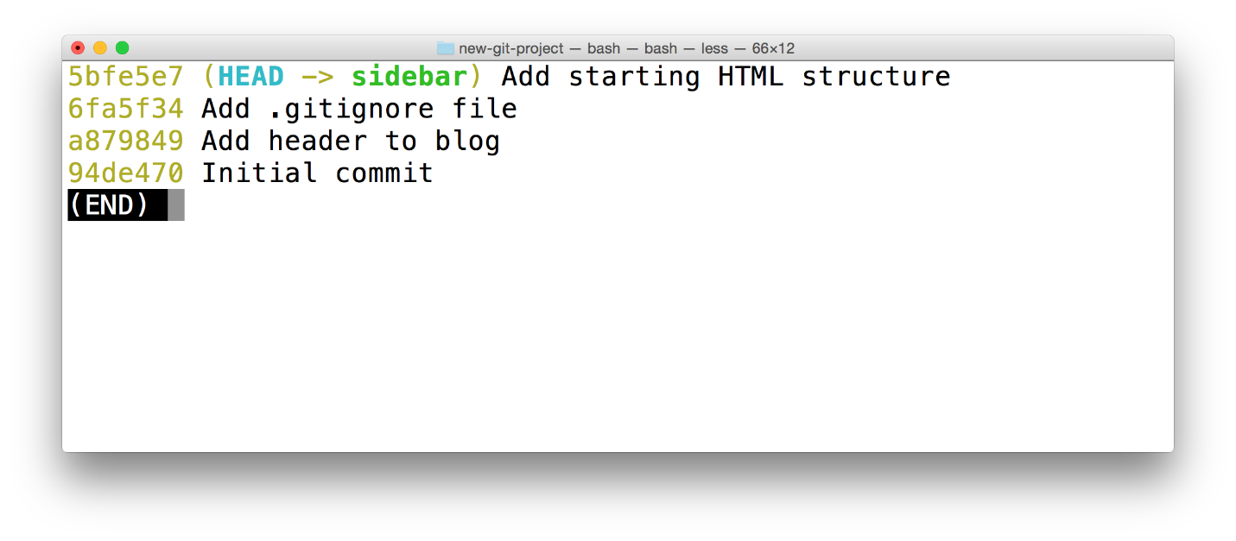

The Terminal application showing the output of *git log --oneline --decorate*. The output does NOT include the *master* branch - it has disappeared.

Did you notice that the master branch does not display in the output? Where did it go!?! Is it lost? Don't worry, it's still there, we'll see how to get it to display in just a second.

But first, in your code editor, switch to the app.css file. Notice that it does not have the CSS we previously entered! Because of this, if you load the project up in the browser, the page won't have a colored background. This makes sense since the CSS file is empty, but do you know why?

#### QUESTION 1 OF 2

Thinking back to the branching repository video from the previous lesson, why would the CSS file be empty?

* 

The content has been erased.

* 

The content is stored safely on another branch.

* 

The content is in a temporary file that needs to be saved.

* 

A bear ate it.

<https://www.youtube.com/watch?time_continue=1&v=Px6EUylw8Uw&feature=emb_logo>

Create a sidebar by adding the following <aside> code to the HTML file:

<div class="container">

<main>

</main>

</div>

*<!-- start of new content -->*

<aside>

<h2>About Me</h2>

<p>Lorem ipsum dolor sit amet, consectetur adipisicing elit. Eos, debitis earum molestias veniam suscipit aliquam totam exercitationem tempore neque vitae. Minima, corporis pariatur facere at quo porro beatae similique! Odit.</p>

</aside>

*<!-- end of new content -->*

<footer>

Made with ♥ @ Udacity

</footer>

I added my <aside> content next to the <main> element as a fellow child of the <div class="container"> element.

Feel free to add any content inside the <aside> element!

### ⚠️ Don't Change the CSS

WARNING: It's very important that you do not change the CSS file.

We'll change it later, but if you make a change right now, we'll end up having what's known as a "merge conflict". We'll manually cause a merge conflict in a bit, but we don't want to have one right now, so just don't make any changes to the CSS file, yet.

We're done with this step, so it's time to commit the changes.

Task List

* 

I've saved index.html

* 

I've staged index.html

* 

I've committed index.html to the repsitory

### Change 3 - Change Heading On Master

Let's switch back to the master branch and update the page heading.

Use the git checkout command to switch back to the master branch. (Notice that the HTML for the new sidebar is no longer there(!) because all that code is stored safely on the sidebar branch.)

Now change the <h1> heading of the page from "Expedition" to something else. How about something exciting like the word "Adventure"!?!

#### QUESTION 2 OF 2

Pop quiz time! How do you have Git show you the changes you've saved, but not yet committed?

* 

git show --diff

* 

git log -p

* 

git diff

* 

git log --stat

SUBMIT

### **Heading Change Have Been Saved And Committed**

Now it's time to save the index.html file and make a commit to add this change to the repository. (I used the commit message "Improve site heading for SEO", but see if you can think of a better one)

Task List

* 

I've saved index.html

* 

I've staged index.html

* 

I've committed index.html to the repsitory

### Change 4 - Add More Content To Sidebar

Switch back to the sidebar branch (notice, again, that content we've added to the master branch isn't visible on the sidebar branch).

Now just add some content inside the <aside> element. Add something about yourself - your favorite movie or book (my favorite is LOTR!). Anything will work, you just need to add some content.

Again, make sure that you do not make changes to the CSS file.

Now save the index.html file and make a commit.

### Change 5 - Add Social Links To Footer

We've made a number of changes, and we're about to make our last one. Let's add some social icons to the page's footer. For grins and giggles, let's make this change on a new footer branch that's based off the master branch. So we need to create a new footer branch, first.

### 💡 Switch and Create Branch In One Command💡

The way we currently work with branches is to create a branch with the git branch command and then switch to that newly created branch with the git checkout command.

But did you know that the git checkout command can actually create a new branch, too? If you provide the -b flag, you can create a branch and switch to it all in one command.

$ git checkout -b richards-branch-for-awesome-changes

It's a pretty useful command, and I use it often.

Let's use this new feature of the git checkout command to create our new footer branch and have this footer branch start at the same location as the master branch:

$ git checkout -b footer master

Now if we run a quick git log --oneline --decorate, we should see (your commit messages might be different):

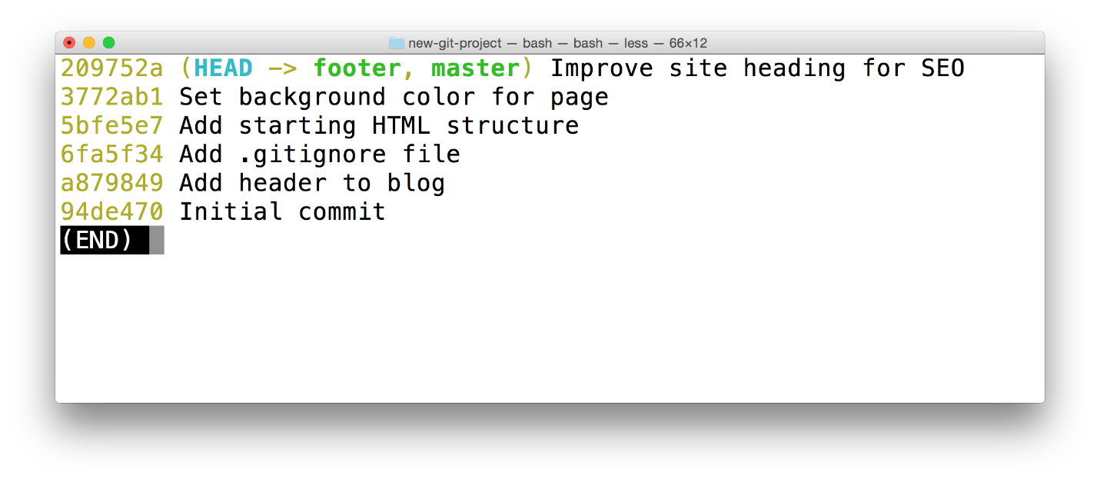

The Terminal application showing the output of *git log --oneline --decorate*. The special *HEAD* pointer is pointing at the *footer* branch. The *footer* branch is on the same commit as the "master" branch.

#### Add Social Links

Now that we're on a new branch, let's add some social links to the page's footer. I've added the following content:

<footer>

*<!-- start of new content -->*

<section>

<h3 class="visuallyhidden">Social Links</h3>

<a class="social-link" href="https://twitter.com/udacity">

<img src="img/social-twitter.png" alt="Twitter">

</a>

<a class="social-link" href="https://www.instagram.com/udacity/">

<img src="img/social-instagram.png" alt="Instagram">

</a>

<a class="social-link" href="https://plus.google.com/+Udacity">

<img src="img/social-google.png" alt="Google Plus">

</a>

</section>

*<!-- end of new content -->*

</footer>

Feel free to link to your own social accounts.

Now save the file and make a commit. (I used the commit message "Add links to social media", but definitely try coming up with a better one)

Task List

* 

I've saved index.html

* 

I've staged index.html

* 

I've committed index.html to the repsitory

### See All Branches At Once

We've made it to the end of all the changes we needed to make! Awesome job!

Now we have multiple sets of changes on three different branches. We can't see other branches in the git log output unless we switch to a branch. Wouldn't it be nice if we could see all branches at once in the git log output.

As you've hopefully learned by now, the git log command is pretty powerful and can show us this information. We'll use the new --graph and --all flags:

$ git log --oneline --decorate --graph --all

The --graph flag adds the bullets and lines to the leftmost part of the output. This shows the actual branching that's happening. The --all flag is what displays all of the branches in the repository.

Running this command will show all branches and commits in the repository:

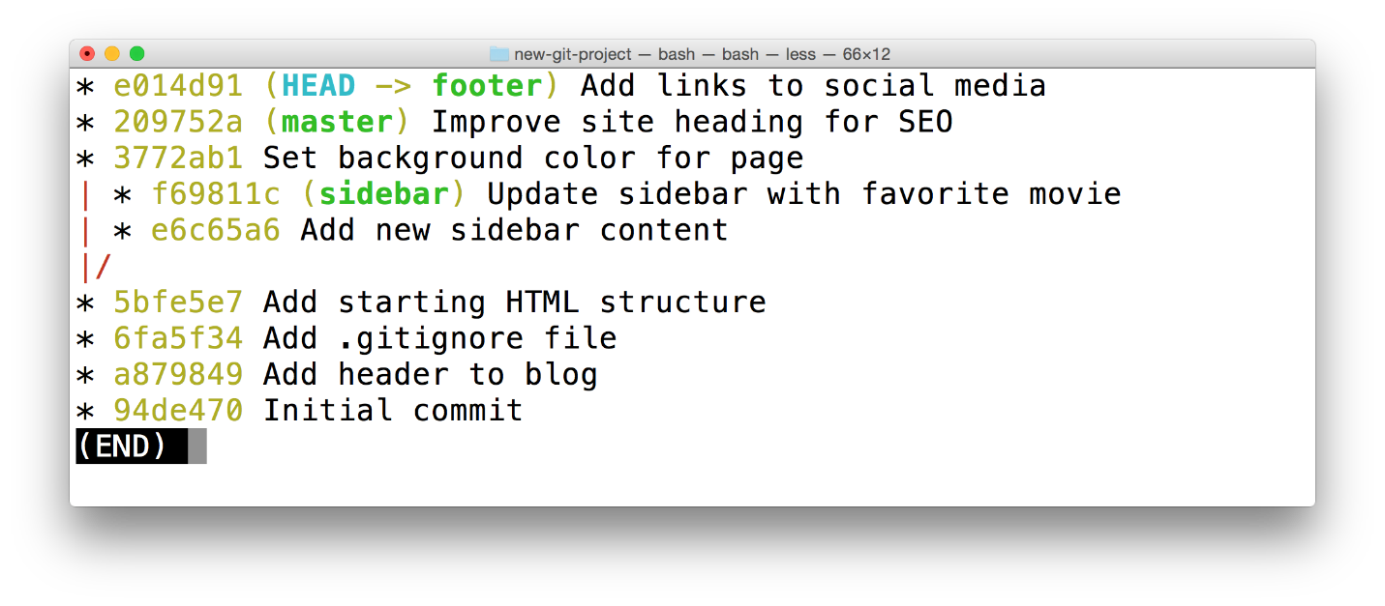

The Terminal application showing the output of *git log --oneline --graph --decorate --all*. This shows all branches and therefore all commits in the repository.

### Recap Of Changes

We've made the following changes:

1. on the master branch, we added a default color to the page
2. we created a sidebar branch and added code for a sidebar
3. on the master branch, we changed the heading of the page
4. on the sidebar branch, we added more content to the sidebar
5. we created a footer branch and added social links to the footer

These changes are all on their own, separate branches. Let's have Git combine these changes together. Combining branches together is called **merging**

## Merging

Remember that the purpose of a topic branch (like sidebar) is that it lets you make changes that do not affect the master branch. Once you make changes on the topic branch, you can either decide that you don't like the changes on the branch and you can just delete that branch, or you can decide that you want to keep the changes on the topic branch and combine those changes in with those on another branch.

Combining branches together is called **merging**.

Git can automatically merge the changes on different branches together. This branching and merging ability is what makes Git incredibly powerful! You can make small or extensive changes on branches, and then just use Git to combine those changes together.

Let's see how this works, in theory. Pay attention to the two main types of merges in Git, a regular **merge** and a **Fast-forward merge**.

<https://www.youtube.com/watch?time_continue=1&v=gQiWicrreJg&feature=emb_logo>

### **Quick Check In**

Let's do a quick check-in to make sure we're both starting at the same point. Check off each of the following:

Task List

* 

I am in the new-git-project project

* 

I have checked out the master branch

* 

the output of git status includes the text working directory clean

### ⚠️ Know The Branch ⚠️

It's very important to know which branch you're on when you're about to merge branches together. Remember that making a merge makes a commit.

As of right now, we do not know how to undo changes. We'll go over it in the next lesson, but if you make a merge on the wrong branch, use this command to undo the merge:

git reset --hard HEAD^

(Make sure to include the ^ character! It's a known as a "Relative Commit Reference" and indicates "the parent commit". We'll look at Relative Commit References in the next lesson.)

### The Merge Command

The git merge command is used to combine Git branches:

$ git merge <name-of-branch-to-merge-in>

When a merge happens, Git will:

* look at the branches that it's going to merge
* look back along the branch's history to find a single commit that both branches have in their commit history
* combine the lines of code that were changed on the separate branches together
* makes a commit to record the merge

#### Fast-forward Merge

In our project, I've checked out the master branch and I want \_it\_ to have the changes that are on the footer branch. If I wanted to verbalize this, I could say this is - "I want to merge in the footer branch". That "merge in" is important; when a merge is performed, the other branch's changes are brought into the branch that's currently checked out.

Let me stress that again - When we merge, we're merging some other branch into the current (checked-out) branch. We're not merging two branches into a new branch. We're not merging the current branch into the other branch.

Now, since footer is directly ahead of master, this merge is one of the easiest merges to do. Merging footer into master will cause a **Fast-forward merge**. A Fast-forward merge will just move the currently checked out branch forward until it points to the same commit that the other branch (in this case, footer) is pointing to.

To merge in the footer branch, run:

$ git merge footer

This is what my Terminal displays after running the command:



\_The Terminal application showing the result of merging the footer branch into the master branch.\_

#### QUESTION 1 OF 2

Take a look at the repository, again, now that you've merged the two branches together. Do the master branch and the footer branch point to the same commit?

* 

Yes

* 

No

### Perform A Regular Merge

Fantastic work doing a Fast-forward merge! That wasn't too hard, was it?

But you might say - "Of course that was easy, all of the commits are already there and the branch pointer just moved forward!"...and you'd be right. It's the simplest of merges.

So let's do the more common kind of merge where two divergent branches are combined. You'll be surprised that to merge in a divergent branch like sidebar is actually no different!

To merge in the sidebar branch, make sure you're on the master branch and run:

$ git merge sidebar

Because this combines two divergent branches, a commit is going to be made. And when a commit is made, a commit message needs to be supplied. Since this is a merge commit a default message is already supplied. You can change the message if you want, but it's common practice to use the default merge commit message. So when your code editor opens with the message, just close it again and accept that commit message.

This is what my Terminal shows after using the default commit message:

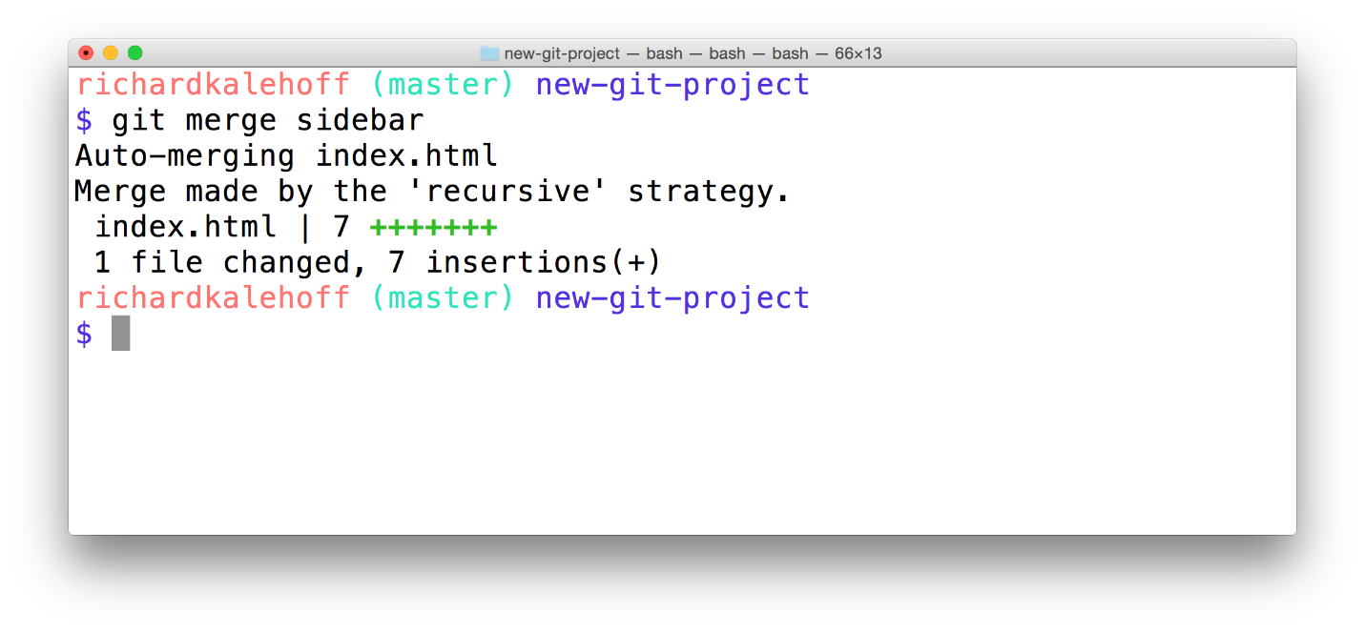

The Terminal application showing the result of merging the *sidebar* branch.

Aaaand that's all there is to merging! It's pretty simple, isn't it? You might read a lot of material that makes branching and merging seem overly complicated, but it's really not too bad at all.

#### QUESTION 2 OF 2

How about a quick quiz to see if you're following along with how merging works.

Let's say a repository has 4 branches in it:

* master
* allisons-mobile-footer-fix
* nav-updates
* jonathans-seo-changes

The changes on master and allisons-mobile-footer-fix need to be merged together. If HEAD points to allisons-mobile-footer-fix, which branch will move when the merge is performed?

* 

master

* 

allisons-mobile-footer-fix

* 

nav-updates

* 

jonathans-seo-changes

SUBMIT

### What If A Merge Fails?

The merges we just did were able to merge successfully. Git is able to intelligently combine lots of work on different branches. However, there are times when it can't combine branches together. When a merge is performed and fails, that is called a **merge conflict**. We'll look at merge conflicts, what causes them, and how to resolve them in the next lesson.

### Merge Recap

To recap, the git merge command is used to combine branches in Git:

$ git merge <other-branch>

There are two types of merges:

* Fast-forward merge – the branch being merged in must be ahead of the checked out branch. The checked out branch's pointer will just be moved forward to point to the same commit as the other branch.
* the regular type of merge
  + two divergent branches are combined
  + a merge commit is created

### Further Research

* **[Basic Merging](https://git-scm.com/book/en/v2/Git-Branching-Basic-Branching-and-Merging" \l "Basic-Merging" \t "_blank)** from Git Book
* **[git-merge](https://git-scm.com/docs/git-merge" \t "_blank)** from Git Docs
* **[git merge](https://www.atlassian.com/git/tutorials/git-merge" \t "_blank)** from Atlassian blog

## Merge Conflicts

### Sometimes Merges Fail

Most of the time Git will be able to merge branches together without any problem. However, there are instances when a merge cannot be fully performed automatically. When a merge fails, it's called a **merge conflict**.

If a merge conflict does occur, Git will try to combine as much as it can, but then it will leave special markers (e.g. >>> and <<<) that tell you where you (yep, you the programmer!) needs to manually fix.

#### What Causes A Merge Conflict

As you've learned, Git tracks lines in files. A merge conflict will happen when the exact same line(s) are changed in separate branches. For example, if you're on a alternate-sidebar-style branch and change the sidebar's heading to "About Me" but then on a different branch and change the sidebar's heading to "Information About Me", which heading should Git choose? You've changed the heading on both branches, so there's no way Git will know which one you actually want to keep. And it sure isn't going to just randomly pick for you!

Let's force a merge conflict so we can learn to resolve it. Trust me, it's simple once you get the hang of it! Remember that a merge conflict occurs when Git isn't sure which line(s) you want to use from the branches that are being merged. So we need to edit the same line on two different branches...and then try to merge them.

### Forcing A Merge Conflict!

Remember that a merge conflict occurs when the exact same line(s) are changed in separate branches. Let's alter the page's heading on two different branches. So Let's:

* change the heading on the master branch
* create a heading-update branch that's located on the commit right before the recently modified *master* branch
* change the same heading
* switch back to the master branch
* merge in the heading-update branch

### Change Heading On Branch 1

Since the master branch is just a regular ol' branch like all the rest, let's just alter the heading while we're on the master branch. So change the <h1> heading from whatever you have it to something else. For me, the heading is currently "Adventure" on line 13, and I'm changing it to "Quest".

Once you've made the change, save the file and commit it to the repository.

### Change Heading On Branch 2

Now we need to create a different branch and update the heading on that branch.

Now this is important, we need to create a branch that's not branching from the master branch. If we make a change that branches off of the master branch, then that change will be "ahead" of this one and Git will just use that change instead of the one we just made on master. So we need to put the branch "in the past".

Let's just create a branch that's on the commit right before the most recent one. So use Git log to get the previous commit's SHA and create a branch on that commit. Here's what my Git log looks like after creating a heading-update branch:

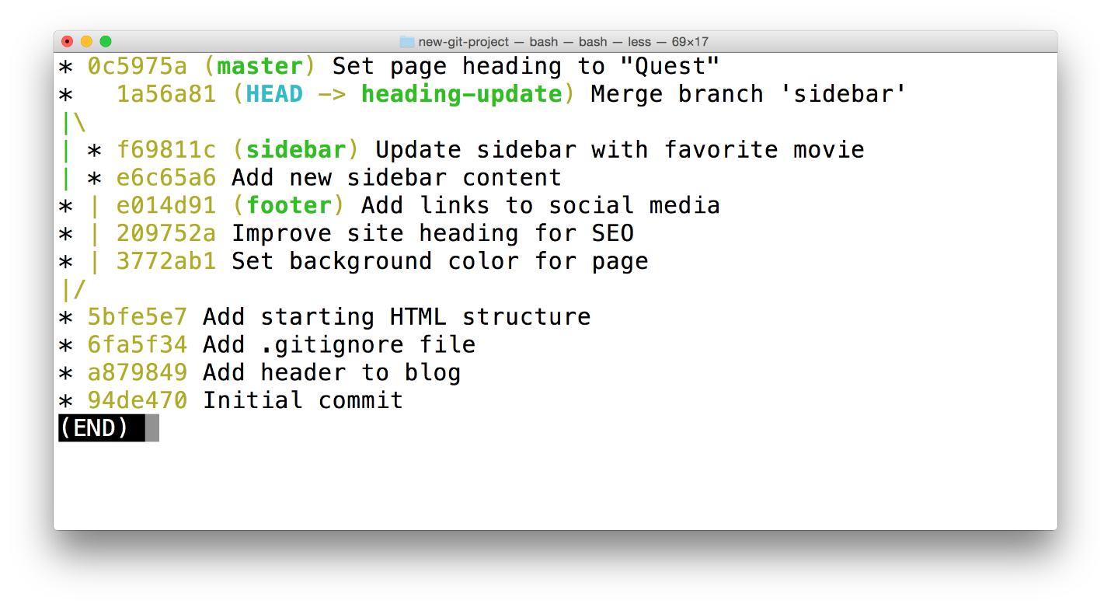

The Terminal application showing the output of *git log --oneline --decorate --graph --all*. The *heading-update* branch is currently checked out.

Ok, now that we've got our branch created, we just need to update the heading, again. Now make sure you change the exact same line that you changed on the master branch. I'm changing "Adventure" on line 13 to "Crusade".

Then save the file and commit it to the repository.

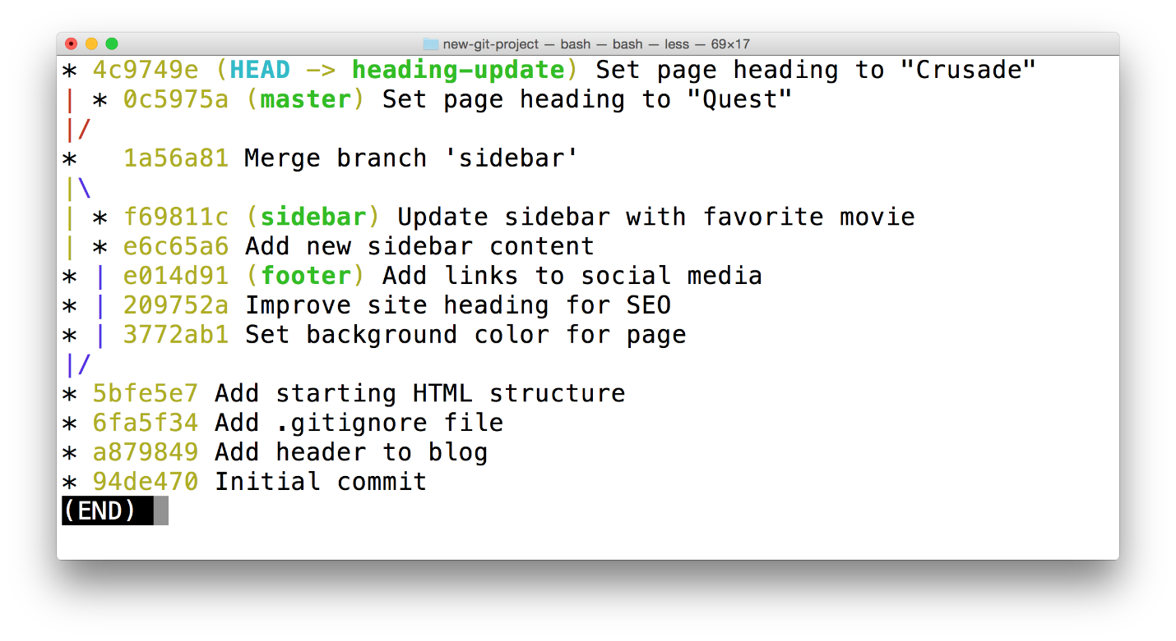

The Terminal application showing the output of *git log --oneline --decorate --graph --all*. Both the *master* branch and the *heading-update* branch alter the same line of the same file.

#### Prepped For Merge Conflict

Ok, we're just about to cause a merge conflict, make sure you're at the same place I am:

Task List

* 

I've made a commit on the master branch that changes the heading

* 

I've made a commit on the heading-update branch that also changes the heading

* 

I am currently on the master branch

Make sure you're on the master branch (we could really do this on either branch, but I just have a habit of keeping the master branch the main one that other topic branches get merged into) and merge in the heading-update branch:

$ git merge heading-update

You should see the following:

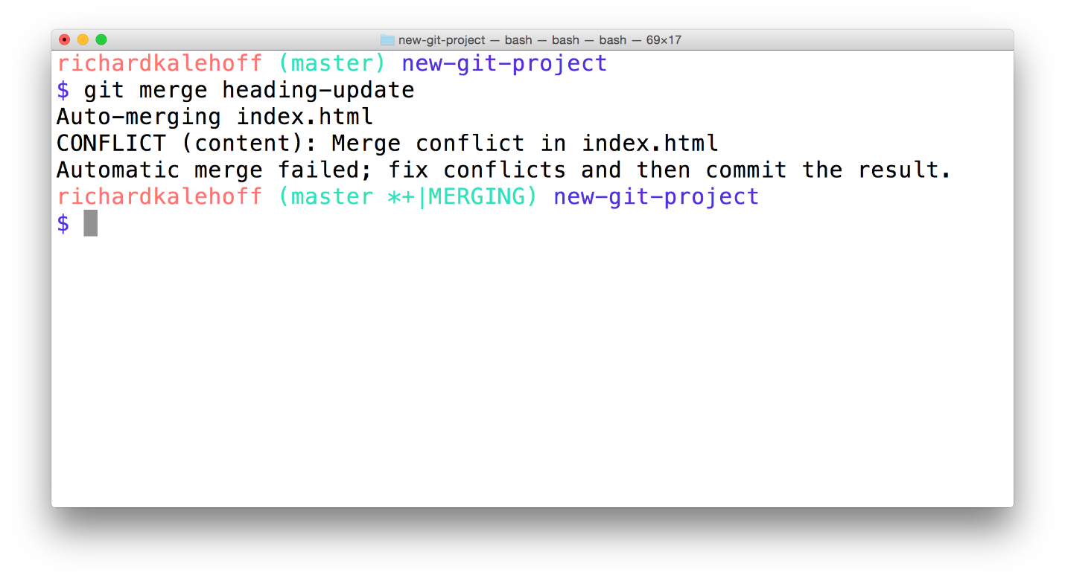

The Terminal application showing the output of a merge that resulted in a merge conflict. The word "CONFLICT" appears and says that the conflict occurred in the index.html file.

### Merge Conflict Output Explained

The output that shows in the Terminal is:

$ git merge heading-update

Auto-merging index.html

CONFLICT (content): Merge conflict **in** index.html

Automatic merge failed; fix conflicts and **then** commit the result.

Notice that right after the git merge heading-update command, it tries merging the file that was changed on both branches (index.html), but that there was a conflict. Also, notice that it tells you what happened - "Automatic merge failed; fix conflicts and then commit the result".

Remember our good friend git status? Well he'll come in really handy when working with merge conflicts.

#### QUESTION 1 OF 2

Try running git status right now. Which of the following information does it show?

* 

You have unmerged paths

* 

Unmerged paths

* 

fix conflicts and run "git commit"

* 

use "git add ..." to mark resolution

SUBMIT

The git status output tells us to that the merge conflict is inside index.html. So check out that file in your code editor!

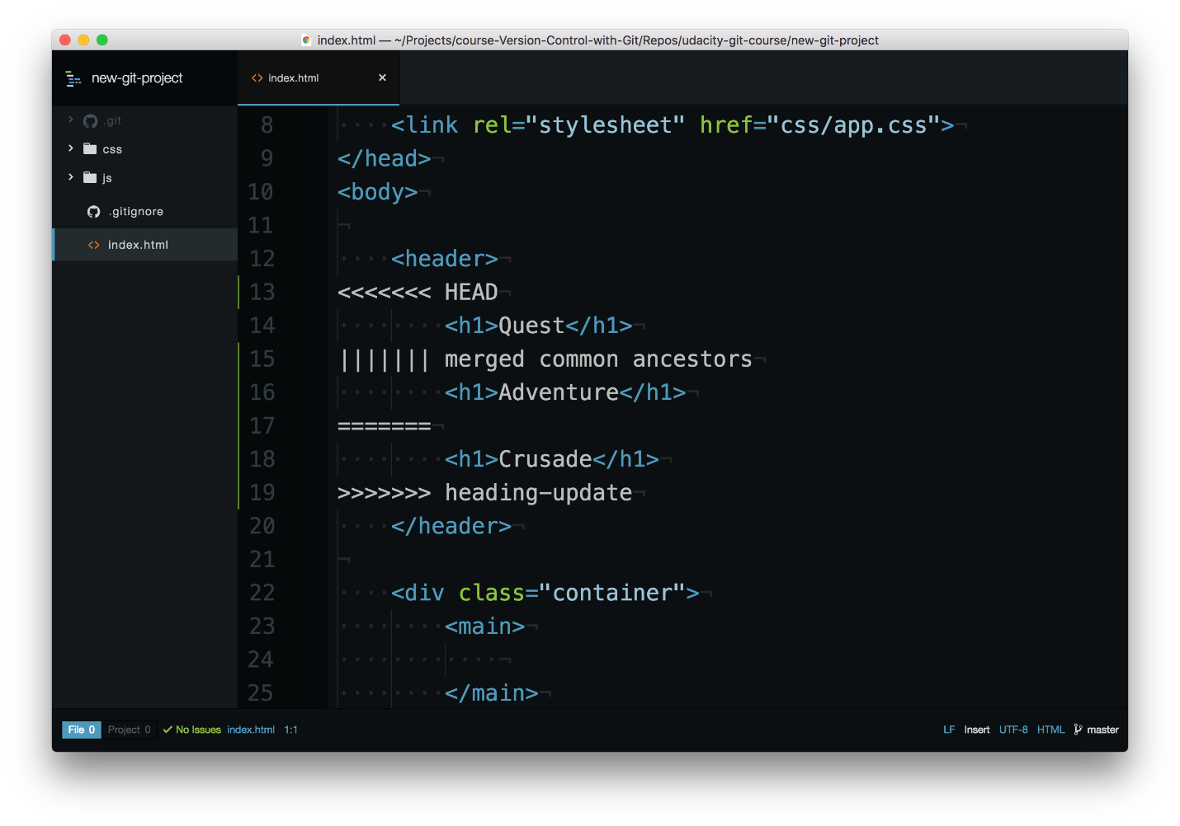

Code editor showing the merge conflict indicators.

### Merge Conflict Indicators Explanation

The editor has the following merge conflict indicators:

* <<<<<<< HEAD everything below this line (until the next indicator) shows you what's on the current branch
* ||||||| merged common ancestors everything below this line (until the next indicator) shows you what the original lines were
* ======= is the end of the original lines, everything that follows (until the next indicator) is what's on the branch that's being merged in
* >>>>>>> heading-update is the ending indicator of what's on the branch that's being merged in (in this case, the heading-update branch)

### Resolving A Merge Conflict

Git is using the merge conflict indicators to show you what lines caused the merge conflict on the two different branches as well as what the original line used to have. So to resolve a merge conflict, you need to:

1. choose which line(s) to keep
2. remove all lines with indicators

For some reason, I'm not happy with the word "Crusade" right now, but "Quest" isn't all that exciting either. How about "Adventurous Quest" as a heading?!?



Code editor where showing the merge conflict indicators being removed and the page heading being updated.

### Commit Merge Conflict

Once you've removed all lines with merge conflict indicators and have selected what heading you want to use, just save the file, add it to the staging index, and commit it! Just like with a regular merge, this will pop open your code editor for you to supply a commit message. Just like before, it's common to use the provided merge commit message, so after the editor opens, just close it to use the provided commit message.

And that's it! Merge conflicts really aren't all that challenging once you understand what the merge conflict indicators are showing you.

#### QUESTION 2 OF 2

You've made numerous commits so far in your exploration of Git. If a merge conflict occurs in a file and you edit the file, save it, stage it, and commit it but forget to remove the merge conflict indicators, will Git commit the file?

* 

Yes

* 

No

SUBMIT

### Merge Conflict Recap

A merge conflict happens when the same line or lines have been changed on different branches that are being merged. Git will pause mid-merge telling you that there is a conflict and will tell you in what file or files the conflict occurred. To resolve the conflict in a file:

* locate and remove all lines with merge conflict indicators
* determine what to keep
* save the file(s)
* stage the file(s)
* make a commit

Be careful that a file might have merge conflicts in multiple parts of the file, so make sure you check the entire file for merge conflict indicators - a quick search for <<< should help you locate all of them.

### Further Research

* **[Basic Merge Conflicts](https://git-scm.com/book/en/v2/Git-Branching-Basic-Branching-and-Merging" \l "Basic-Merge-Conflicts" \t "_blank)** from the Git book
* **[How Conflicts Are Presented](https://git-scm.com/docs/git-merge" \l "_how_conflicts_are_presented" \t "_blank)** from the Git docs

## Outro

<https://www.youtube.com/watch?v=ot4fPX1jzOI&feature=emb_logo>

# Lesson 6: Undoing Changes

## Intro

<https://www.youtube.com/watch?time_continue=1&v=Kfi7l41wUVc&feature=emb_logo>

## Modifying The Last Commit

### Changing The Last Commit

You've already made plenty of commits with the git commit command. Now with the --amend flag, you can alter the most-recent commit.

$ git commit --amend

If your Working Directory is clean (meaning there aren't any uncommitted changes in the repository), then running git commit --amend will let you provide a new commit message. Your code editor will open up and display the original commit message. Just fix a misspelling or completely reword it! Then save it and close the editor to lock in the new commit message.

### Add Forgotten Files To Commit

Alternatively, git commit --amend will let you include files (or changes to files) you might've forgotten to include. Let's say you've updated the color of all navigation links across your entire website. You committed that change and thought you were done. But then you discovered that a special nav link buried deep on a page doesn't have the new color. You could just make a new commit that updates the color for that one link, but that would have two back-to-back commits that do practically the exact same thing (change link colors).

Instead, you can amend the last commit (the one that updated the color of all of the other links) to include this forgotten one. To do get the forgotten link included, just:

* edit the file(s)
* save the file(s)
* stage the file(s)
* and run git commit --amend

So you'd make changes to the necessary CSS and/or HTML files to get the forgotten link styled correctly, then you'd save all of the files that were modified, then you'd use git add to stage all of the modified files (just as if you were going to make a new commit!), but then you'd run git commit --amend to update the most-recent commit instead of creating a new one.

## Reverting A Commit

### What Is A Revert?

When you tell Git to **revert** a specific commit, Git takes the changes that were made in commit and does the exact opposite of them. Let's break that down a bit. If a character is added in commit A, if Git reverts commit A, then Git will make a new commit where that character is deleted. It also works the other way where if a character/line is removed, then reverting that commit will add that content back!

We ended the previous lesson with a merge conflict and resolved that conflict by setting the heading to Adventurous Quest. Let's say that there's a commit in your repository that changes the heading now to Quests & Crusades.

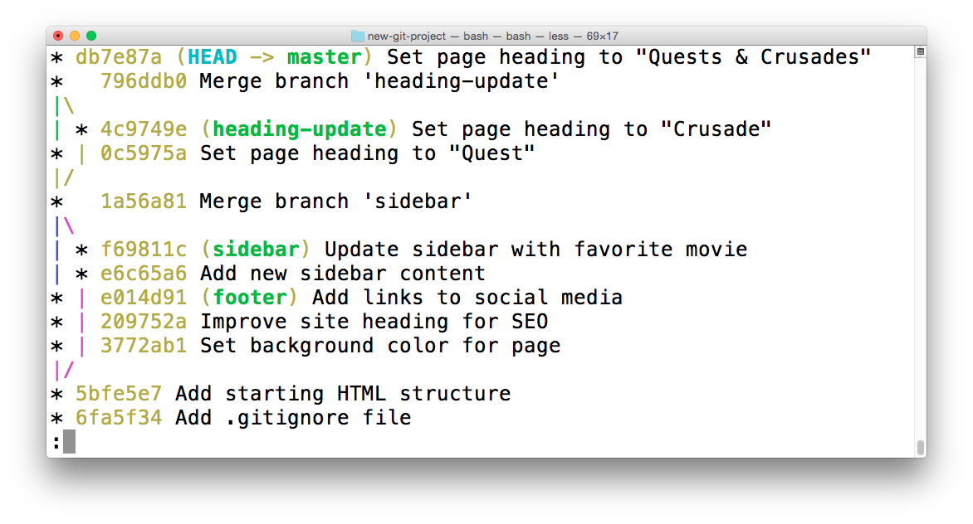

The Terminal application showing the log of a repository. The most-recent commit changes the heading from "Adventurous Quest" to "Quests & Crusades".

### The git revert Command

Now that I've made a commit with some changes, I can revert it with the git revert command

$ git revert <SHA-of-commit-to-revert>

Since the SHA of the most-recent commit is db7e87a, to revert it: I'll just run git revert db7e87a (this will pop open my code editor to edit/accept the provided commit message)

I'll get the following output:

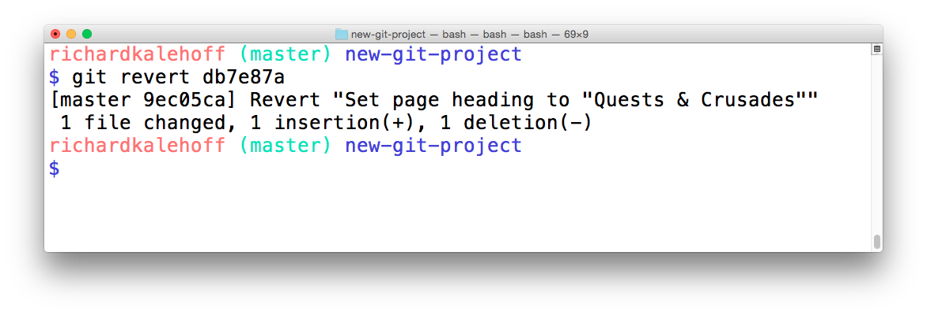

The Terminal application showing the output of reverting a commit. The output provides the commit message of the commit that was reverted. It also creates a new commit to record this change.

Did you see how the output of the git revert command tells us what it reverted? It uses the commit message of the commit that I told it to revert. Something that's also important is that it creates a new commit.

### Revert Recap

To recap, the git revert command is used to reverse a previously made commit:

$ git revert <SHA-of-commit-to-revert>

This command:

* will undo the changes that were made by the provided commit
* creates a new commit to record the change

### Further Research

* **[git-revert](https://git-scm.com/docs/git-revert" \t "_blank)** from Git Docs
* **[git revert](https://www.atlassian.com/git/tutorials/undoing-changes" \t "_blank)** Atlassian tutorial

## Resetting Commits

### Reset vs Revert

At first glance, resetting might seem coincidentally close to reverting, but they are actually quite different. Reverting creates a new commit that reverts or undos a previous commit. Resetting, on the other hand, erases commits!

### ⚠️ Resetting Is Dangerous ⚠️

You've got to be careful with Git's resetting capabilities. This is one of the few commands that lets you erase commits from the repository. If a commit is no longer in the repository, then its content is gone.

To alleviate the stress a bit, Git does keep track of everything for about 30 days before it completely erases anything. To access this content, you'll need to use the git reflog command. Check out these links for more info:

* **[git-reflog](https://git-scm.com/docs/git-reflog" \t "_blank)**
* **[Rewriting History](https://www.atlassian.com/git/tutorials/rewriting-history" \t "_blank)**
* **[reflog, your safety net](http://gitready.com/intermediate/2009/02/09/reflog-your-safety-net.html" \t "_blank)**

### Relative Commit References

You already know that you can reference commits by their SHA, by tags, branches, and the special HEAD pointer. Sometimes that's not enough, though. There will be times when you'll want to reference a commit relative to another commit. For example, there will be times where you'll want to tell Git about the commit that's one before the current commit...or two before the current commit. There are special characters called "Ancestry References" that we can use to tell Git about these relative references. Those characters are:

* ^ – indicates the parent commit
* ~ – indicates the first parent commit

Here's how we can refer to previous commits:

* the parent commit – the following indicate the parent commit of the current commit
  + HEAD^
  + HEAD~
  + HEAD~1
* the grandparent commit – the following indicate the grandparent commit of the current commit
  + HEAD^^
  + HEAD~2
* the great-grandparent commit – the following indicate the great-grandparent commit of the current commit
  + HEAD^^^
  + HEAD~3

The main difference between the ^ and the ~ is when a commit is created from a merge. A merge commit has two parents. With a merge commit, the ^ reference is used to indicate the first parent of the commit while ^2 indicates the second parent. The first parent is the branch you were on when you ran git merge while the second parent is the branch that was merged in.

It's easier if we look at an example. This what my git log currently shows:

\* 9ec05ca (HEAD -> master) Revert "Set page heading to "Quests & Crusades""

\* db7e87a Set page heading to "Quests & Crusades"

\* 796ddb0 Merge branch 'heading-update'

|\

| \* 4c9749e (heading-update) Set page heading to "Crusade"

\* | 0c5975a Set page heading to "Quest"

|/

\* 1a56a81 Merge branch 'sidebar'

|\

| \* f69811c (sidebar) Update sidebar with favorite movie

| \* e6c65a6 Add new sidebar content

\* | e014d91 (footer) Add links to social media

\* | 209752a Improve site heading **for** SEO

\* | 3772ab1 Set background color **for** page

|/

\* 5bfe5e7 Add starting HTML structure

\* 6fa5f34 Add .gitignore file

\* a879849 Add header to blog

\* 94de470 Initial commit

Let's look at how we'd refer to some of the previous commits. Since HEAD points to the 9ec05ca commit:

* HEAD^ is the db7e87a commit
* HEAD~1 is also the db7e87a commit
* HEAD^^ is the 796ddb0 commit
* HEAD~2 is also the 796ddb0 commit
* HEAD^^^ is the 0c5975a commit
* HEAD~3 is also the 0c5975a commit
* HEAD^^^2 is the 4c9749e commit (this is the grandparent's (HEAD^^) second parent (^2))

### Which Commit?

Use this repository to answer the following quiz questions:

\* 9ec05ca (HEAD -> master) Revert "Set page heading to "Quests & Crusades""

\* db7e87a Set page heading to "Quests & Crusades"

\* 796ddb0 Merge branch 'heading-update'

|\

| \* 4c9749e (heading-update) Set page heading to "Crusade"

\* | 0c5975a Set page heading to "Quest"

|/

\* 1a56a81 Merge branch 'sidebar'

|\

| \* f69811c (sidebar) Update sidebar with favorite movie

| \* e6c65a6 Add new sidebar content

\* | e014d91 (footer) Add links to social media

\* | 209752a Improve site heading **for** SEO

\* | 3772ab1 Set background color **for** page

|/

\* 5bfe5e7 Add starting HTML structure

\* 6fa5f34 Add .gitignore file

\* a879849 Add header to blog

\* 94de470 Initial commit

#### QUESTION 1 OF 4

Which commit is referenced by HEAD~6?

* 

4c9749e

* 

0c5975a

* 

1a56a81

* 

f69811c

* 

e014d91

* 

209752a

SUBMIT

You did so well on that last one, why not give this one a go! Using the same repository, which commit is referenced by HEAD~4^2?

SUBMIT

### The git reset Command

The git reset command is used to reset (erase) commits:

$ git reset <reference-to-commit>

It can be used to:

* move the HEAD and current branch pointer to the referenced commit
* erase commits
* move committed changes to the staging index
* unstage committed changes

### Git Reset's Flags

The way that Git determines if it erases, stages previously committed changes, or unstages previously committed changes is by the flag that's used. The flags are:

* --mixed
* --soft
* --hard

It's easier to understand how they work with a little animation.

<https://www.youtube.com/watch?v=UN7ki2G2yKc&feature=emb_logo>

### 💡 Backup Branch 💡

Remember that using the git reset command will erase commits from the current branch. So if you want to follow along with all the resetting stuff that's coming up, you'll need to create a branch on the current commit that you can use as a backup.

Before I do any resetting, I usually create a backup branch on the most-recent commit so that I can get back to the commits if I make a mistake:

$ git branch backup

### Reset's --mixed Flag

Let's look at each one of these flags.

\* 9ec05ca (HEAD -> master) Revert "Set page heading to "Quests & Crusades""

\* db7e87a Set page heading to "Quests & Crusades"

\* 796ddb0 Merge branch 'heading-update'

Using the sample repo above with HEAD pointing to master on commit 9ec05ca, running git reset --mixed HEAD^ will take the changes made in commit 9ec05ca and move them to the working directory.

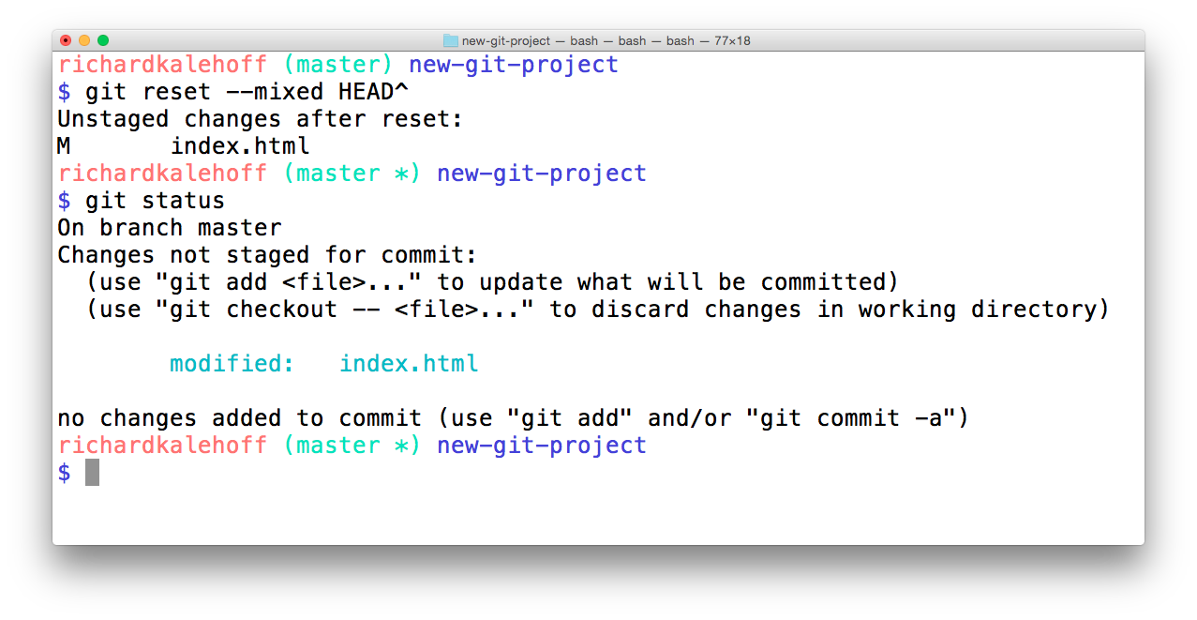

The Terminal application showing the result of resetting with the *--mixed* flag. The changes are unstaged.

### 💡 Back To Normal 💡

If you created the backup branch prior to resetting anything, then you can easily get back to having the master branch point to the same commit as the backup branch. You'll just need to:

1. remove the uncommitted changes from the working directory
2. merge backup into master (which will cause a Fast-forward merge and move master up to the same point as backup)

$ git checkout -- index.html

$ git merge backup

### Reset's --soft Flag

Let's use the same few commits and look at how the --soft flag works:

\* 9ec05ca (HEAD -> master) Revert "Set page heading to "Quests & Crusades""

\* db7e87a Set page heading to "Quests & Crusades"

\* 796ddb0 Merge branch 'heading-update'

Running git reset --soft HEAD^ will take the changes made in commit 9ec05ca and move them directly to the Staging Index.

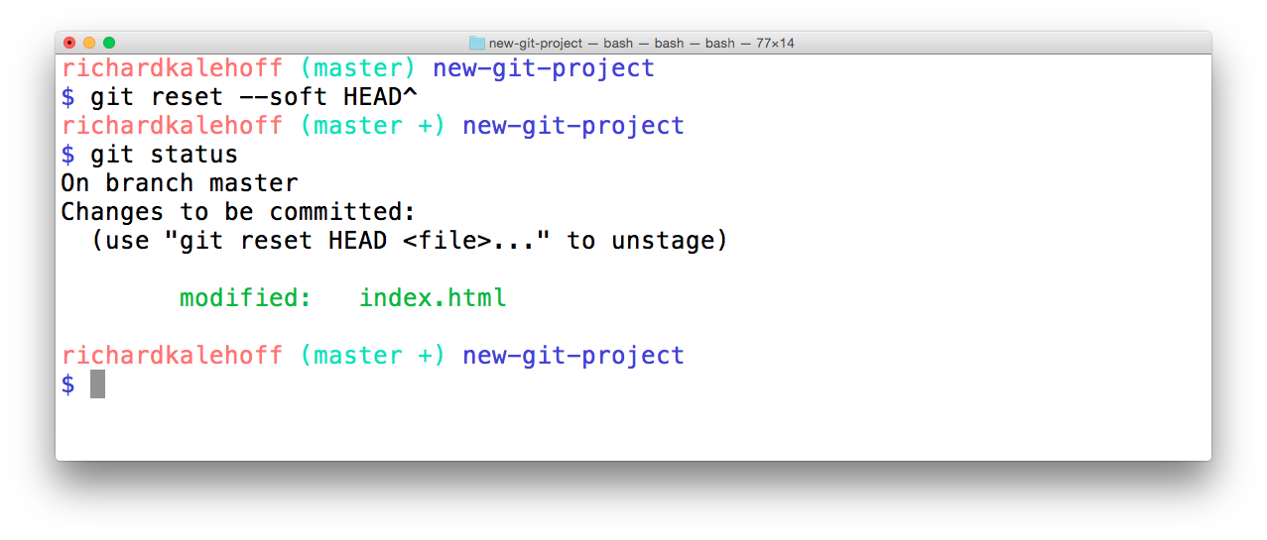

The Terminal application showing the result of resetting with the *--soft* flag. The changes are moved to the Staging Index.

### Reset's --hard Flag

Last but not least, let's look at the --hard flag:

\* 9ec05ca (HEAD -> master) Revert "Set page heading to "Quests & Crusades""

\* db7e87a Set page heading to "Quests & Crusades"

\* 796ddb0 Merge branch 'heading-update'

Running git reset --hard HEAD^ will take the changes made in commit 9ec05ca and erases them.

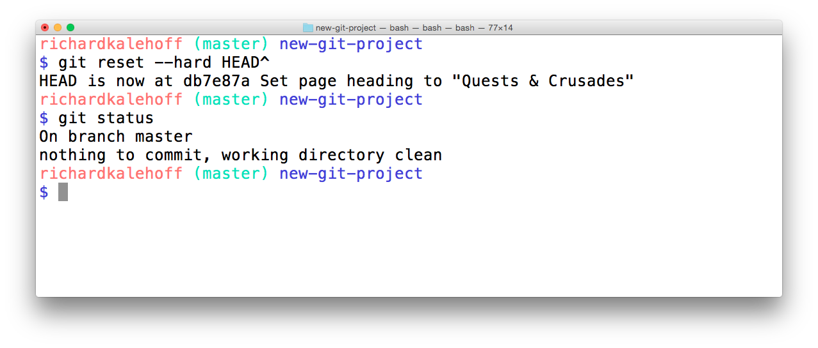

The Terminal application showing the result of resetting with the *--hard* flag. The changes are moved erased.

Now it's your turn!

Refer to the following repository:

\* e014d91 (HEAD -> master, footer) Add links to social media

\* 209752a Improve site heading **for** SEO

\* 3772ab1 Set background color **for** page

\* 5bfe5e7 Add starting HTML structure

\* 6fa5f34 Add .gitignore file

\* a879849 Add header to blog

\* 94de470 Initial commit

#### QUESTION 3 OF 4

What will happen to the changes from the 3772ab1 commit if git reset --hard HEAD~3 is run? Will the changes be in the Staging Index, in the Working Directory, or complete erased?

* 

Staging Index

* 

Working Directory

* 

erased

SUBMIT

#### QUESTION 4 OF 4

What will happen to the changes from the 209752a commit if git reset --soft HEAD^^ is run? Will the changes be in the Staging Index, in the Working Directory, or complete erased?

* 

Staging Index

* 

Working Directory

* 

erased

SUBMIT

### Reset Recap

To recap, the git reset command is used erase commits:

$ git reset <reference-to-commit>

It can be used to:

* move the HEAD and current branch pointer to the referenced commit
* erase commits with the --hard flag
* moves committed changes to the staging index with the --soft flag
* unstages committed changes --mixed flag

Typically, ancestry references are used to indicate previous commits. The ancestry references are:

* ^ – indicates the parent commit
* ~ – indicates the first parent commit

### Further Research

* **[git-reset](https://git-scm.com/docs/git-reset" \t "_blank)** from Git docs
* **[Reset Demystified](https://git-scm.com/book/en/v2/Git-Tools-Reset-Demystified" \t "_blank)** from Git Blog
* **[Ancestry References](https://git-scm.com/book/en/v2/Git-Tools-Revision-Selection" \l "Ancestry-References" \t "_blank)** from Git Book

## Lesson Outro

<https://www.youtube.com/watch?time_continue=1&v=-_PPVk2UZMU&feature=emb_logo>

## Course Outro

<https://www.youtube.com/watch?v=twn_cheqoK8&feature=emb_logo>